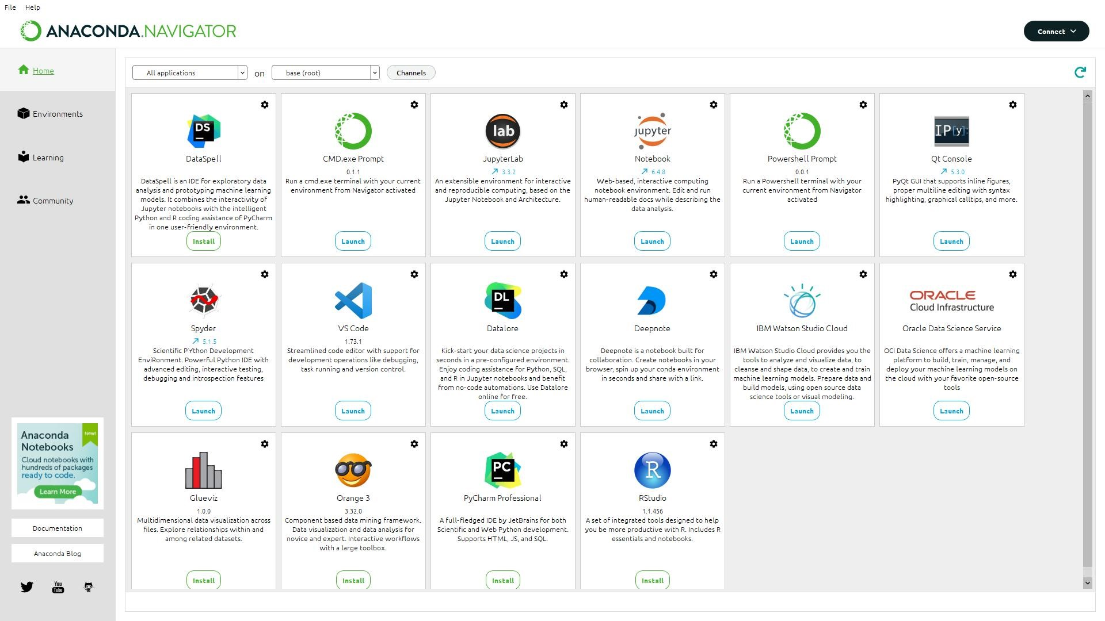**Project Pre-Requisites**

|  |  |
| --- | --- |
| Date | 12 November 2022 |
| TeamID | PNT2022TMID14329 |
| Project Name | Car Resale value Prediction |

1. First install Anaconda software.
2. Then in Anaconda Navigator download Jupyter Notebook.
3. Install Python packages

The following packages are installed

* + Flask
  + Scikit-learn
  + Matplotlib
  + Pandas
  + Numpy

