**Assignment -1**

**Student Name:** Nivendra K

**Student Roll Number:** CITC1905104

**Question-1:**

**Create registration page in html with username, email and phone number and by using POST method display it in next html page.**

**Solution:**

**next.html**

<!DOCTYPE html>

<html lang="en">

<head>

    <meta charset="UTF-8">

    <meta http-equiv="X-UA-Compatible" content="IE=edge">

    <meta name="viewport" content="width=device-width, initial-scale=1.0">

    <title>Document</title>

</head>

<body>

</body>

<script>

    //get data from get

    let data = new URLSearchParams(window.location.search);

    let username = data.get("username");

    let email = data.get("email");

    let phone = data.get("phone");

    //create elements

    let div = document.createElement("div");

    let h1 = document.createElement("h1");

    let p1 = document.createElement("p");

    let p2 = document.createElement("p");

    let p3 = document.createElement("p");

    //add text to elements

    h1.innerText = "Welcome " + username;

    p1.innerText = "Your email is " + email;

    p2.innerText = "Your phone number is " + phone;

    p3.innerText = "Thank you for registering";

    //append elements

    div.appendChild(h1);

    div.appendChild(p1);

    div.appendChild(p2);

    div.appendChild(p3);

    document.body.appendChild(div);

</script>

</html>

**registration.html**

<!DOCTYPE html>

<html lang="en">

<head>

    <meta charset="UTF-8">

    <meta http-equiv="X-UA-Compatible" content="IE=edge">

    <meta name="viewport" content="width=device-width, initial-scale=1.0">

    <title>Document</title>

    <style>

        label{

            display: block;

            margin: 10px;

        }

        input{

            margin: 10px;

            height: 20px;

        }

        button{

            margin: 10px;

            cursor: pointer;

        }

        form{

            max-width: 300px;

            margin: 10px auto;

        }

    </style>

</head>

<body>

    <div style="text-align:center;font-size: 80px;"> Form</div>

    <form action="./next.html" method="get">

        <div>

            <label for="username">Username</label>

            <input type="text" name="username" id="username">

        </div>

        <div>

            <label for="email">E-mail</label>

            <input type="text" name="email" id="username">

        </div>

        <div>

            <label for="phone">Phone number</label>

            <input type="text" name="phone" id="username">

        </div>

        <button type="submit">Submit</button>

    </form>

</body>

</html>

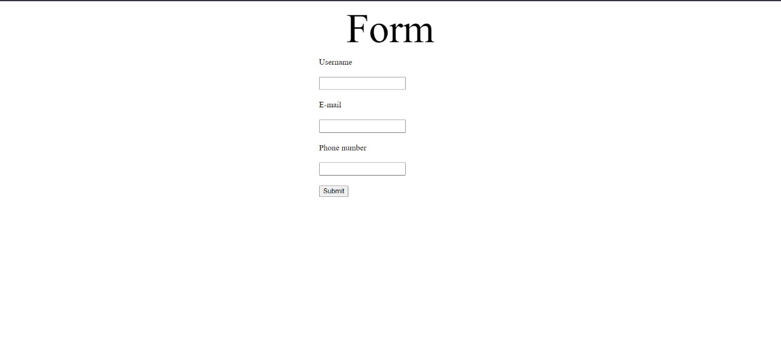

**Question-2:**

**Develop a flask program which should contain at least 5 packages used from pypi.org.**

**Solution:**

**base.html**

<!DOCTYPE html>

<html lang="en">

<head>

    <meta charset="UTF-8">

    <title>{% block title %} {% endblock %} - FlaskApp</title>

    <style>

        nav a {

            color: #d64161;

            font-size: 3em;

            margin-left: 50px;

            text-decoration: none;

        }

    </style>

</head>

<body>

    <nav>

        <a href="#">FlaskApp</a>

        <a href="#">About</a>

    </nav>

    <hr>

    <div class="content">

        {% block content %} {% endblock %}

    </div>

</body>

</html>

**index.html**

{% extends 'base.html' %}

{% block content %}

    <h1>{% block title %} Index {% endblock %}</h1>

    <h1>Hello World!</h1>

    <h2>Welcome to FlaskApp!</h2>

    <h3>{{ utc_dt }}</h3>

{% endblock %}

**main.py**

from flask import Flask

import ibm_db

import urllib.parse

from flask_cors import CORS

app=Flask(__name__)

cors=CORS(app)

**router.py**

from main import app

from flask import request,jsonify,render_template

@app.route("/",methods=["POST","GET"])

def main():

    return render_template("index.html")

**run.py**

from main import *

from router import *

if __name__=="__main__":

    app.run(port=3000,debug=True)

