**Assignment -2**

**Student Name:** Nivendra K

**Student Roll Number**: CITC1905104

**Question-1:**

Create User table with user with email, username, roll number, password.

**Solution:**

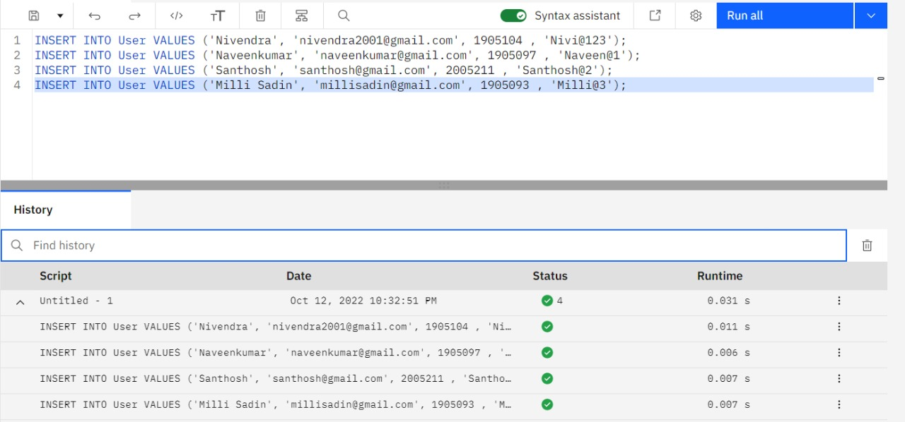

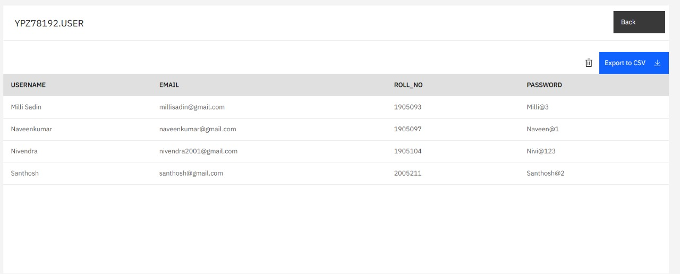

**Question-2:**

Perform UPDATE,DELETE Queries with user table.

**Solution:**

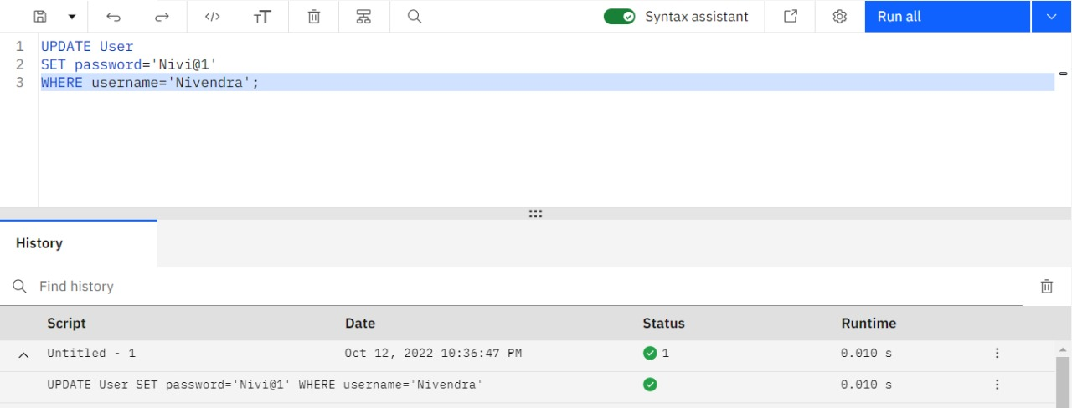

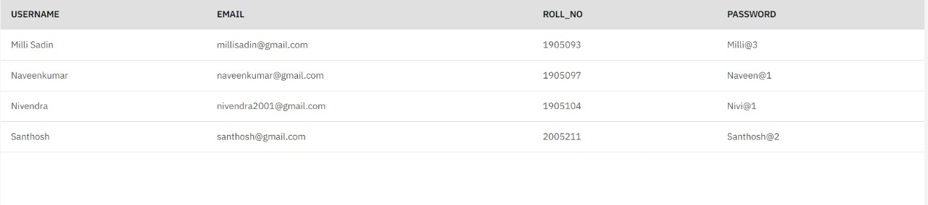

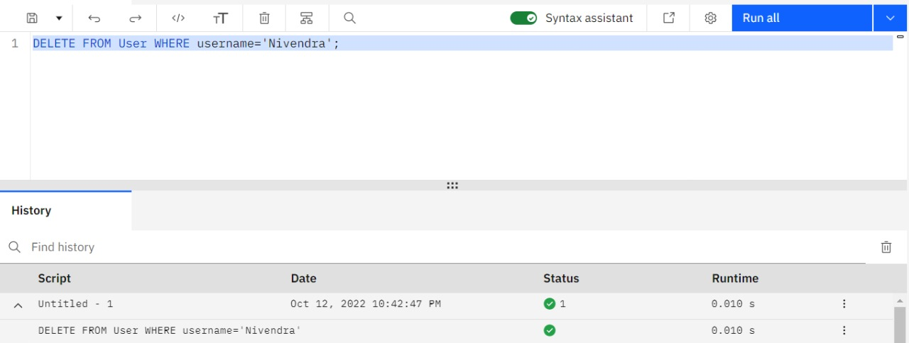

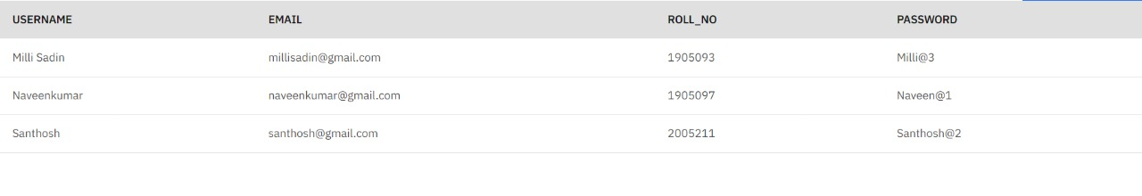

**Question-3:**

Connect python code to db2.

**Solution:**

**index.py**

from flask import Flask, render_template, request, session

import ibm_db

import re

app = Flask(__name__)

app.secret_key = 'a'

try:

    conn = ibm_db.connect("DATABASE=bludb;HOSTNAME=19af6446-6171-4641-8aba-9dcff8e1b6ff.c1ogj3sd0tgtu0lqde00.databases.appdomain.cloud;PORT=30699;SECURITY=SSL;SSLServerCertificate=DigiCertGlobalRootCA.crt;UID=gpf28409;PWD=G9IH9SYk8j8QnHJi;", "", "")

    print("Connected to DB")

except:

    print("Unable to connect to the db")

**Question-4:**

Create a flask app with registration page, login page and welcome page. By default load the registration page once the user enters all the fields store the data in database and navigate to login page authenticate user username and password. If the user is valid show the welcome page.

**Solution:**

**index.py**

from flask import Flask, render_template, request, session

import ibm_db

import re

app = Flask(__name__)

app.secret_key = 'a'

try:

    conn = ibm_db.connect("DATABASE=bludb;HOSTNAME=19af6446-6171-4641-8aba-9dcff8e1b6ff.c1ogj3sd0tgtu0lqde00.databases.appdomain.cloud;PORT=30699;SECURITY=SSL;SSLServerCertificate=DigiCertGlobalRootCA.crt;UID=gpf28409;PWD=G9IH9SYk8j8QnHJi;", "", "")

    print("Connected to DB")

except:

    print("Unable to connect to the db")

@app.route('/')

def home():

    return render_template('home.html')

@app.route("/register",methods=["GET","POST"])

def register():

    msg = " "

    if request.method=="POST":

        username = request.form['username']

        email = request.form['email']

        regno=request.form['regno']

        password = request.form['password']

        print(username,email,regno,password)

        sql = "SELECT * FROM USERS WHERE username =?"

        stmt = ibm_db.prepare(conn,sql)

        ibm_db.bind_param(stmt,1,username)

        ibm_db.execute(stmt)

        account = ibm_db.fetch_assoc(stmt)

        print(account)

        if account:

            msg="Account already exists!"

        elif not re.match(r'[^@]+@[^@]+\.[^@]+',email):

            msg = "Invalid Email Address!"

        elif not re.match(r'[A-Za-z0-9]+',username):

            msg = "name must contain only characters and numbers"

        else:

            insert_sql = "INSERT INTO USERS VALUES(?,?,?,?)"

            prep_stmt = ibm_db.prepare(conn,insert_sql)

            ibm_db.bind_param(prep_stmt,1,username)

            ibm_db.bind_param(prep_stmt,2,email)

            ibm_db.bind_param(prep_stmt,3,regno)

            ibm_db.bind_param(prep_stmt,4,password)

            ibm_db.execute(prep_stmt)

            msg = "You have successfully Logged In"

            return render_template('dashboard.html',msg=msg,username = username)

    elif request.method=="POST":

        msg = "Please fill out the form!"

    return render_template('Register.html',msg=msg)

@app.route("/login",methods=["GET","POST"])

def login():

    global userid

    msg = " "

    if request.method=="POST":

        username = request.form['username']

        password = request.form['password']

        print(username,password)

        sql = "SELECT * FROM USERS WHERE username =? AND userpassword=?"

        stmt = ibm_db.prepare(conn,sql)

        ibm_db.bind_param(stmt,1,username)

        ibm_db.bind_param(stmt,2,password)

        ibm_db.execute(stmt)

        account = ibm_db.fetch_assoc(stmt)

        print(account)

        if account:

            session['Loggedin'] = True

            session['id'] = account ['USERNAME']

            userid = account["USERNAME"]

            session['username'] = account["USERNAME"]

            msg = "Logged IN successfully!"

            return render_template('dashboard.html',msg=msg,username = session['username'])

        else:

            msg = "Incorrect Username or Password"

    return render_template('login.html',msg=msg)

@app.route('/dashboard')

def dashboard():

    return render_template('Dashboard.html')

@app.route('/logout')

def logout():

    session.pop('loggedin',None)

    session.pop('id',None)

    session.pop('username',None)

    return render_template('Register.html')

if __name__ == "__main__":

    app.run('0.0.0.0', debug=True)

**Dashboard.html**

<!DOCTYPE html>

<html lang="en">

  <head>

    <meta charset="UTF-8" />

    <meta http-equiv="X-UA-Compatible" content="IE=edge" />

    <meta name="viewport" content="width=device-width, initial-scale=1.0" />

    <title>Dashboard</title>

  </head>

  <body>

    <h1 class="mb-8 text-3xl text-center">Dashboard</h1>

    <div>

      <h2>{{msg}}</h2>

      <h2>{{username}}</h2>

    </div>

  </body>

</html>

**Login.html**

<!DOCTYPE html>

<html lang="en">

  <head>

    <meta charset="UTF-8" />

    <meta http-equiv="X-UA-Compatible" content="IE=edge" />

    <meta name="viewport" content="width=device-width, initial-scale=1.0" />

    <script src="https://cdn.tailwindcss.com"></script>

    <title>Log In</title>

  </head>

  <body>

    <div class="bg-grey-lighter min-h-screen flex flex-col">

      <div

        class="container max-w-sm mx-auto flex-1 flex flex-col items-center justify-center px-2"

      >

        <form method="post" class="bg-white px-6 py-8 rounded shadow-md text-black w-full">

          <h1 class="mb-8 text-3xl text-center">Log In</h1>

          <h1 class="mb-8 text-xl text-center">{{msg}}</h1>

          <input

            type="text"

            class="block border border-grey-light w-full p-3 rounded mb-4"

            name="username"

            placeholder="Username"

          />

          <input

            type="password"

            class="block border border-grey-light w-full p-3 rounded mb-4"

            name="password"

            placeholder="Password"

          />

          <button

            type="submit"

            class="w-full text-center py-3 rounded bg-green-400 hover:bg-green-500 focus:outline-none my-1"

          >

            Log in

          </button>

        </form>

        <div class="text-grey-dark mt-6">

          New User?

          <a

            class="no-underline border-b border-blue text-blue"

            href="./Register.html"

          >

            Create Account </a

          >.

        </div>

      </div>

    </div>

  </body>

</html>

**Register.html**

<!DOCTYPE html>

<html lang="en">

  <head>

    <meta charset="UTF-8" />

    <meta http-equiv="X-UA-Compatible" content="IE=edge" />

    <meta name="viewport" content="width=device-width, initial-scale=1.0" />

    <script src="https://cdn.tailwindcss.com"></script>

    <title>Register</title>

  </head>

  <body>

    <div class="bg-grey-lighter min-h-screen flex flex-col">

      <div

        class="container max-w-sm mx-auto flex-1 flex flex-col items-center justify-center px-2"

      >

        <form method="post" class="bg-white px-6 py-8 rounded shadow-md text-black w-full">

          <h1 class="mb-8 text-3xl text-center">Sign Up</h1>

          <h1 class="mb-8 text-xl text-center">{{msg}}</h1>

          <input

            type="text"

            class="block border border-grey-light w-full p-3 rounded mb-4"

            name="username"

            placeholder="User Name"

          />

          <input

            type="text"

            class="block border border-grey-light w-full p-3 rounded mb-4"

            name="email"

            placeholder="Email"

          />

          <input

            type="text"

            class="block border border-grey-light w-full p-3 rounded mb-4"

            name="regno"

            placeholder="Roll No"

          />

          <input

            type="password"

            class="block border border-grey-light w-full p-3 rounded mb-4"

            name="password"

            placeholder="Password"

          />

          <button

            type="submit"

            class="w-full text-center py-3 rounded bg-green-400 hover:bg-green-500 focus:outline-none my-1"

          >

            Create Account

          </button>

        </form>

        <div class="text-grey-dark mt-6">

          Already have an account?

          <a

            class="no-underline border-b border-blue text-blue"

            href="./Login.html"

          >

            Log in </a

          >.

        </div>

      </div>

    </div>

  </body>

</html>