Team ID : PNT2022TMID48646

Step 1: Install Python IDLE

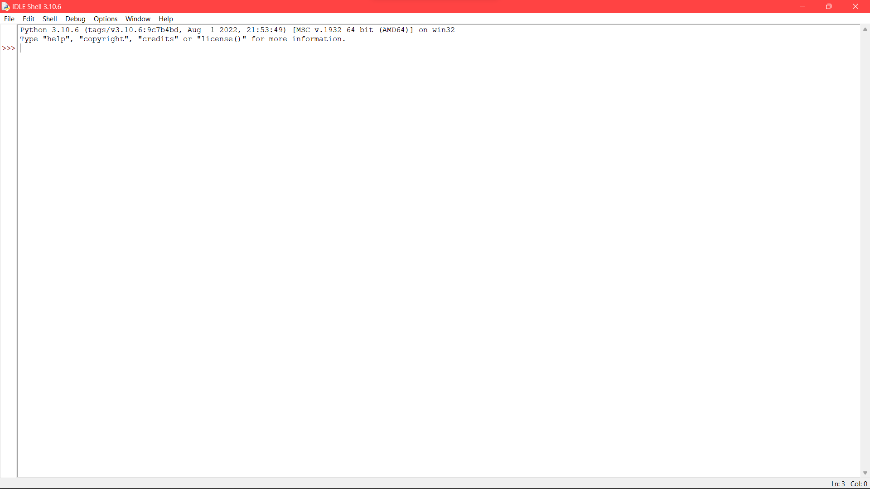

Step 2: Install wiotp-sdk

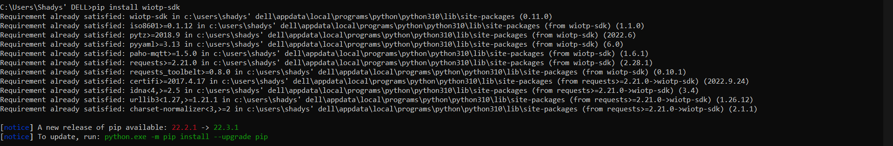

Step 3: Install ibmcloudant

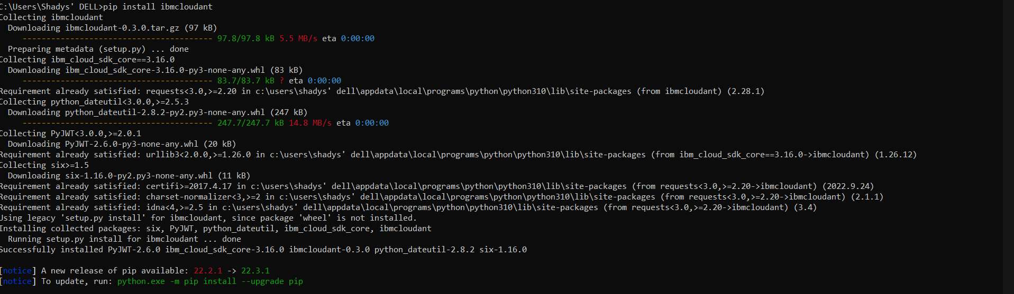

Step 4: Install opencv-python

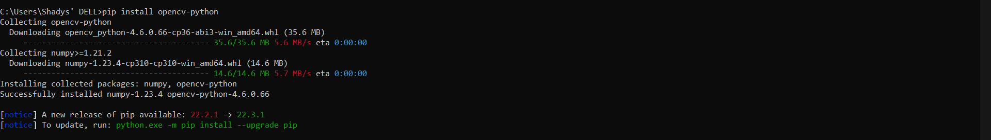

Step 5: Install pyzbar

