**COIMBATORE INSTITUTE OF TECHNOLOGY**

***(Government Aided Autonomous Institution Affiliated to Anna University)***

**COIMBATORE-641 014**

**ANNA UNIVERSITY - CHENNAI 600 025**

**DEPARTMENT OF COMPUTER SCIENCE AND ENGINEERING**



**SOFTWARE REQUIREMENTS SPECIFICATION**

**EFFICIENT WATER QUALITY ANALYSIS & PREDICTION USING MACHINE LEARNING**

**Submitted by**

Hari Prasath M(1905083)

Meeradevi S (1905094)

Sanjai V (1905111)

Thendral S (1905119)

**Guided by**

Dr.R.Nedunchezhian

**Table of Contents:**

**1. Introduction**

           1.1 Purpose

           1.2 Intended Audience

           1.3 Intended Use

           1.4 Scope

           1.5 Definitions and Acronyms

**2. Overall Description**

           2.1 User Needs

           2.2 Assumptions and Dependencies

**3. System Features and Requirements**

            3.1 Functional Requirements

            3.2 External Interface Requirements

            3.3 System Features

            3.4 Non-Functional Requirements

**4.Project Flow**

4.1. Technical Architecture

* 1. List of Activities/Tasks

**1.Introduction:**

Smart bin is a garbage collecting dust bin, which is self-aware and detects the level and weight of the waste in the dustbin, based on that it can send alert messages to respective officers, so the authorities make the arrangements to replace or empty the dustbin. This type of dustbins will be very useful in places where the frequency of people using the dustbin varies because timely checks won’t be sufficient. Other features are also added, one is finding the level of dustbin with the help of using an Ultrasonic Sensor. In addition, we also have weight sensors attached below the garbage bins. Thus the system sends over the internet the level of fill of the garbage bins as well as the weight of the fill of the garbage bins and the location of the bin will be identified via GPS module. An ESP32 board is used to send the information to a server. An ultrasonic Sensor is used for detecting the level filled in the dustbin. These Sensors are connected to the ESP32 . The board also consists of a voltage regulator, which is used to provide the required voltage to the Sensors and the ESP board. The ESP32 consists of an integrated WIFI and dual-mode Bluetooth, which is used for server-client communication. Using this, information can be passed from the client to server, and vice versa. This is used for passing information about the current state of the dustbin.

**1.1**  **Purpose:**

* Ø  To collect dustbins placed at public places in the city.
* Ø  Automatic level indication for ease of use.
* Ø  Automatic weight measurement of garbage in the bin.
* Ø  Prevention from germs and diseases because it avoids the overflow condition.
* Ø  Warning message indication when a Smart Trash Bin is nearly full. Also indicate location in the dashboard in the particular area.

**1.2**  **Intended Audience**

* In accordance with the Waste Act, waste holders, such as private individuals, property owners or companies, are primarily responsible for the management of waste. An exception to this rule is the responsibility municipalities and certain manufacturers may have for organizing waste management.
* The most economically viable technology and the best practices for preventing harmful environmental or health effects must be used in waste management. The Waste Act prohibits uncontrolled dumping or treatment of waste.

**1.3 Intended Use**

Smart waste management is characterized by the usage of technology in order to be more efficient when it comes to managing waste. This makes it possible to plan more efficient routes for the trash collectors who empty the bins, but also lowers the chance of any bin being full for over a week.This technology can be used by all the residents and municipalities to prevent themselves from creating a harmful environment.

**1.4  Scope**

The main aim of this project is to reduce human resources and efforts along with the enhancement of a smart city vision. We have often seen garbage spilling over from dustbins on to streets and this was an issue that required immediate attention. This can be resolved using this smart dustbin solution. This is a cost effective and efficient method. Further enhancement of this project is that it will not only notify about their values but also share the locations so that it becomes easy to find those dustbins and empty them. This can be implemented with the help of GPS tracking devices monitored by GPS master control stations which are responsible for location identification. Another way is to implement this project in institutions or universities where garbage disposal is one of the mandatory tasks. By implementing this system resource optimization, cost reduction, effective usage of smart dustbins can be done. Provide basic infrastructure, Quality of life, Clean and sustainable environment.

**1.5 Definitions and Acronyms**

* ESP32 - Espressif System 32 series
* ESP8266 - Espressif System 8266 series
* EmailJS-Electronic Mail Javascript
* GPS-Global Positioning System

**2.1 User Needs**

The intended users of this project are concerned authorities of a municipal corporation who always send front line workers to collect the garbage even though they weren't aware of the status of the dustbin it leads to waste of man power. For sake of that we were developing an bin with sensors integrated and it send message to the concerned authorities regarding the bin status through a web App to empty the bin whenever the bins are full. The user needs  to have an active internet connection and a GPS enabled device. The Trash collectors doesn't need to worry about the internal working of the model, instead they get direct instructions and it was also eco friendly.

    a message from a sensor based dustbin about the location and  the level of waste in it.In the software, the capacity of the container is indicated and alerts the authorized person (Trash collectors) through a web App to empty the bin whenever the bins are full. The user needs  to have an active internet connection and a GPS enabled device. The Trash collectors doesn't need to worry about the internal working of the model, instead they get direct instructions

**2.2 Assumptions and Dependencies**

    The set of assumptions we take into account are as follows:

* If the dustbin is full it sends a message to the worker

**3.1 Functional Requirements:**

* Taking sensor reading from the Sensor Circuit
* Pushing the data to IBM Cloud.
* Retrieving information from cloud for Calculation of the garbage bin which  fulfills the condition for garbage collection, example : Collect garbage from bins  whose level is over 50% of bin.
* Sending messages to concerned authorities to empty the garbage bin.

**3.2 External Interface Requirements**

* Concerned authorities can access the webpage regarding bin status and location.
* There is specific hardware needed for real time monitoring through IOT devices.
* IDE : Arduino 1.8.18
* WEB Page Coding : HTML
* Ultrasonic Sensor
* ESP32

Software requirement :

* IBM Watson Iot Platform And Devices
* Node-RED Service
* A database in Cloudant DB

**3.3 System Features**

* A computer with at least 4GB RAM.
* A computer or a mobile device with a  browser and internet connectivity is enough to work with the webpage and analyze real time data.

**3.4 Non-functional Requirement:**

* The project requires a user interface for monitoring and manually intervening (if required) in the efficient and timely collection of garbage from the selected Garbage bins.
* Another user interface where Garbage collection truck‟s driver(s) can see their next  stop location.

**4.Project Flow**

4.1. Technical Architecture

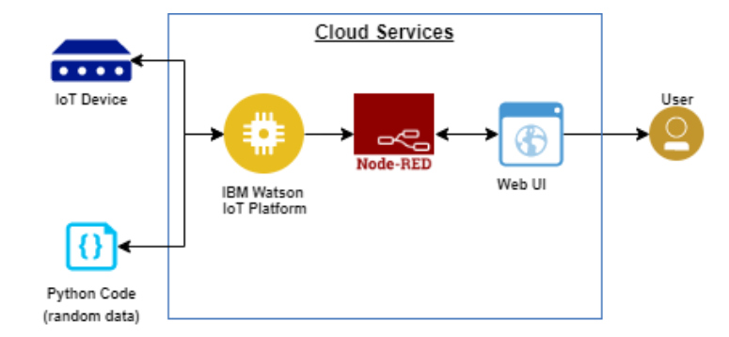

* 1. List of Activities/Tasks
* The GPS coordinates of the garbage bin will be sent to the IBM IoT platform
* The location of the bins along with bin status can be viewed in the Web Application
* Notifies the admin if the bin value crosses the threshold value

To accomplish this, we have to complete all the activities and tasks listed below:

* Create and configure IBM Cloud Services
  + Create IBM Watson IoT Platform
  + Create a device & configure the IBM IoT Platform
  + Create Node-RED service
  + Create a database in Cloudant DB to store location data
* Develop a web Application using Node-RED Service.
  + Develop the web application using Node-RED
* Develop a python script to publish the location details to the IBM IoT platform