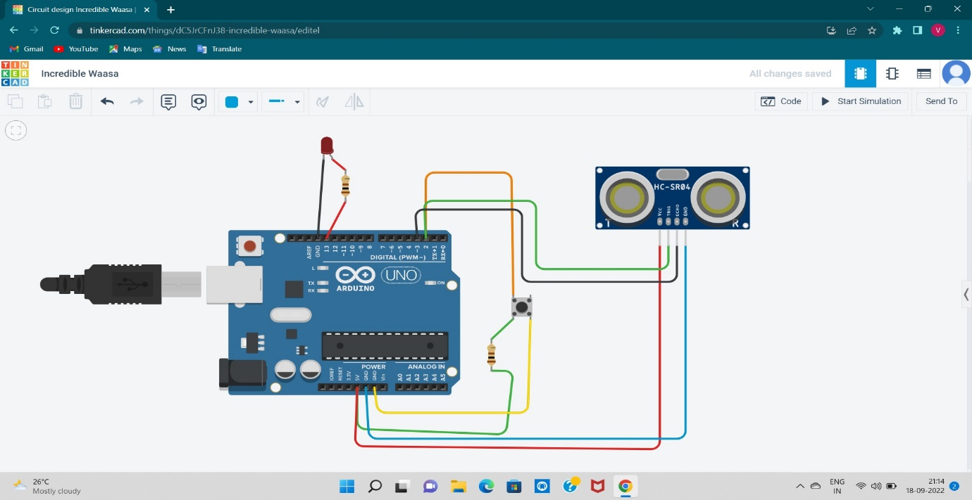

int t=2;

int e=3;

void setup()

{

pinMode(2, INPUT);

Serial.begin(9600);

pinMode(13, OUTPUT);

pinMode(t,OUTPUT);

pinMode(e,INPUT);

}

void loop()

{

int a=digitalRead(2);

Serial.println(a);

if(a==0)

digitalWrite(13,HIGH);

else

digitalWrite(13,LOW);

digitalWrite(t,LOW);

digitalWrite(t,HIGH);

delayMicroseconds(10);

digitalWrite(t,LOW);

float dur= pulseIn(e, HIGH);

float dis= (dur\*0.0343)/2;

Serial.print("distance is ");

Serial.println(dis);

}