**ABSTRACT**

**Traffic management is difficult at some critical situations, Smart Traffic light Management based on Vehicle density using Raspberry Pi is already done, in addition if there is an ambulance entry Traffic signal management is very difficult, to overcome those difficulties we are introducing this Raspberry Pi project which already works as smart traffic signal system based on vehicle density, in addition we are adding further facility like whenever the Ambulance is on the one direction, by pressing the direction button present in the Ambulance, that certain path signal is changed to Green to allow the vehicle to pass by that signal and by making other three directions as Red. The buttons which pressed by the driver in ambulance using Active RF technology which having 4 push buttons each is used for each direction which should be pressed to make that direction signal as green.**

Block Diagram

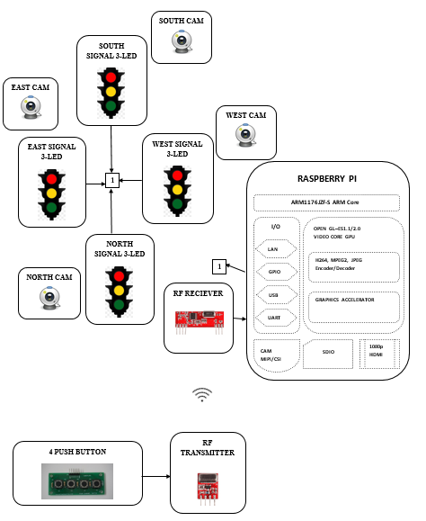

**BLOCK DIAGRAM DESCRIPTION**

**In the above Block diagram 12-LED is connected as 3 LED for each direction with the 8 Resistor for each LED in GPIO Pins of the Raspberry Pi. Then 4 camera is connected to the Raspberry Pi, either by USB or by using 4 mobile as IP Cam. Then RF Reciever is connected in the Serial pins of Raspberry Pi, Then 4 Push buttons are connected at the RF Transmitter side which is presented in The Ambulance Vehicle.**

**PROJECT DESCRIPTION**

**This Smart Traffic system initially runs based on the Traffic density to turn the Green Light where there is more vehicle and make remaining signals as Red based on Vehicle density. As same as for every direction signals getting changed based on the Vehicle density in every direction. In addition, RF Transmitter will be presented in every Ambulance dashboard, if he heading towards one direction, he will press the push button which is mapped to that direction. If he is heading towards North direction he will Press the North push button, so the signal gets transmitted to the RF receiver and based on the received signal, Traffic signal gets automatically changed to the Greenlight in the North direction as well as the system will make remaining signal light to the Red light. So that ambulance can be pass away the Traffic signal easily.**

**HARDWARE REQUIRED**

* **Raspberry Pi**
* **Power Adapter**
* **HDMI to VGA converter (optional, when connecting to Monitor)**
* **3 Red LED**
* **3 yellow LED**
* **3 Green LED**
* **4 camera (either USB camera or 4 Mobile Phone as IP camera)**
* **RF Transmitter**
* **RF Reciever**
* **4 Push buttons**

**SOFTWARE REQUIRED**

* **SD Card Formatter**
* **Win32 Disk Imager (or) Etcher**

**LIBRARIES USED**

* **Rpi.GPIO as GPIO (To access GPIO Pins of Raspberry Pi)**
* **Time library (For Delay functions)**
* **Argparse**
* **Datetime**
* **Imutils**
* **Urllib**
* **Cv2**
* **Numpy**

**CONCLUSION**

**This Raspberry Pi Smart Traffic system is a very efficient system for managing Traffics, especially when the Ambulance is on the road. So that Traffic management system becomes easy. Since the Raspberry Pi contains the feature of processing cameras, It can be able to do all image processing applications using Open CV.**