**Assignment -3**

|  |  |
| --- | --- |
| Assignment Date | 01 October 2022 |
| Student Name | Sathyan |
| Student Roll Number | 210419104149 |
| Maximum Marks | 2 Marks |

**Question 1:**

**Create a bucket in IBM objectstorage**

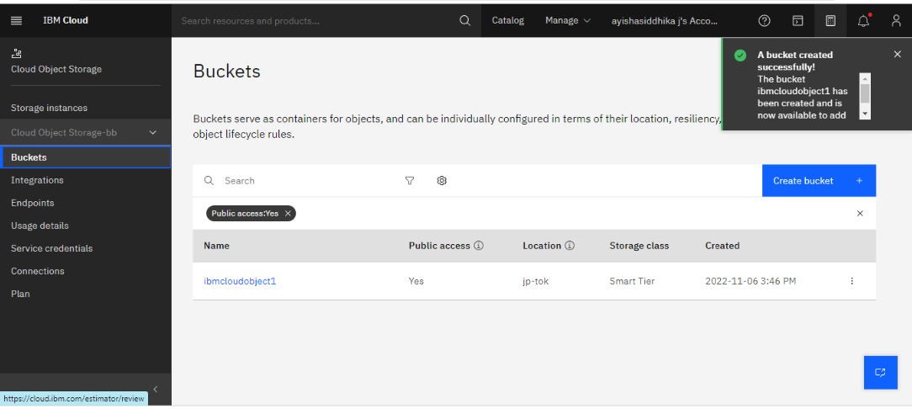

**Question 2 :**

**Upload 5 images to objectstorage and make it public.writehtml code to display all the 5 images**

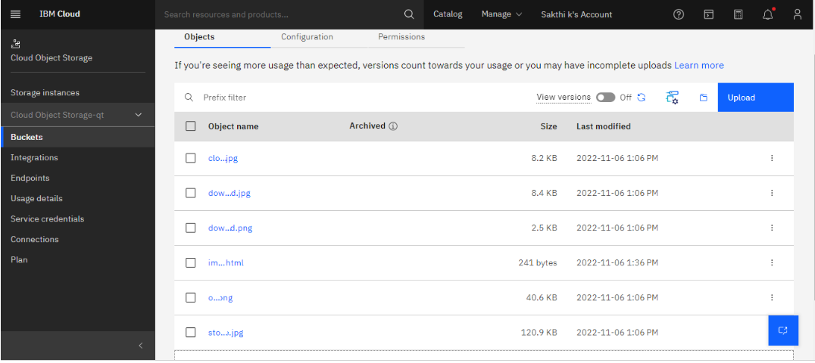

**Question 3 :**

**Upload a css page to object storage and use the same page in html code**



**Question 4 :**

**Design a chatbot using IBM watson for hospital assistant : eg. a user comes with query to know the know the branches of hospital in your city . submit the web URL of the chat box as assistant & create watson assistant service with 10 steps and use 3 condition in it.**

