**Assignment -4**

|  |  |
| --- | --- |
| Assignment Date | 07 October 2022 |
| Student Name | Sathyan |
| Student Roll Number | 210419104149 |
| Maximum Marks | 2 Marks |

**Question 1:**

1. **Pull an Image from docker hub and run it in docker playground.**

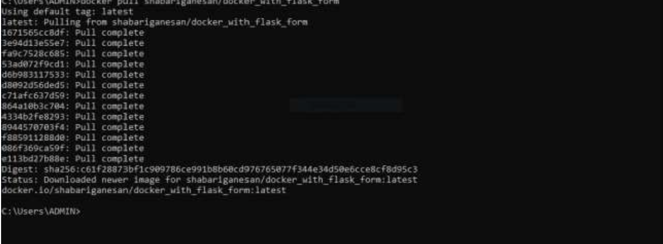

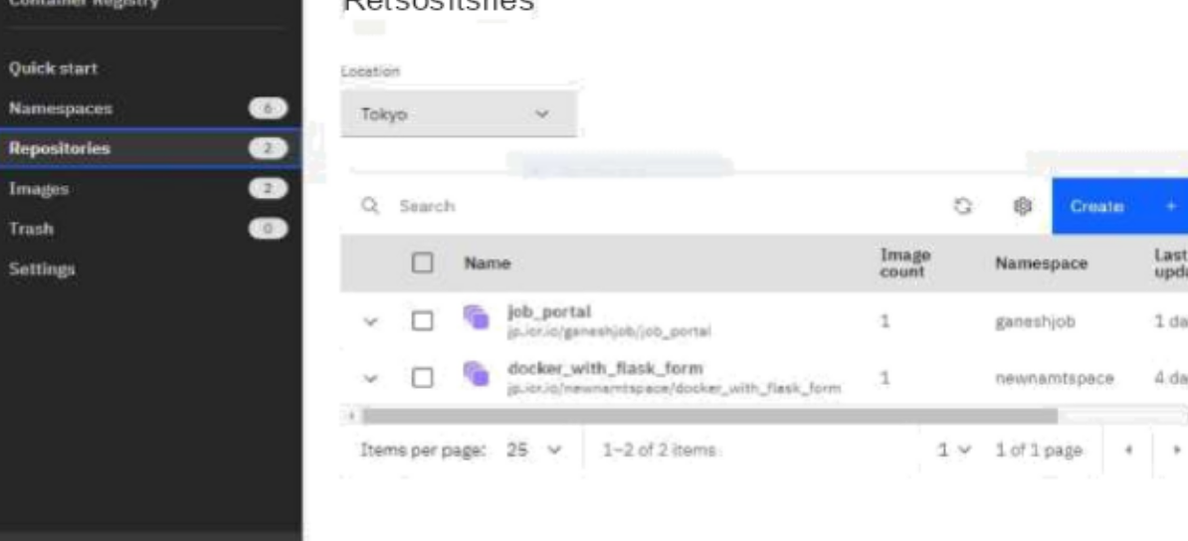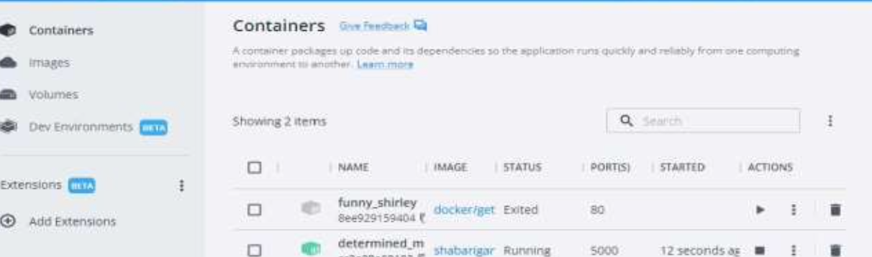

**Question 2 :**

**2.Create a docker file for the jobportal application and deploy it in Docker desktop application.**

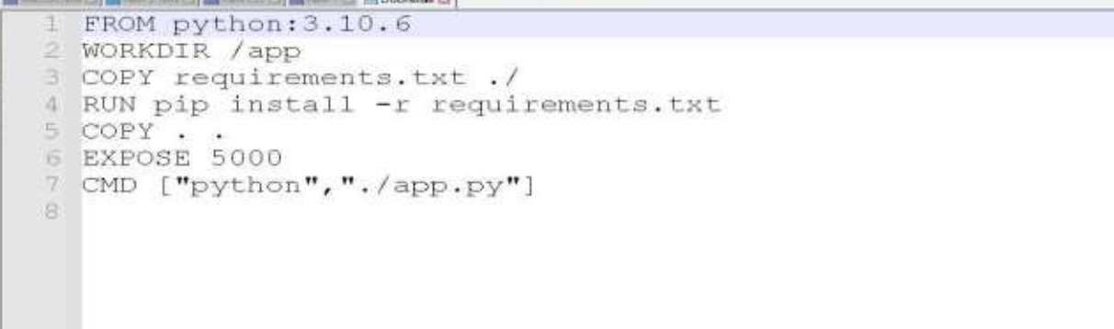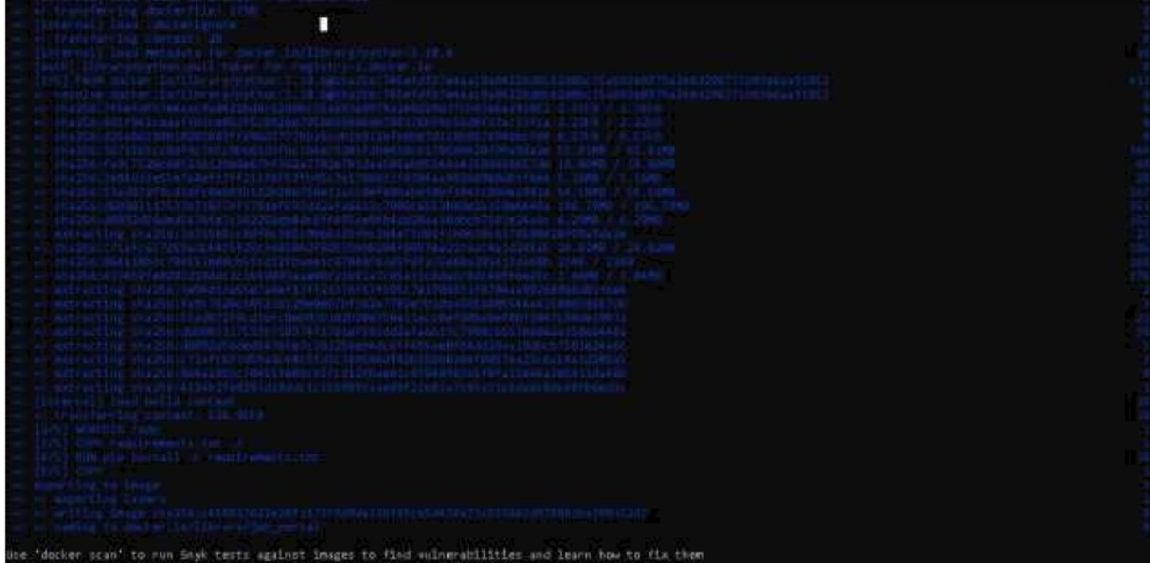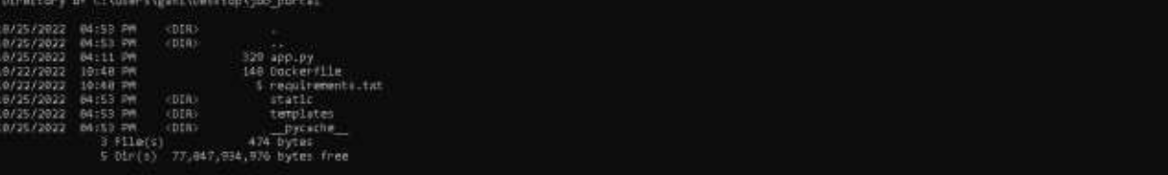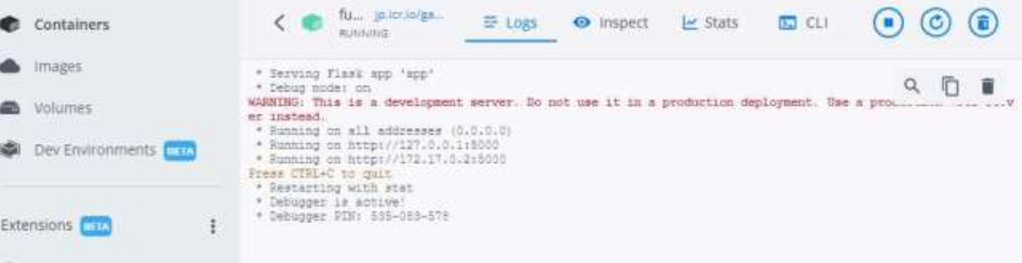

**Question 3 :**

**3.Create a IBM container registry and deploy helloworld app or jobportalapp.**

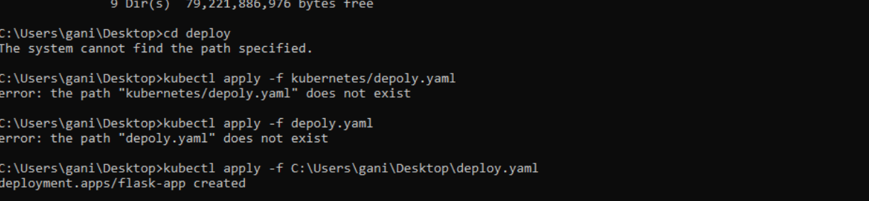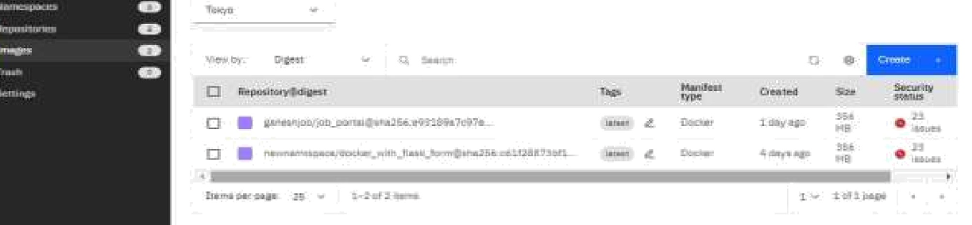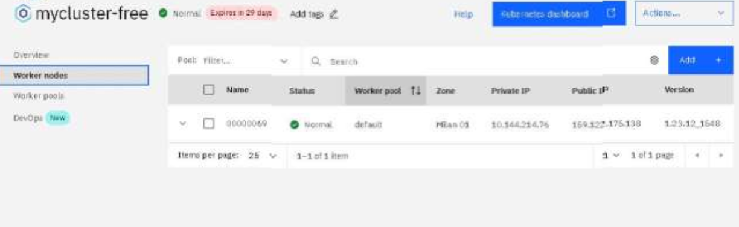

**Question 4 :**

**4.Create a Kubernetes cluster in IBM cloud and deploy helloworld image or jobportal image and also expose the same app to run in nodeport.**

