Assignment -1

HTML

|  |  |
| --- | --- |
| Assignment Date | 06 September 2022 |
| Student Name | Sathyan |
| Student Roll Number | 210419104149 |
| Maximum Marks | 2 Marks |

Question 1:

Develop sample 4 input boxes wich are name ,qualification,age,submit button

HTML

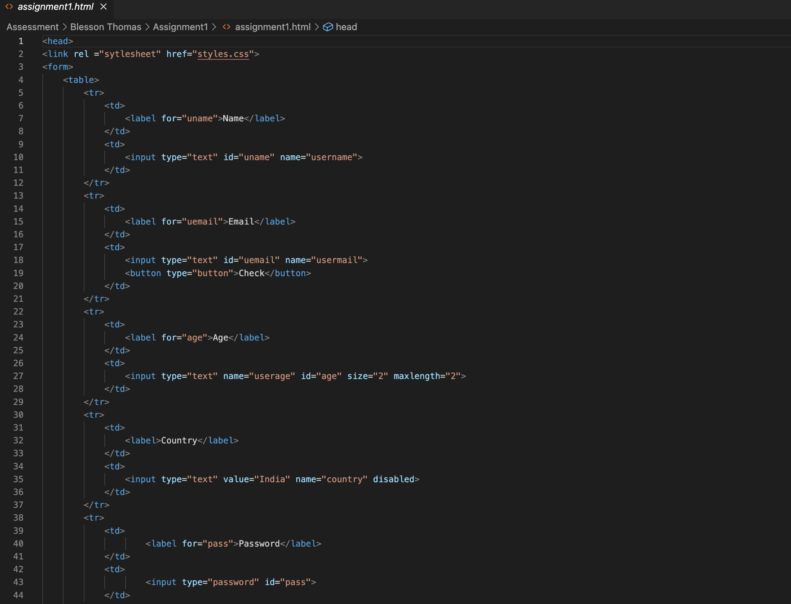

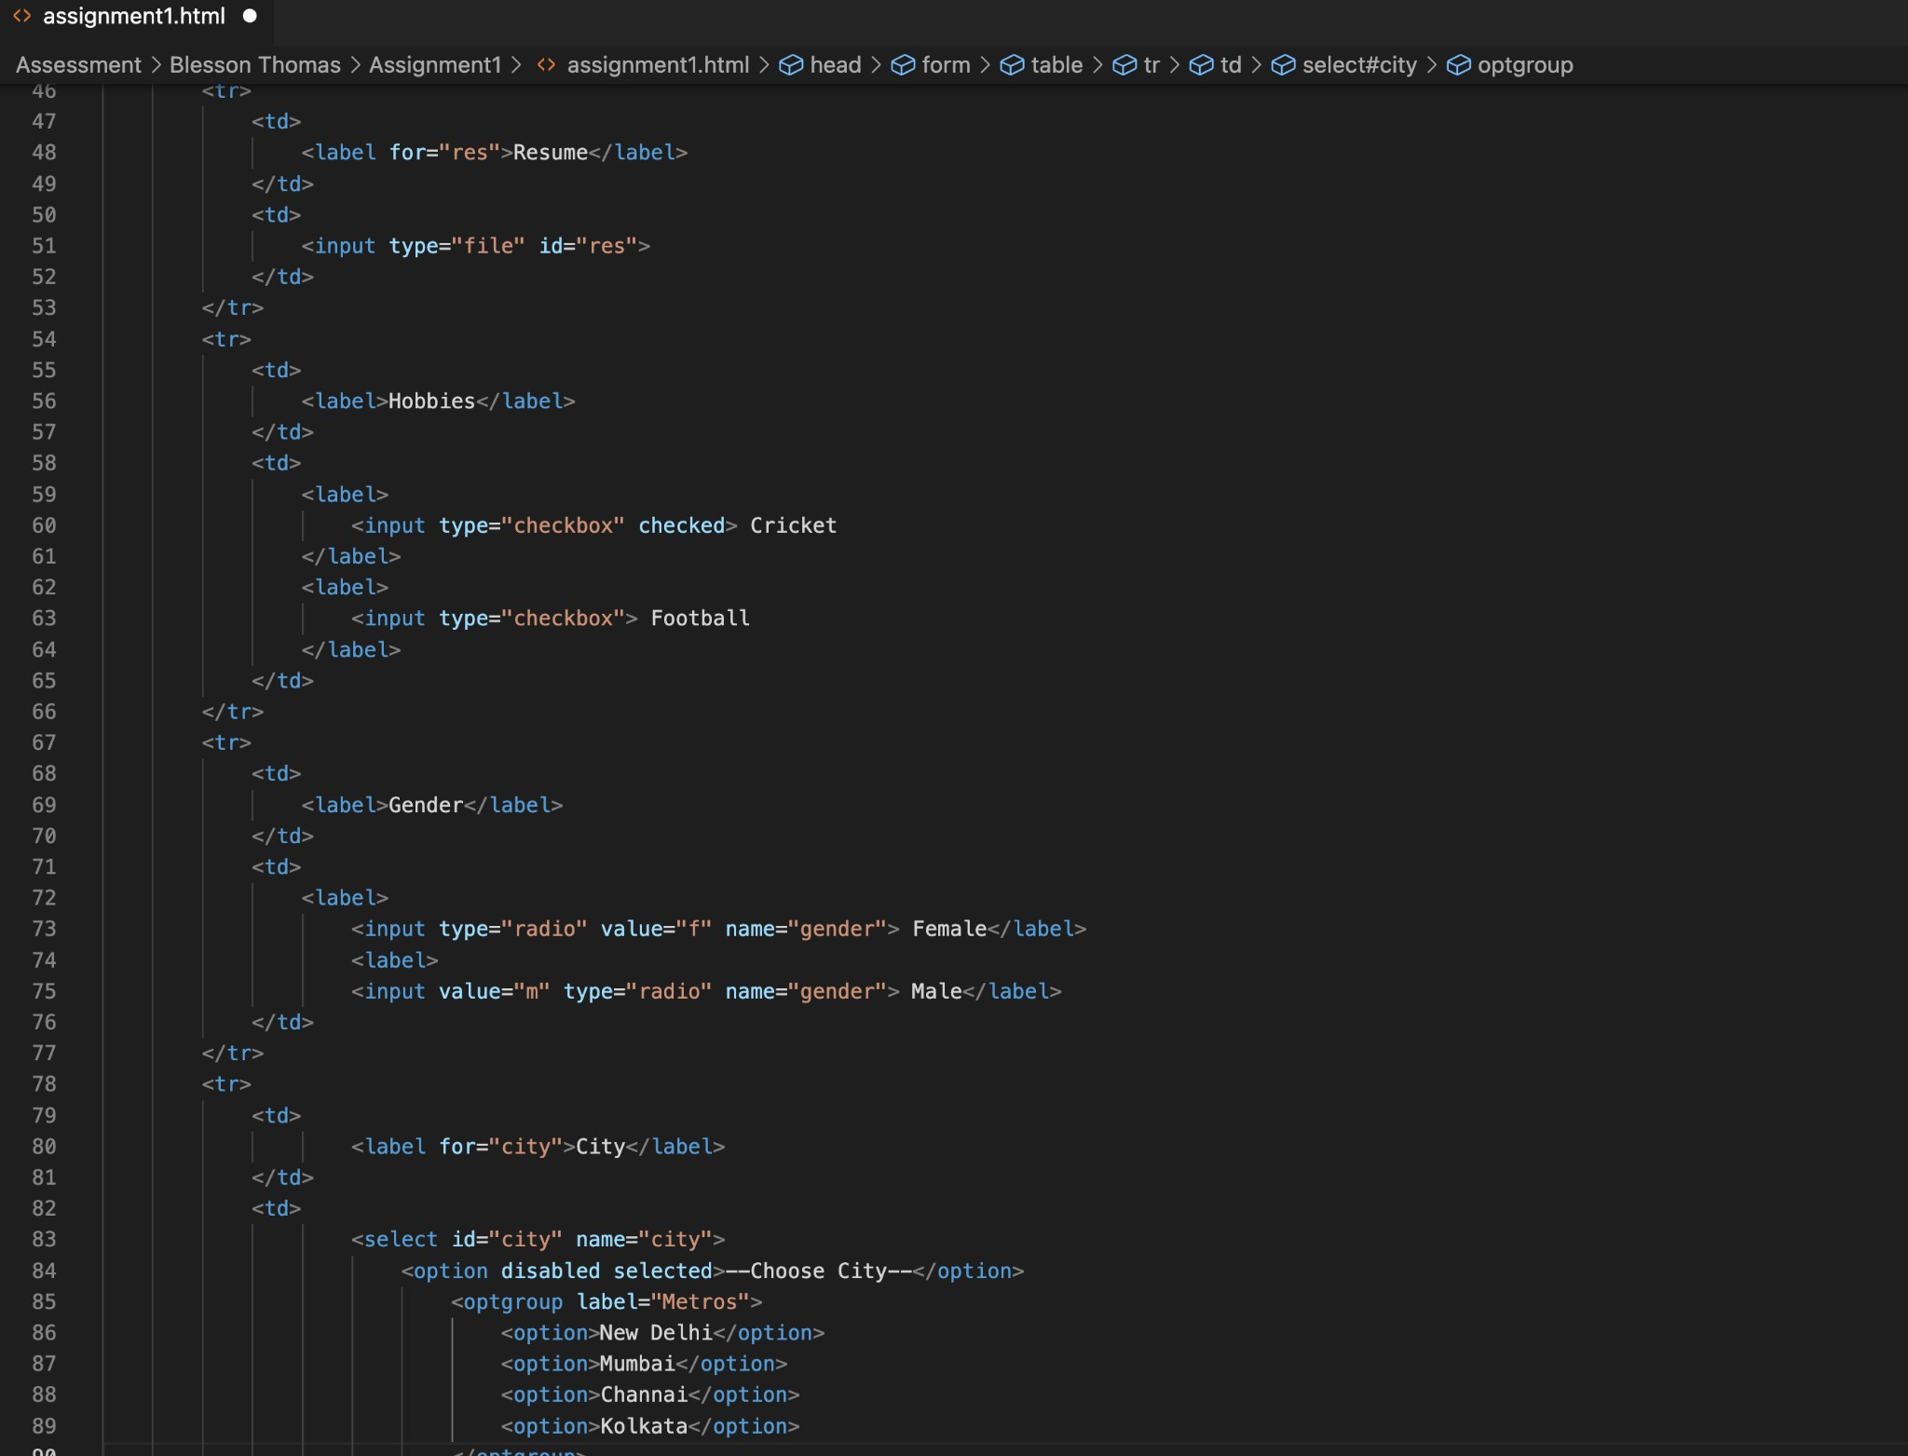



‹ : assignment1.html M X

Assessment

Bless on Thomas Assignment1 ‹ › assignment1. html @ head @ form @ table

la eel

in Dut va tue=" m" type=" radio" nane=" gende r" Make la fret

-d

t r

@ tr

td

Ta 9e\ fo r=" c ity" C1ty Ta be I

id td

select id=" c ity" name=" c ity"

opt ion d1s abI ed seI ect ed ——Choose C1ty-— opt1o n optg roup Iabet="Met ros"

opt ie n New Deth1 opt ion option Mumbai option opt ion Channa1 opt ion opt ion Kolkata opt ion

se’ect

-d

t r

td

Ta be T Add res s label

id td

text a I-ea rows=" 4" cots="40" text a -ea

zd

t r

td td td

input type-"submit" value-"Submit" input type="reset”

zd

tr

table