Assignment -2

HTML

|  |  |
| --- | --- |
| Assignment Date | 26 September 2022 |
| Student Name | Sathyan |
| Student Roll Number | 210419104149 |
| Maximum Marks | 2 Marks |

Question 1:

Create form of type input text, email, password, radio button text Area, drop down and navigate to success page and display files of form in table (CSS, HTML).

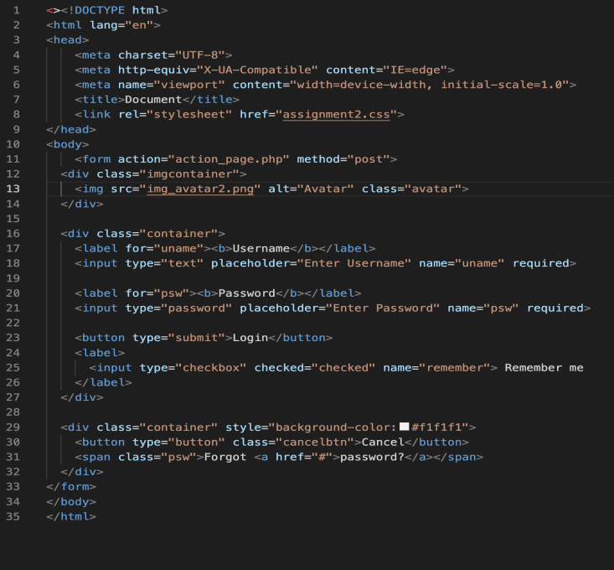

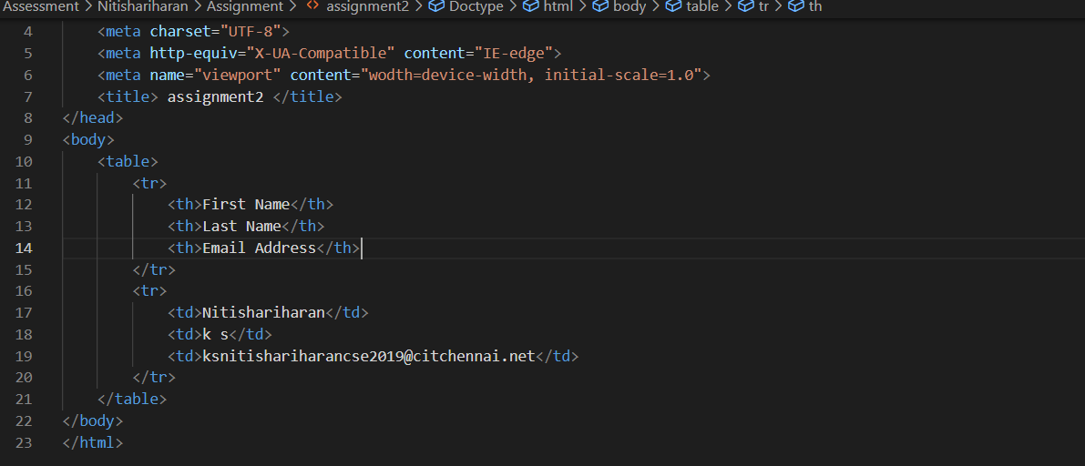

Question 2:

For CSS create external style sheet for above task (separate CSS file and link that in html).2. For CSS create external style sheet for above task (separate CSS file and link thatinhtml).

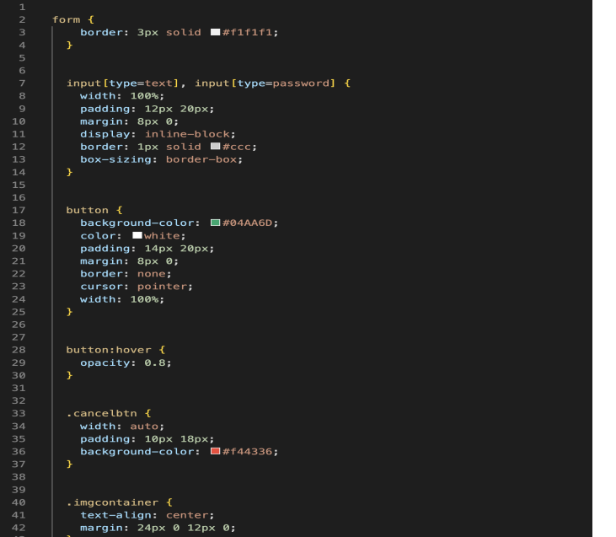

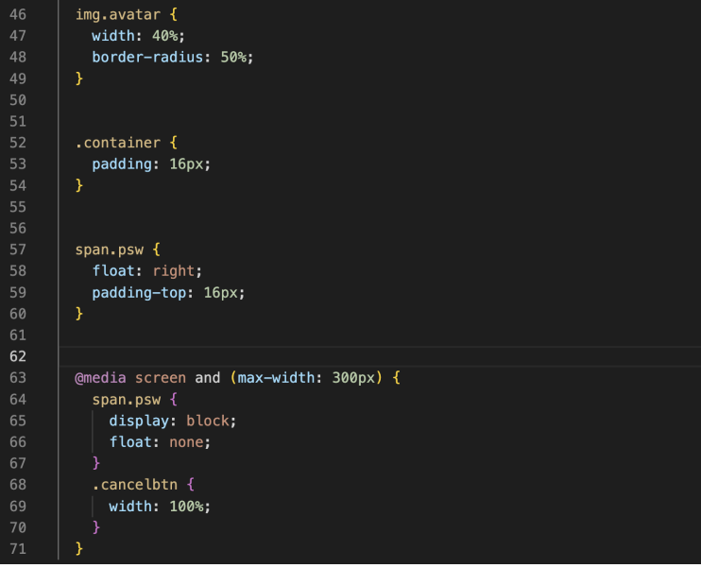

Question 3:

Create sample program for Flask HTTP methods (list or map and Perform operations of PUT, GET, DELETE and POST.

