IBM

Assignment-4

-Yogeshwari N B

Sketch.ino

#include <WiFi.h>//library for wifi

#include <PubSubClient.h>//library for MQtt

#define ECHO_PIN 2

#define TRIG_PIN 4

#define LED 5

//-------credentials of IBM Accounts------

#define ORG "g6mgrr"//IBM ORGANITION ID

#define DEVICE_TYPE "Smart_farmer_yogi"//Device type mentioned in ibm watson IOT Platform

#define DEVICE_ID "Smart_farmer"//Device ID mentioned in ibm watson IOT Platform

#define TOKEN "8610303929"     //Token

//-------- Customise the above values --------

char server[] = ORG ".messaging.internetofthings.ibmcloud.com";// Server Name

char publishTopic[] = "iot-2/evt/Data/fmt/json";// topic name and type of event perform and format in which data to be send

char subscribetopic[] = "iot-2/cmd/test/fmt/String";// cmd  REPRESENT command type AND COMMAND IS TEST OF FORMAT STRING

char authMethod[] = "use-token-auth";// authentication method

char token[] = TOKEN;

char clientId[] = "d:" ORG ":" DEVICE_TYPE ":" DEVICE_ID;//client id

//-----------------------------------------

WiFiClient wifiClient; // creating the instance for wificlient

PubSubClient client(server, 1883,wifiClient); //calling the predefined client id by passing parameter like server id,portand wificredential

void setup()// configureing the ESP32

{

**Serial**.begin(115200);

  pinMode(TRIG_PIN, OUTPUT);

  pinMode(ECHO_PIN, INPUT);

  pinMode(LED,OUTPUT);

  delay(10);

**Serial**.println();

  wificonnect();

  mqttconnect();

}

float readDistanceCM() {

  digitalWrite(TRIG_PIN, LOW);

  delayMicroseconds(2);

  digitalWrite(TRIG_PIN, HIGH);

  delayMicroseconds(10);

  digitalWrite(TRIG_PIN, LOW);

  int duration = pulseIn(ECHO_PIN, HIGH);

  return duration * 0.034 / 2;

}

void loop()// Recursive Function

{

  float distance = readDistanceCM();

  bool isNearby = distance < 100;

  digitalWrite(LED, isNearby);

**Serial**.print("Measured distance: ");

**Serial**.println(distance);

  delay(100);

  if (isNearby == 1){

  PublishData(distance);

  }

  delay(1000);

  if (!client.loop()) {

    mqttconnect();

  }

}

/*.....................................retrieving to Cloud...............................*/

void PublishData(float distance) {

  mqttconnect();//function call for connecting to ibm

  /*

     creating the String in in form JSon to update the data to ibm cloud

  */

  String payload = "{\"Alert\":""\"";

  payload += distance;

  payload += " is less than 100cms\"";

  payload += "}";

**Serial**.print("Sending payload: ");

**Serial**.println(payload);

  if (client.publish(publishTopic, (char*) payload.c_str())) {

**Serial**.println("Publish ok");// if it sucessfully upload data on the cloud then it will print publish ok in Serial monitor or else it will print publish failed

  } else {

**Serial**.println("Publish failed");

  }

}

void mqttconnect() {

  if (!client.connected()) {

**Serial**.print("Reconnecting client to ");

**Serial**.println(server);

    while (!!!client.connect(clientId, authMethod, token)) {

**Serial**.print(".");

      delay(500);

    }

     initManagedDevice();

**Serial**.println();

  }

}

void wificonnect() //function defination for wificonnect

{

**Serial**.println();

**Serial**.print("Connecting to ");

  WiFi.begin("Wokwi-GUEST", "", 6);//passing the wifi credentials to establish the connection

  while (WiFi.status() != WL_CONNECTED) {

    delay(500);

**Serial**.print(".");

  }

**Serial**.println("");

**Serial**.println("WiFi connected");

**Serial**.println("IP address: ");

**Serial**.println(WiFi.localIP());

}

void initManagedDevice() {

  if (client.subscribe(subscribetopic)) {

**Serial**.println((subscribetopic));

**Serial**.println("subscribe to cmd OK");

  } else {

**Serial**.println("subscribe to cmd FAILED");

  }

}

Libraries.txt

# Wowki Library list

# See <https://docs.wowki.com/guides/libraries>

#Automatically added based on includes:

PubSubClient

ArduinoJson

Output Screenshot:

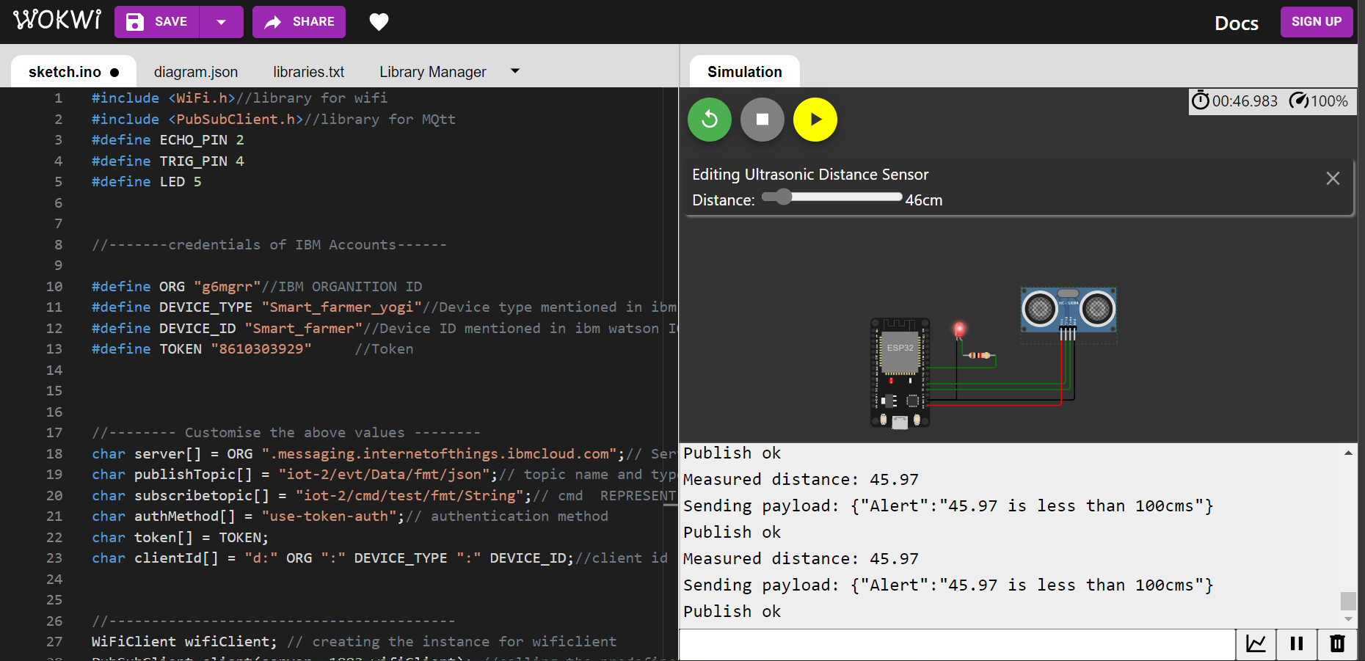

Link:

[sketch.ino - Wokwi Arduino and ESP32 Simulator](https://wokwi.com/projects/346205897060516434)

Cloud output:

