# Assignment -1

|  |  |
| --- | --- |
| Assignment Date | 01 October 2022 |
| Student Name | Thrisha R J |
| Student Roll Number | 211419205172 |
| Maximum Marks | 2 Marks |

**Question-1:**

Develop a sample webpage with html, css which should include banner, image and describe yourself and contact form.

#Resume.html

<!DOCTYPE html>

<html lang="en">

<head>

<meta charset="UTF-8">

<title>Resume/CV Design</title>

<link rel="stylesheet" href="resume.css">

<script src="https://kit.fontawesome.com/b99e675b6e.js"></script>

</head>

<body>

<div class="resume">

<div class="resume_left">

<div class="resume_profile">

<img src="user.png" alt="profile_pic">

</div>

<div class="resume_content">

<div class="resume_item resume_info">

<div class="title">

<p class="bold">Sangeetha S</p>

<p class="regular">Student</p>

</div>

<ul>

<li>

<div class="icon">

<i class="fas fa-map-signs"></i>

</div>

<div class="data">

21 Street, Texas <br /> USA

</div>

</li>

<li>

<div class="icon">

<i class="fas fa-mobile-alt"></i>

</div>

<div class="data">

+324 4445678

</div>

</li>

<li>

<div class="icon">

<i class="fas fa-envelope"></i>

</div>

<div class="data"> [stephen@gmail.com](mailto:stephen@gmail.com)

</div>

</li>

<li>

<div class="icon">

<i class="fab fa-weebly"></i>

</div>

<div class="data"> [www.stephen.com](http://www.stephen.com/)

</div>

</li>

</ul>

</div>

<div class="resume_item resume_skills">

<div class="title">

<p class="bold">skill's</p>

</div>

<ul>

<li>

<div class="skill_name"> HTML

</div>

<div class="skill_progress">

<span style="width: 80%;"></span>

</div>

<div class="skill_per">80%</div>

</li>

<li>

<div class="skill_name"> CSS

</div>

<div class="skill_progress">

<span style="width: 70%;"></span>

</div>

<div class="skill_per">70%</div>

</li>

<li>

<div class="skill_name"> SASS

</div>

<div class="skill_progress">

<span style="width: 90%;"></span>

</div>

<div class="skill_per">90%</div>

</li>

<li>

<div class="skill_name"> JS

</div>

<div class="skill_progress">

<span style="width: 60%;"></span>

</div>

<div class="skill_per">60%</div>

</li>

<li>

<div class="skill_name"> JQUERY

</div>

<div class="skill_progress">

<span style="width: 88%;"></span>

</div>

<div class="skill_per">88%</div>

</li>

</ul>

</div>

<div class="resume_item resume_social">

<div class="title">

<p class="bold">Social</p>

</div>

<ul>

<li>

<div class="icon">

<i class="fab fa-facebook-square"></i>

</div>

<div class="data">

<p class="semi-bold">Facebook</p>

<p>Stephen@facebook</p>

</div>

</li>

<li>

<div class="icon">

<i class="fab fa-twitter-square"></i>

</div>

<div class="data">

<p class="semi-bold">Twitter</p>

<p>Stephen@twitter</p>

</div>

</li>

<li>

<div class="icon">

<i class="fab fa-youtube"></i>

</div>

<div class="data">

<p class="semi-bold">Youtube</p>

<p>Stephen@youtube</p>

</div>

</li>

<li>

<div class="icon">

<i class="fab fa-linkedin"></i>

</div>

<div class="data">

<p class="semi-bold">Linkedin</p>

<p>Stephen@linkedin</p>

</div>

</li>

</ul>

</div>

</div>

</div>

<div class="resume_right">

<div class="resume_item resume_about">

<div class="title">

<p class="bold">About us</p>

</div>

<p>Lorem ipsum dolor sit, amet consectetur adipisicing elit. Perspiciatis illo fugit officiis distinctio culpa officia totam atque exercitationem inventore repudiandae?</p>

</div>

<div class="resume_item resume_work">

<div class="title">

<p class="bold">Work Experience</p>

</div>

<ul>

<li>

<div class="date">2013 - 2015</div>

<div class="info">

<p class="semi-bold">Lorem ipsum dolor sit amet.</p>

<p>Lorem ipsum dolor sit amet consectetur adipisicing elit. Nostrum, voluptatibus!</p>

</div>

</li>

<li>

<div class="date">2015 - 2017</div>

<div class="info">

<p class="semi-bold">Lorem ipsum dolor sit amet.</p>

<p>Lorem ipsum dolor sit amet consectetur adipisicing elit. Nostrum, voluptatibus!</p>

</div>

</li>

<li>

<div class="date">2017 - Present</div>

<div class="info">

<p class="semi-bold">Lorem ipsum dolor sit amet.</p>

<p>Lorem ipsum dolor sit amet consectetur adipisicing elit. Nostrum, voluptatibus!</p>

</div>

</li>

</ul>

</div>

<div class="resume_item resume_education">

<div class="title">

<p class="bold">Education</p>

</div>

<ul>

<li>

<div class="date">2010 - 2013</div>

<div class="info">

<p class="semi-bold">Web Designing (Texas University)</p>

<p>Lorem ipsum dolor sit amet consectetur adipisicing elit. Nostrum, voluptatibus!</p>

</div>

</li>

<li>

<div class="date">2000 - 2010</div>

<div class="info">

<p class="semi-bold">Texas International School</p>

<p>Lorem ipsum dolor sit amet consectetur adipisicing elit. Nostrum, voluptatibus!</p>

</div>

</li>

</ul>

</div>

<div class="resume_item resume_hobby">

<div class="title">

<p class="bold">Hobby</p>

</div>

<ul>

<li><i class="fas fa-book"></i></li>

<li><i class="fas fa-gamepad"></i></li>

<li><i class="fas fa-music"></i></li>

<li><i class="fab fa-pagelines"></i></li>

</ul>

</div>

</div>

</div>

</body>

</html>

#Resume.css @import

url("https://fonts.googleapis.com/css?family=Montserrat:400,500,700&display=swap");

* {

margin: 0;

padding: 0;

box-sizing: border-box; list-style: none;

font-family: "Montserrat", sans-serif;

}

body {

background: #585c68; font-size: 14px;

line-height: 22px; color: #555555;

}

.bold {

font-weight: 700; font-size: 20px;

text-transform: uppercase;

}

.semi-bold {

font-weight: 500; font-size: 16px;

}

.resume { width: 800px; height: auto; display: flex;

margin: 50px auto;

}

.resume .resume_left { width: 280px; background: #0bb5f4;

}

.resume .resume_left .resume_profile { width: 100%;

height: 280px;

}

.resume .resume_left .resume_profile img { width: 100%;

height: 100%;

}

.resume .resume_left .resume_content { padding: 0 25px;

}

.resume .title {

margin-bottom: 20px;

}

.resume .resume_left .bold { color: #fff;

}

.resume .resume_left .regular { color: #b1eaff;

}

.resume .resume_item { padding: 25px 0;

border-bottom: 2px solid #b1eaff;

}

.resume .resume_left .resume_item:last-child,

.resume .resume_right .resume_item:last-child {

border-bottom: 0px;

}

.resume .resume_left ul li { display: flex;

margin-bottom: 10px; align-items: center;

}

.resume .resume_left ul li:last-child { margin-bottom: 0;

}

.resume .resume_left ul li .icon { width: 35px;

height: 35px; background: #fff; color: #0bb5f4; border-radius: 50%; margin-right: 15px; font-size: 16px; position: relative;

}

.resume .icon i,

.resume .resume_right .resume_hobby ul li i { position: absolute;

top: 50%;

left: 50%;

transform: translate(-50%, -50%);

}

.resume .resume_left ul li .data { color: #b1eaff;

}

.resume .resume_left .resume_skills ul li { display: flex;

margin-bottom: 10px; color: #b1eaff;

justify-content: space-between; align-items: center;

}

.resume .resume_left .resume_skills ul li .skill_name { width: 25%;

}

.resume .resume_left .resume_skills ul li .skill_progress { width: 60%;

margin: 0 5px; height: 5px; background: #009fd9; position: relative;

}

.resume .resume_left .resume_skills ul li .skill_per { width: 15%;

}

.resume .resume_left .resume_skills ul li .skill_progress span { position: absolute;

top: 0;

left: 0;

height: 100%; background: #fff;

}

.resume .resume_left .resume_social .semi-bold { color: #fff;

margin-bottom: 3px;

}

.resume .resume_right { width: 520px; background: #fff; padding: 25px;

}

.resume .resume_right .bold { color: #0bb5f4;

}

.resume .resume_right .resume_work ul,

.resume .resume_right .resume_education ul { padding-left: 40px;

overflow: hidden;

}

.resume .resume_right ul li { position: relative;

}

.resume .resume_right ul li .date { font-size: 16px;

font-weight: 500; margin-bottom: 15px;

}

.resume .resume_right ul li .info { margin-bottom: 20px;

}

.resume .resume_right ul li:last-child .info { margin-bottom: 0;

}

.resume .resume_right .resume_work ul li:before,

.resume .resume_right .resume_education ul li:before { content: "";

position: absolute; top: 5px;

left: -25px; width: 6px; height: 6px;

border-radius: 50%; border: 2px solid #0bb5f4;

}

.resume .resume_right .resume_work ul li:after,

.resume .resume_right .resume_education ul li:after { content: "";

position: absolute; top: 14px;

left: -21px; width: 2px; height: 115px;

background: #0bb5f4;

}

.resume .resume_right .resume_hobby ul { display: flex;

justify-content: space-between;

}

.resume .resume_right .resume_hobby ul li { width: 80px;

height: 80px;

border: 2px solid #0bb5f4; border-radius: 50%; position: relative;

color: #0bb5f4;

}

.resume .resume_right .resume_hobby ul li i { font-size: 30px;

}

.resume .resume_right .resume_hobby ul li:before { content: "";

position: absolute; top: 40px;

right: -52px; width: 50px; height: 2px;

background: #0bb5f4;

}

.resume .resume_right .resume_hobby ul li:last-child:before { display: none;

}

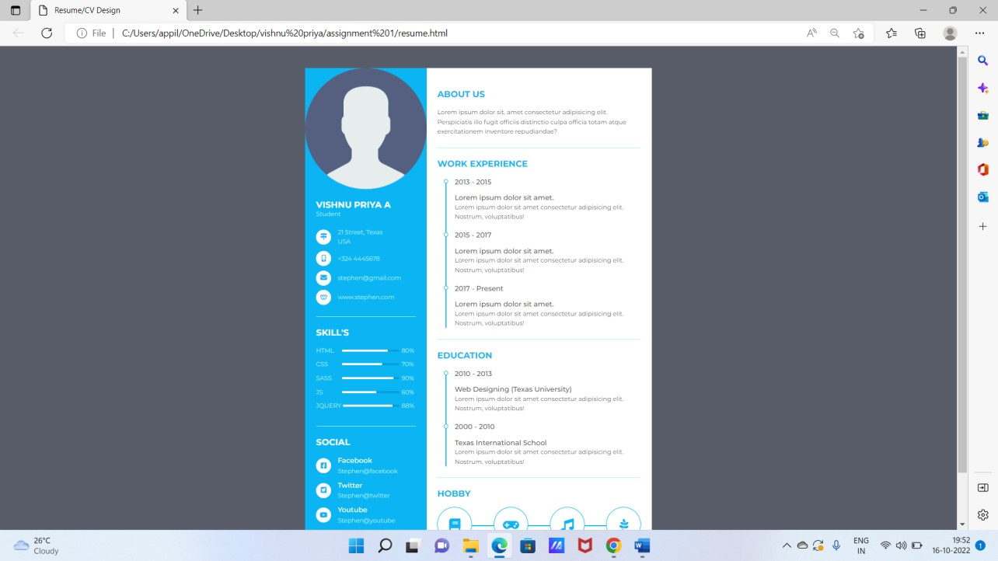

# Question-2:

Create responsive page for mobile and desktop.

#resume.css

@media (max-width:800px){

.resume{ margin:10px;

grid-template-columns:repeat(1,1fr); flex-direction:column;

}

.resume_hobby{ width:70%;

}

.resume_left{ width:px;

margin-right:10px;

}

.resume .resume_left{ width:800px; margin:5px;

}

.resume .resume_left .resume_profile img{ width:40%;

padding:25 25 px; margin:10px; align:center;

}

.resume .resume_right{ width:750px;

}

}

@media (max-width:600px){

.resume{ margin:10px;

grid-template-columns:repeat(1,1fr); flex-direction:column;

}

.resume_hobby{ width:90%;

}

.resume_left{ margin-right:10px;

}

.resume .resume_left{ width:500px; margin:5px;

}

.resume .resume_left .resume_profile img{ width:60%;

padding:25 25 px; margin:10px; align:center;

}

.resume .resume_right{ width:500px;

}

}

