# Assignment-3

|  |  |
| --- | --- |
| Assignment Date | 20 October 2022 |
| Student Name | Thrisha R J |
| Student Roll Number | 211419205172 |
| Maximum Marks | 2 Marks |

**Questions:**

# Create a Bucket in IBM object storage.

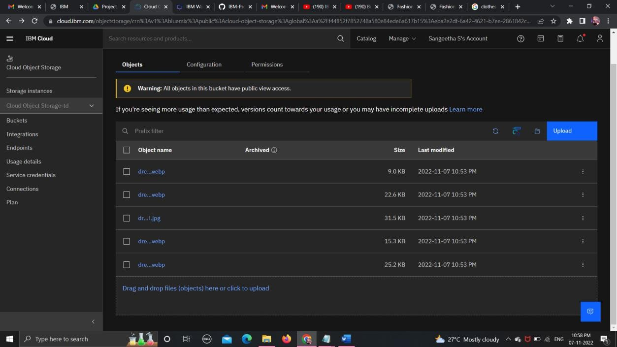

1. **Upload 5 images to ibm object storage and make it public. write html code to displaying all the5 images.**

# # main.html

<html>

<head> <title>Fashion smart</title>

</head>

<body>

<br>

<h1> Fashion with Passion.. </h1>

<br>

<br>

<img src="https://sanju.s3.jp-tok.cloud-object- storage.appdomain.cloud/dress2.webp">

<img src="https://sanju.s3.jp-tok.cloud-object- storage.appdomain.cloud/dress4.webp">

<img src="https://sanju.s3.jp-tok.cloud-object- storage.appdomain.cloud/dress1.webp">

<img src="https://sanju.s3.jp-tok.cloud-object- storage.appdomain.cloud/dress5.webp">

<img src="https://sanju.s3.jp-tok.cloud-object- storage.appdomain.cloud/dress3.jpg">

</body>

</html>

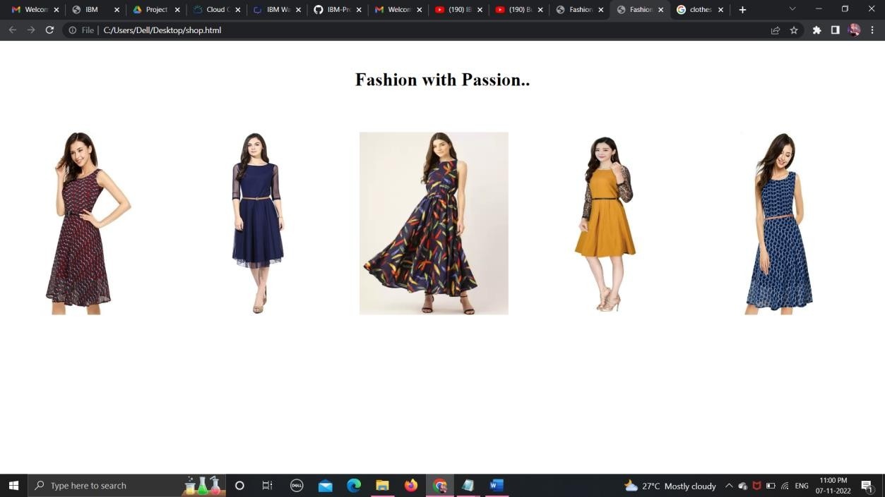

# Upload a css page to the object storage and use the same page in your HTML code.

<html>

<head> <title>Fashion smart</title>

<link rel="stylesheet" href="https://sangeeth.s3.jp-tok.cloud-object- storage.appdomain.cloud/shop.css">

</head>

<body>

<br>

<h1> Fashion with Passion.. </h1>

<br>

<br>

<img src="https://sanju.s3.jp-tok.cloud-object- storage.appdomain.cloud/dress2.webp"><img src="https://sangeeth.s3.jp- tok.cloud-object-storage.appdomain.cloud/dress4.webp">

<img src="https://sanju.s3.jp-tok.cloud-object- storage.appdomain.cloud/dress1.webp"><img src="https://sangeeth.s3.jp- tok.cloud-object-storage.appdomain.cloud/dress5.webp">

<img src="https://sanju.s3.jp-tok.cloud-object- storage.appdomain.cloud/dress3.jpg">

</body>

</html>

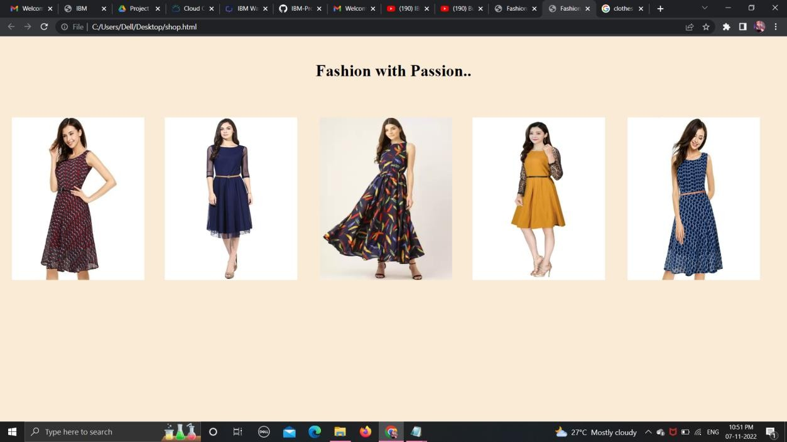

# Design a chatbot using IBM Watson assistant for hospital. Ex: User comes with query to know the branches for that hospital in your city. Submit the web URL of that chat bot as a assignment.

https://web- chat.global.assistant.watson.appdomain.cloud/preview.html?backgroundImageURL

=https%3A%2F%2Fau- syd.assistant.watson.cloud.ibm.com%2Fpublic%2Fimages%2Fupx-5e86a50a-4ed5- 4fce-b2c1-47eeddbf7f6e%3A%3A12080bd5-19ef-4ae3-902b- 618257b9ecf1&integrationID=0f776b87-48a3-4e22-94a3-4f4ae2826506&region=au- syd&serviceInstanceID=5e86a50a-4ed5-4fce-b2c1-47eeddbf7f6e

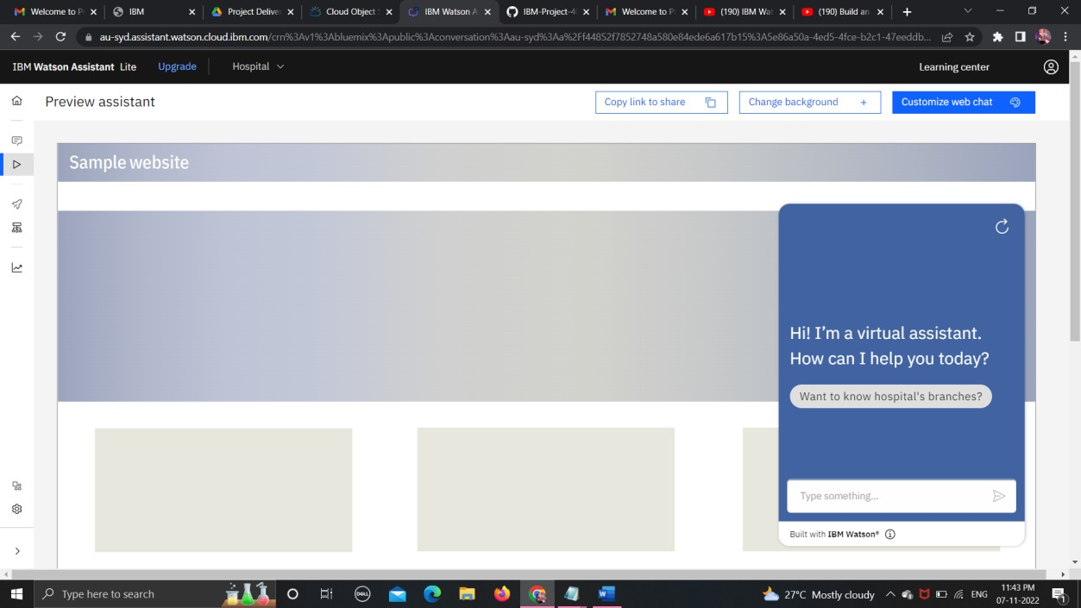

# 5 .Create Watson assistant service with 10 steps and use 3 conditions in it. Load that script in HTML page

