Assignment-4

|  |  |
| --- | --- |
| Assignment Date | 5 November 2022 |
| Student Name | Thrisha R J |
| Student Roll Number | 211419205172 |
| Maximum Marks | 2 Marks |

Question:

1. **Pull an Image from docker hub and run it in docker playground. Pull an image from docker hub.**

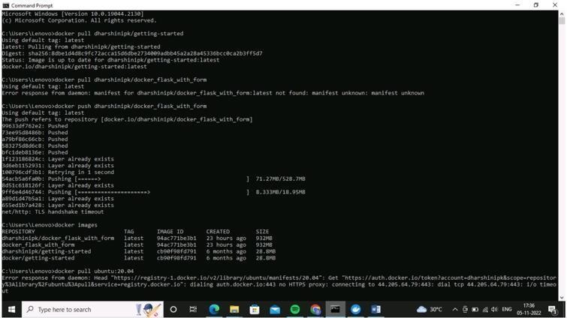

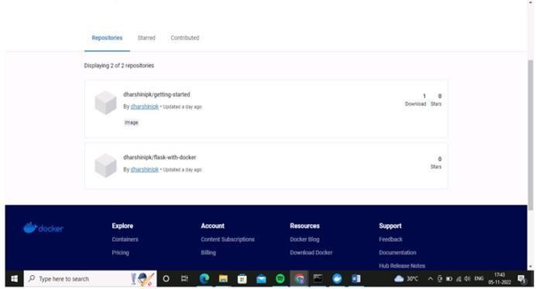

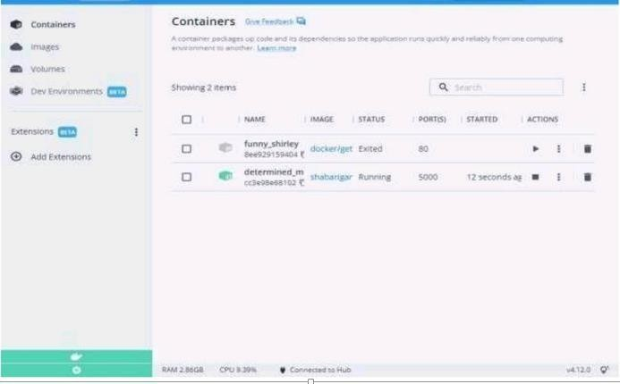

1. **Create a docker file for the jobportal application and deploy it in Docker desktop application.**

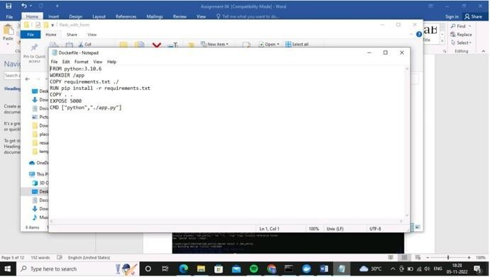

Deploy in docker application

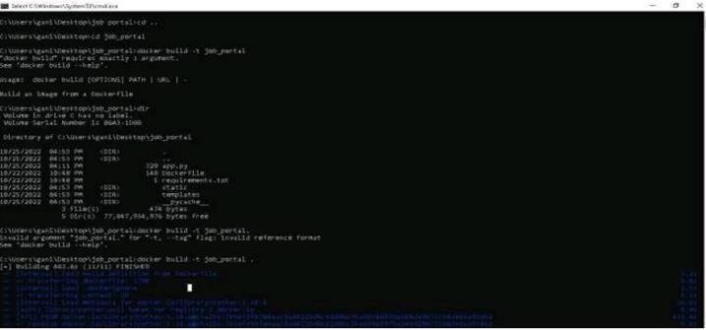

Running in docker desktop

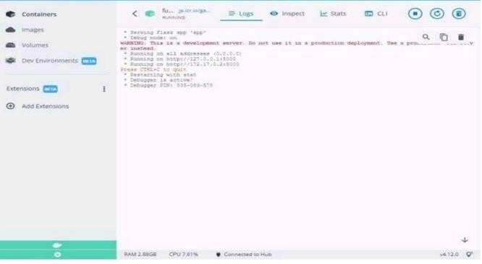

1. **Create a IBM container registry and deploy helloworld app or jobportalapp.**

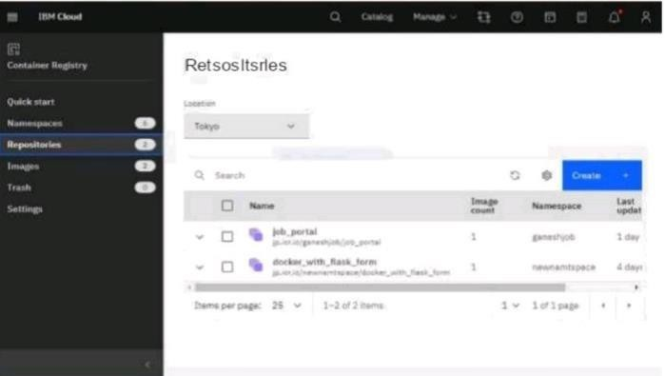

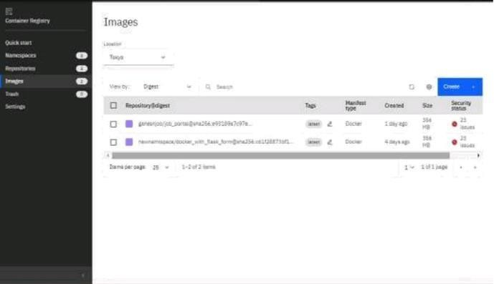

Deploy helloworld or jobportal

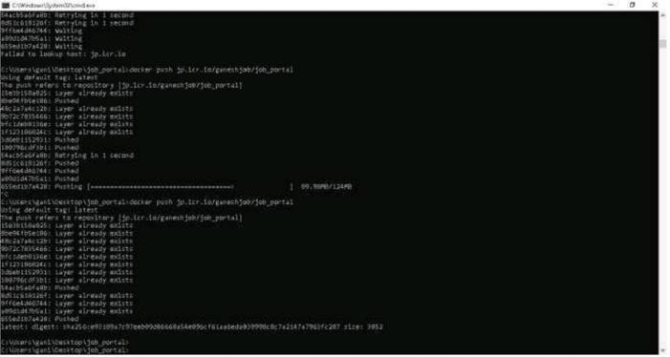

1. **Create a Kubernetes cluster in IBM cloud and deploy helloworld image or jobportal image and also expose the same app to run in nodeport.**

Creating a kubernetes cluster in ibm cloud

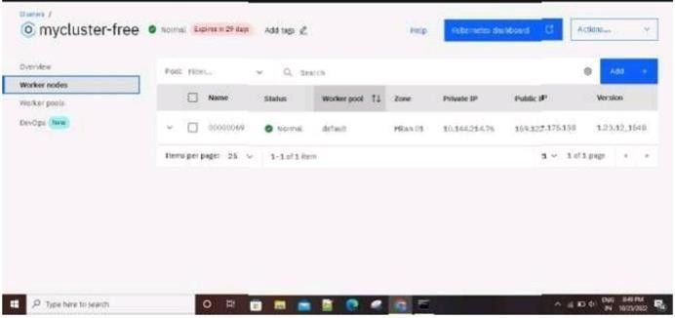

Expose the same app to run in noteport

