**PREREQUISITIES**

**PNT2022TMID25493**

Create IBM Cloud Service

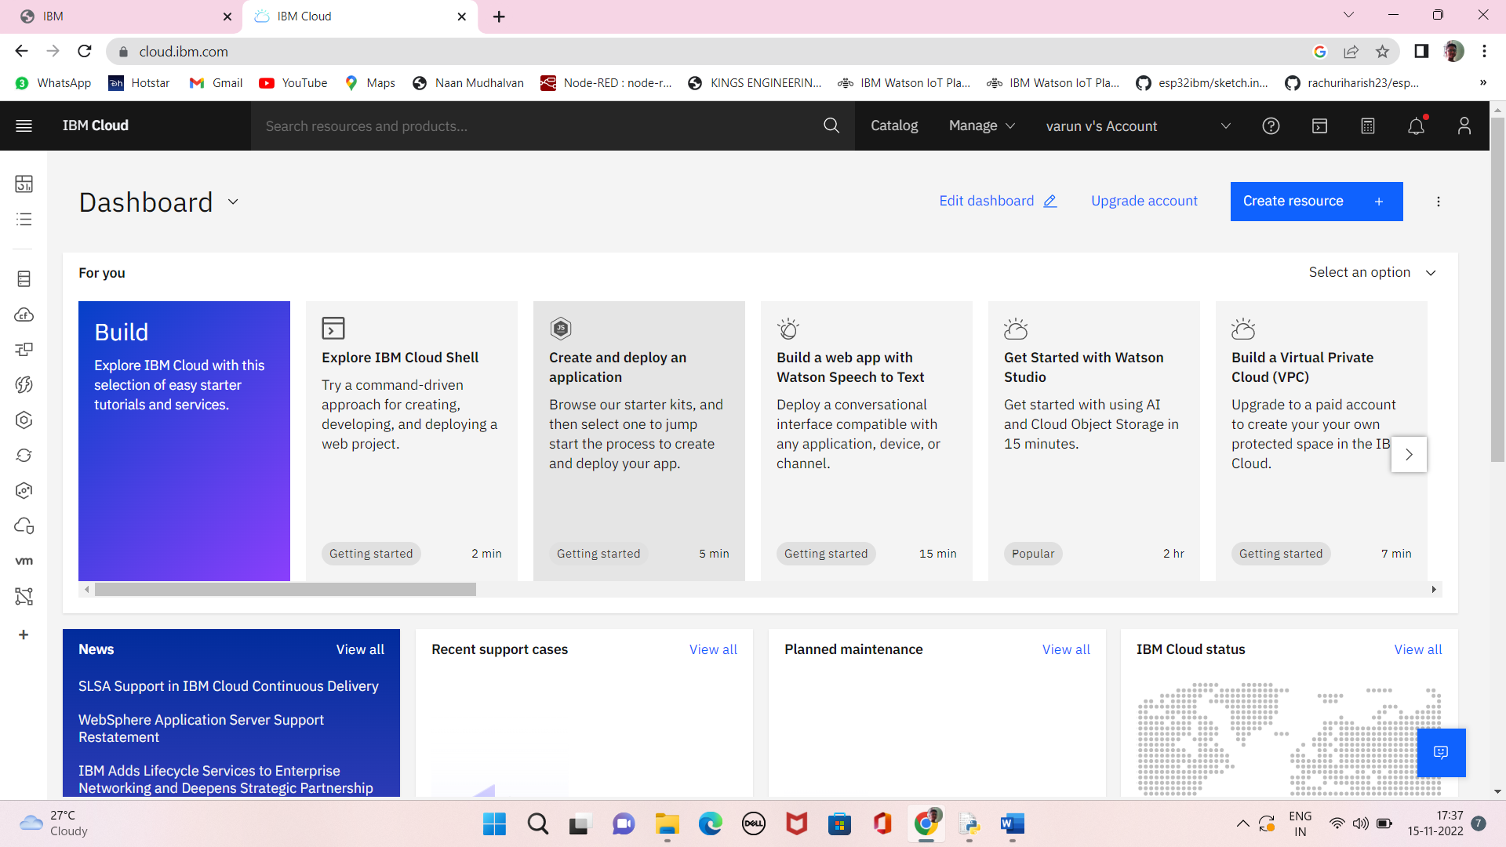

Software

