# ASSIGNMENT- 2

// Temp and humidity sensing. Alarm is detected during high temp

**Code:**

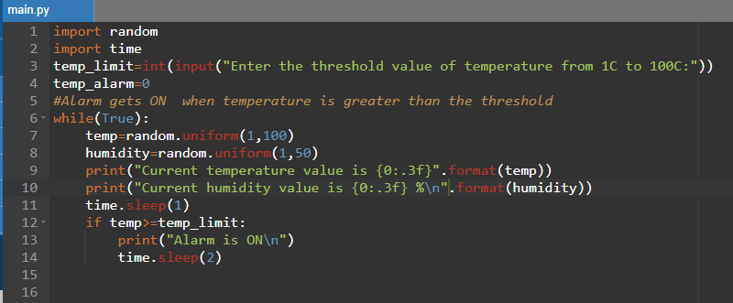

**Output:**

