Assignment -1

**Smart home- Burglar Alarm**

Whenever a thief enters the house, the PIR sensor senses the movement of the thief & the burglar alarm gets activated and generates sound. In addition to this, when thief enters the house, along with alarm sound, an LED light will be blinking to indicate danger situation.

**Circuit:**

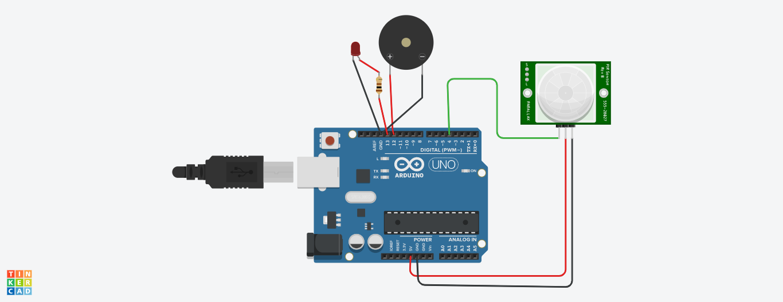

**Code:**

// Smart Home Automation -Burglar Alarm

void setup()

{

pinMode(4,INPUT);

pinMode(12,OUTPUT);

pinMode(13,OUTPUT);

Serial.begin(9600);

}

void loop()

{

int p=digitalRead(4);

Serial.println(p);

if(p)

{

Serial.println(p);

tone(12,30);

digitalWrite(13,HIGH);

delay(100);

digitalWrite(13,LOW);

delay(100);

}

noTone(12);

delay(1000);

}

**Tinkercad link**: https://www.tinkercad.com/things/4MwgVvxEZMO-smart-home-burglar-alarm