SPRINT-II

PROJECT DEVELOPMENT PHASE

|  |  |
| --- | --- |
| **DATE** | **16 OCTOBER 2022** |
| **TEAM LEADER** | **VISHNU KUMAR N** |
| **TEAM MEMBERS** | **SURESH S**  **MATHAN KUMAR T SASI KUMAR K** |
| **PROJECT NAME** | **REAL TIME RIVER WATER QUALITY MONITERING AND CONTROL SYSTEM** |

**WHOLE PROJECT OVERVIEW**

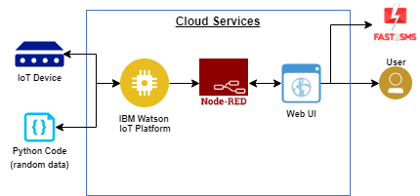

**HTML - CODE**

<!DOCTYPE html>

<html lang="en" >

<head>

<meta charset="UTF-8">

<title>Simple Login Form Example</title>

<link rel='stylesheet' href='https://fonts.googleapis.com/css?family=Rubik:400,700'><link rel="stylesheet" href="./style.css">

</head>

<body>

<!-- partial:index.partial.html -->

<div class="login-form">

<form>

<h1>Login</h1>

<div class="content">

<div class="input-field">

<input type="email" placeholder="Email" autocomplete="nope">

</div>

<div class="input-field">

<input type="password" placeholder="Password" autocomplete="new-password">

</div>

<a href="#" class="link">Forgot Your Password?</a>

</div>

<div class="action">

<button>Register</button>

<button>Sign in</button>

</div>

</form>

</div>

<!-- partial -->

<script src="./script.js"></script>

</body>

</html>

**CSS-CODE**

* {

margin: 0;

padding: 0;

box-sizing: border-box;

-webkit-font-smoothing: antialiased;

}

body {

background: #e35869;

font-family: 'Rubik', sans-serif;

}

.login-form {

background: #fff;

width: 500px;

margin: 65px auto;

display: -webkit-box;

display: flex;

-webkit-box-orient: vertical;

-webkit-box-direction: normal;

flex-direction: column;

border-radius: 4px;

box-shadow: 0 2px 25px rgba(0, 0, 0, 0.2);

}

.login-form h1 {

padding: 35px 35px 0 35px;

font-weight: 300;

}

.login-form .content {

padding: 35px;

text-align: center;

}

.login-form .input-field {

padding: 12px 5px;

}

.login-form .input-field input {

font-size: 16px;

display: block;

font-family: 'Rubik', sans-serif;

width: 100%;

padding: 10px 1px;

border: 0;

border-bottom: 1px solid #747474;

outline: none;

-webkit-transition: all .2s;

transition: all .2s;

}

.login-form .input-field input::-webkit-input-placeholder {

text-transform: uppercase;

}

.login-form .input-field input::-moz-placeholder {

text-transform: uppercase;

}

.login-form .input-field input:-ms-input-placeholder {

text-transform: uppercase;

}

.login-form .input-field input::-ms-input-placeholder {

text-transform: uppercase;

}

.login-form .input-field input::placeholder {

text-transform: uppercase;

}

.login-form .input-field input:focus {

border-color: #222;

}

.login-form a.link {

text-decoration: none;

color: #747474;

letter-spacing: 0.2px;

text-transform: uppercase;

display: inline-block;

margin-top: 20px;

}

.login-form .action {

display: -webkit-box;

display: flex;

-webkit-box-orient: horizontal;

-webkit-box-direction: normal;

flex-direction: row;

}

.login-form .action button {

width: 100%;

border: none;

padding: 18px;

font-family: 'Rubik', sans-serif;

cursor: pointer;

text-transform: uppercase;

background: #e8e9ec;

color: #777;

border-bottom-left-radius: 4px;

border-bottom-right-radius: 0;

letter-spacing: 0.2px;

outline: 0;

-webkit-transition: all .3s;

transition: all .3s;

}

.login-form .action button:hover {

background: #d8d8d8;

}

.login-form .action button:nth-child(2) {

background: #2d3b55;

color: #fff;

border-bottom-left-radius: 0;

border-bottom-right-radius: 4px;

}

.login-form .action button:nth-child(2):hover {

background: #3c4d6d;

}

**JAVASCRIPT**

/*

inspiration:

https://dribbble.com/shots/2292415-Daily-UI-001-Day-001-Sign-Up

*/

let form = document.querySelecter('form');

form.addEventListener('submit', (e) => {

e.preventDefault();

return false;

});

**LOGIN_PAGE**

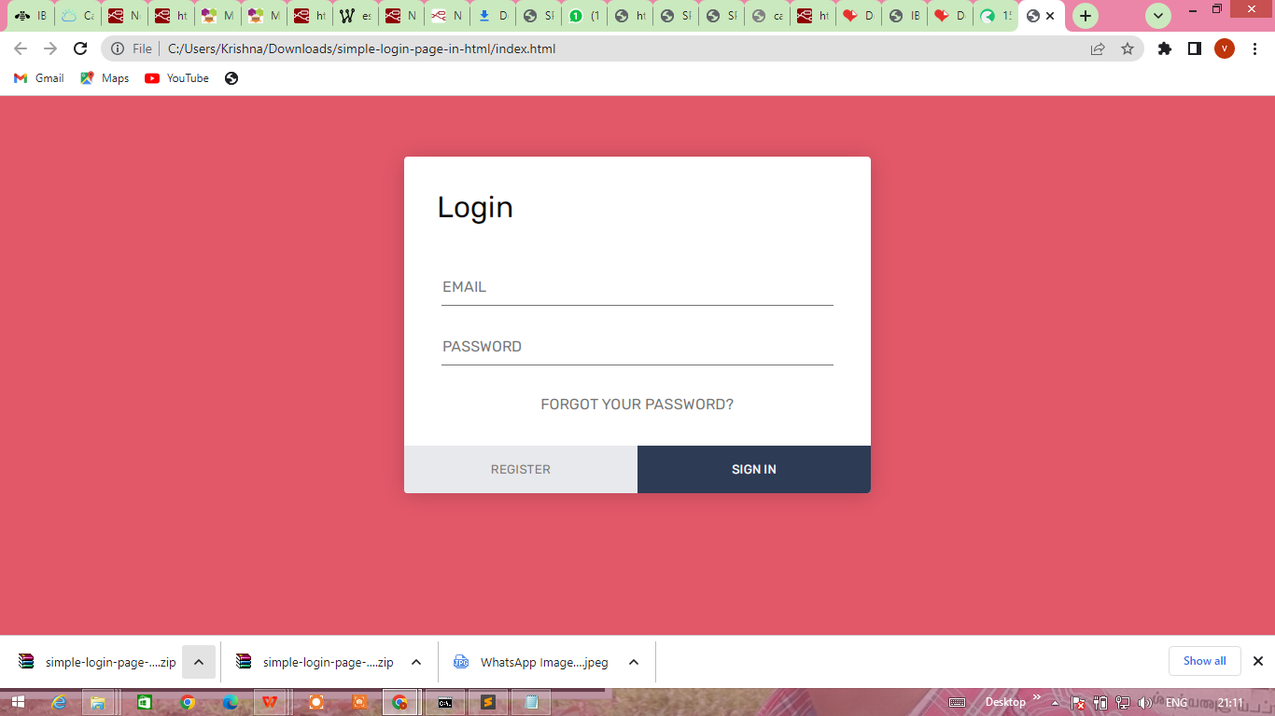

**IBM_CLOUD**

