SPRINT-IV

PROJECT DEVELOPMENT PHASE

|  |  |
| --- | --- |
| **DATE** | **16 OCTOBER 2022** |
| **TEAM LEADER** | **VISHNU KUMAR N** |
| **TEAM MEMBERS** | **SURESH S**  **MATHAN KUMAR T SASI KUMAR K** |
| **PROJECT NAME** | **REAL TIME RIVER WATER QUALITY MONITERING AND CONTROL SYSTEM** |

**WHOLE PROJECT OVERVIEW**

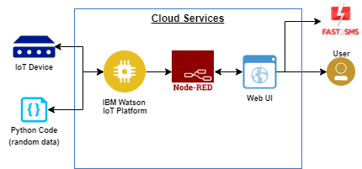

**DESIGN OF MOBILE USER INTERFACE**

**BACK-END**

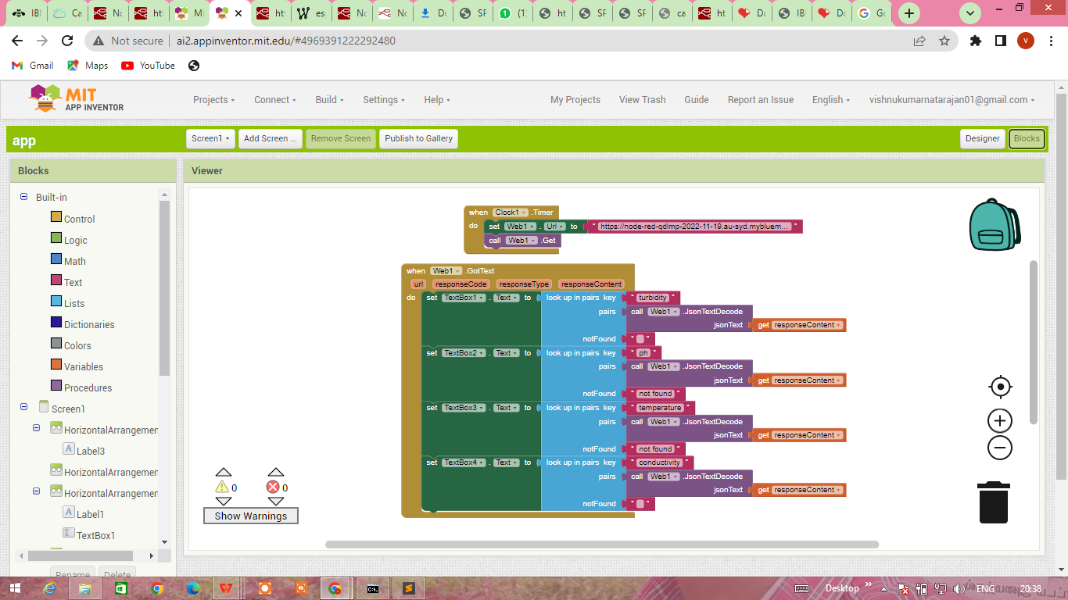

**FRONT-END**

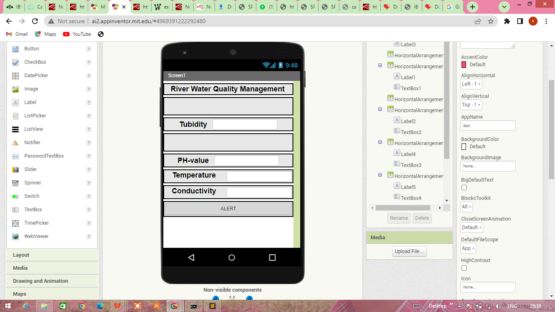

**DEVELOPED MOBILE APP**

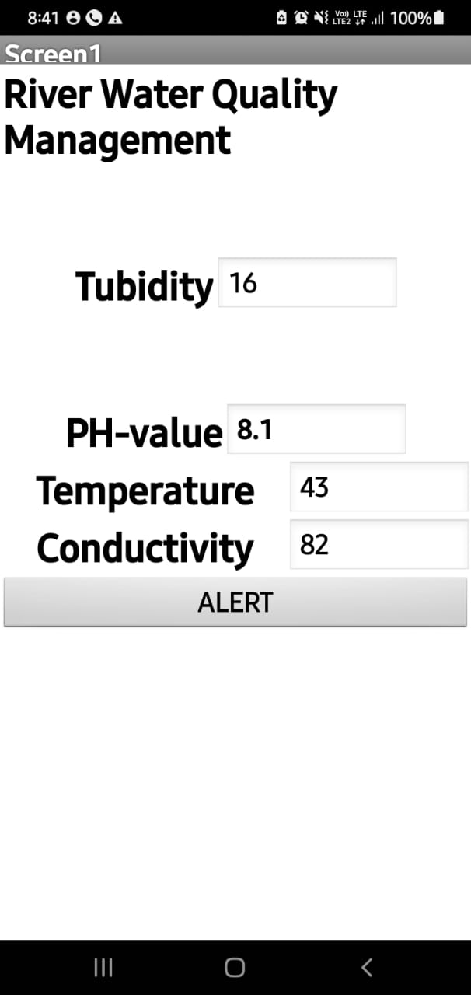

**OUTPUT**

USER CAN ALERT THE SYSTEM WHEN QUALITY OF WATER IS REDUCED

