Creation Of MOBILE APP

Date | 16 OCTOBER 2022
Team Leader | VISHNU KUMAR N
Team Members | SURESH S  MATHAN KUMAR T  SASI KUMAR K
Project Name | REAL TIME RIVER WATER QUALITY MONITERING AND CONTROL SYSTEM

UI SHOWS THE TURBIDITY AND PH VALUE(PHASE 1)

Web UI
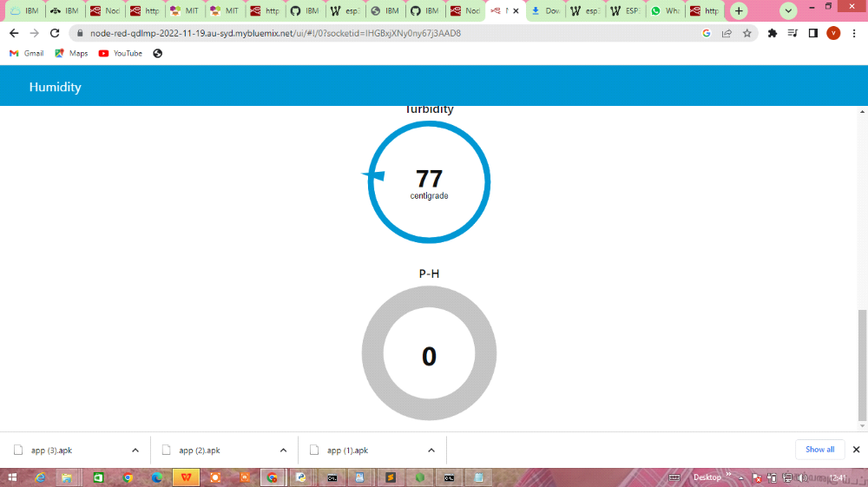

Mobile UI

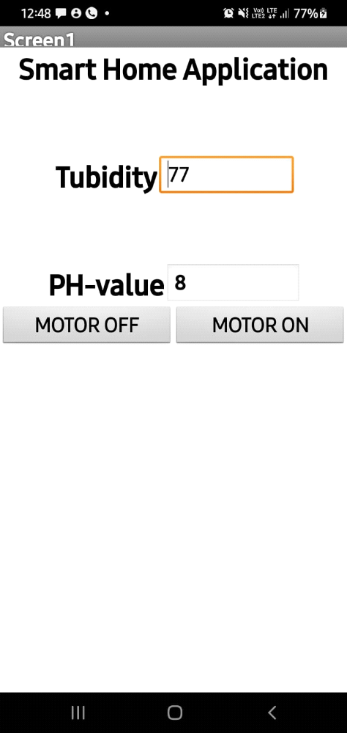

RECEIVING DATA FROM CLOUD(PHASE 2)

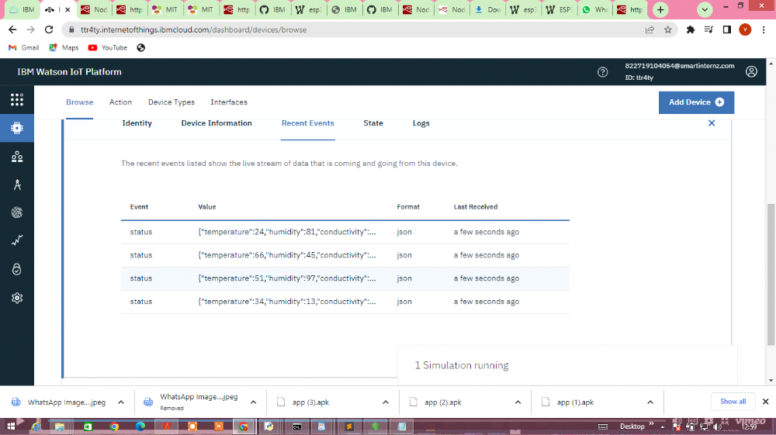

UI for Controlling Motor (PHASE 3)

OUTPUT FOR APPLICATION

