PRE REQUISTIES

PYTHON INSTALLATION IN WINDOWS 11

|  |  |
| --- | --- |
| **TEAM ID** | **PNT2022TMID28861** |
| **PROJECT NAME** | **IOT BASED SMART CROP PROTECTION SYSTEM FOR AGRICULTURE** |

STEP 1:

Download python 3.7.0 using <https://www.python.org/downloads/release/python-370/>this link.

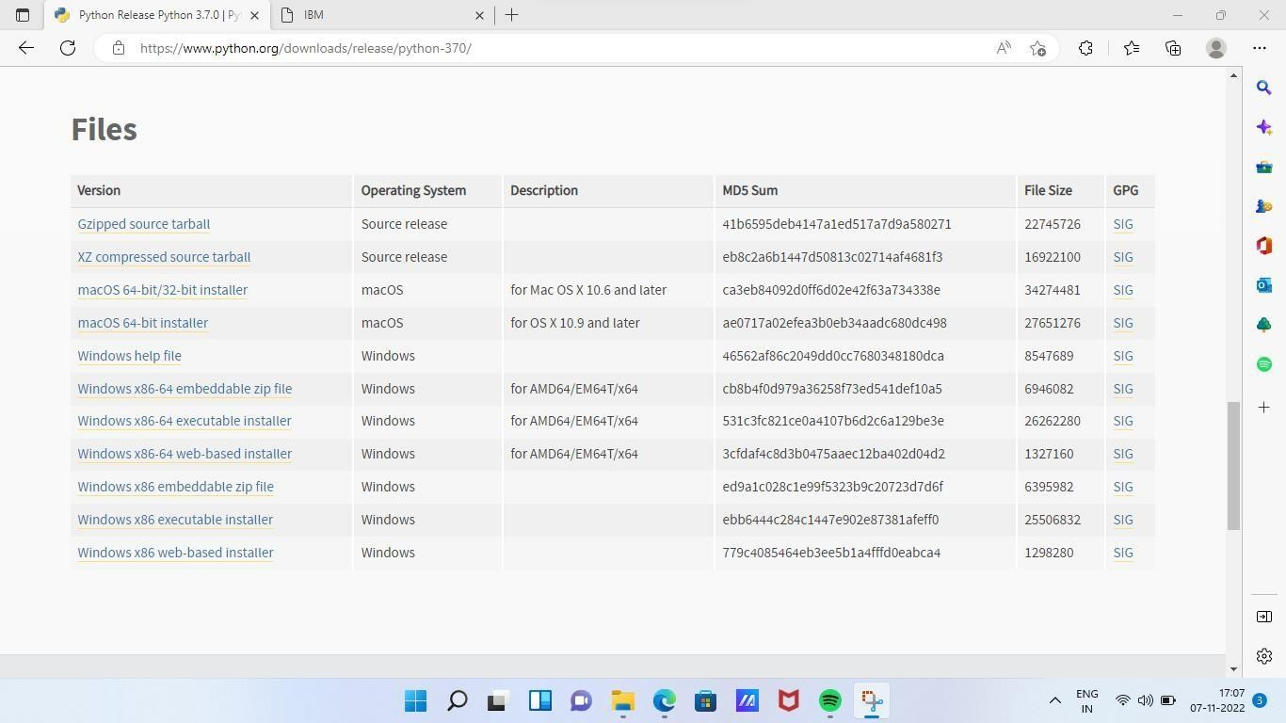

STEP 2:

Double click to install the python3.7.0 version and click next, then wait some time to install the software. Last it shows finish button to finish the installation.

Note: while installing please check add path 3.7.0 to path.

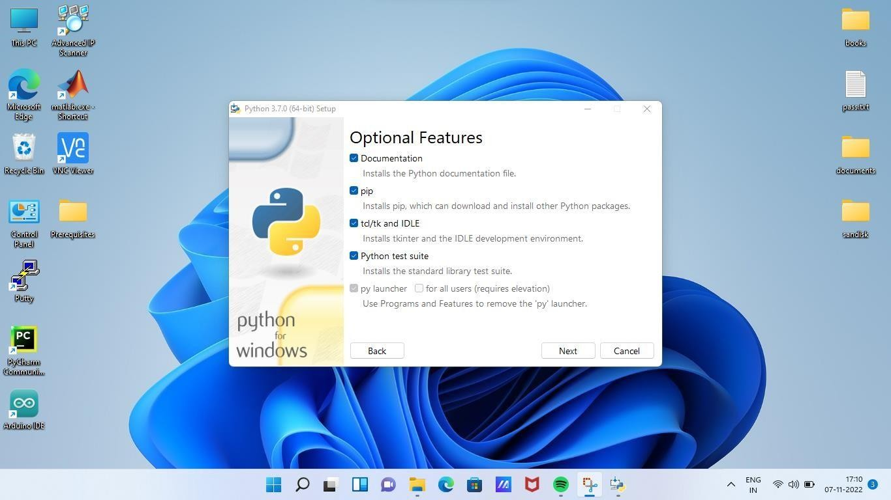

STEP 3:

Search IDLE in search bar then click IDLE (Python 3.7 64-bit) to open python IDLE.

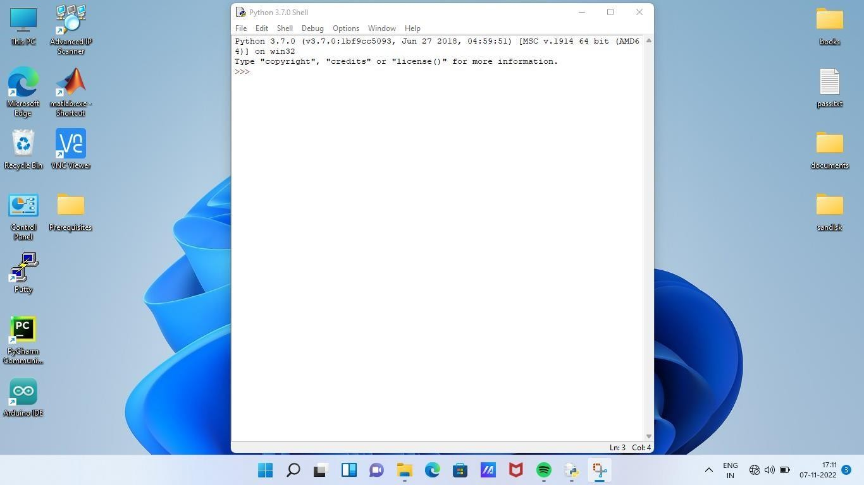

STEP 4:

Type python -m pip install –upgrade pip in cmd then enter to upgrade pip in python.

