**NAME : SRUTHI R**

**TEAM ID:PNT2022TMID00675 ROLL NO:211419104270 BATCH NO:B4-4M6E PROJECT NAME:**

**AIRLINES DATA ANALYTICS FOR AVIATIOIN INDUSTRY**

**ASSIGNMENT NO:02**

# UPLOAD THE DATASET

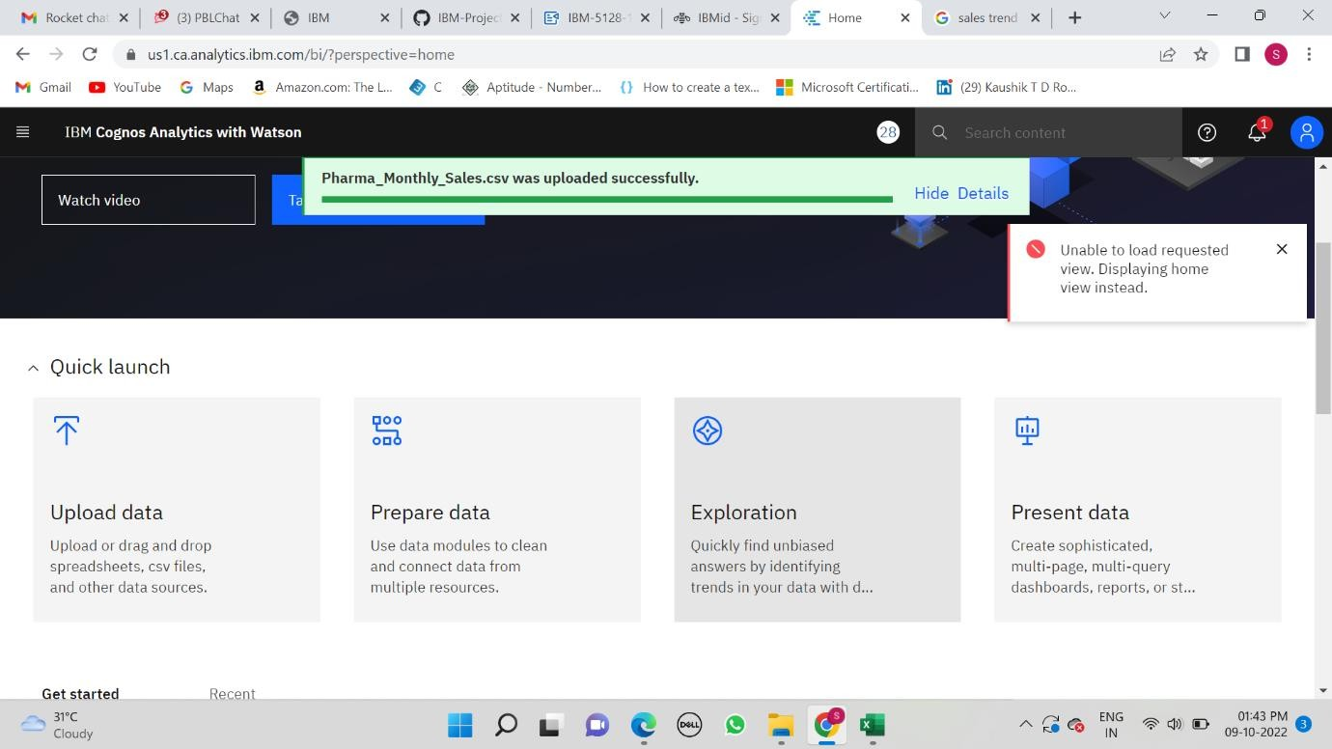

**PREPARE THE DATASET**

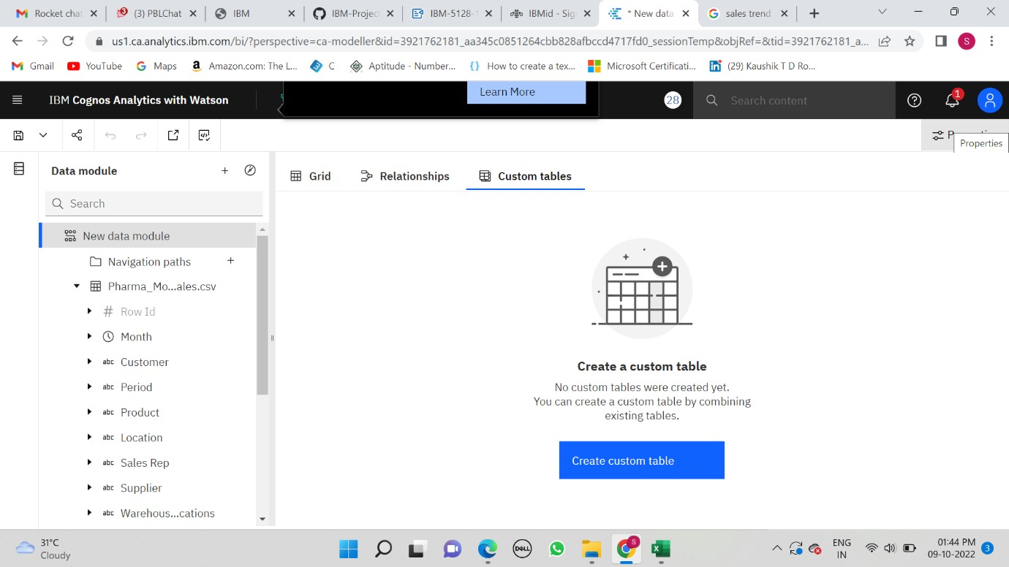

# EXPLORE THE DATASET

TASK 1:SALES BY CUSTOMER.

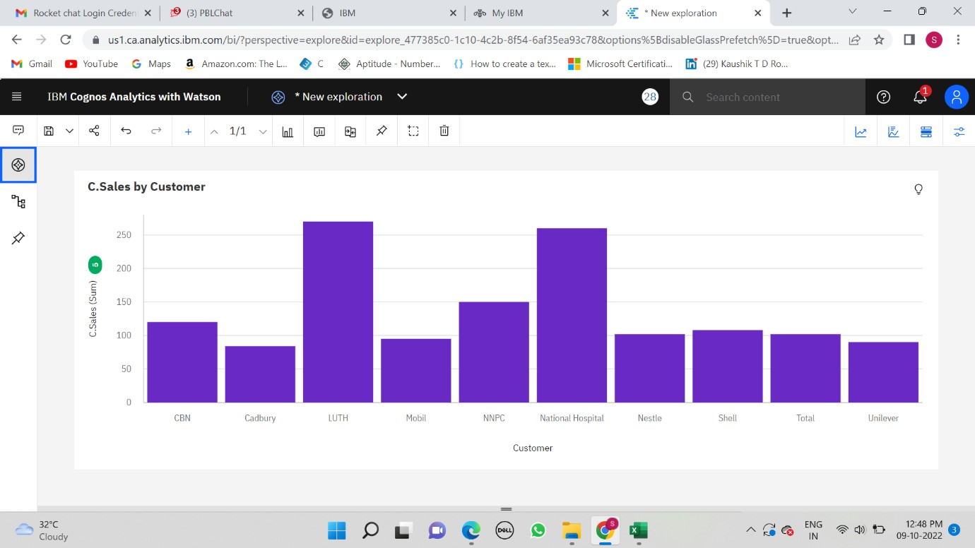

TASK 2:SALES BY LOCATION

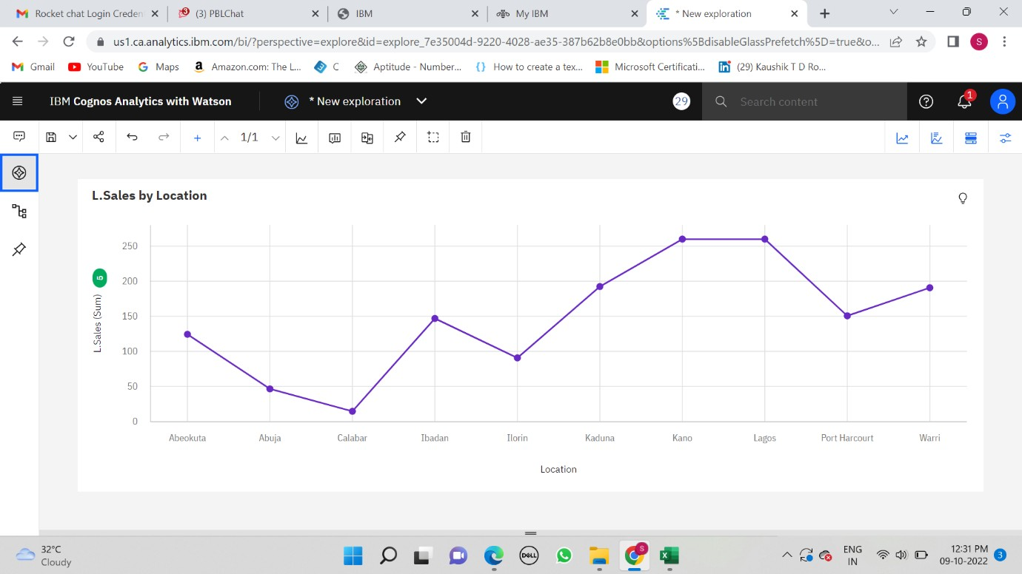

TASK 3:SALES BY SALES REPRESENTATIVE

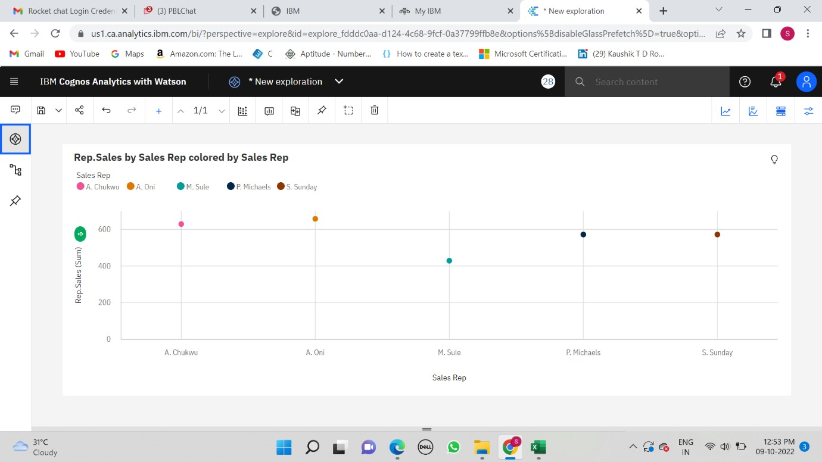

TASK 4: RECEIVED INVENTORY FROM SUPPLIER

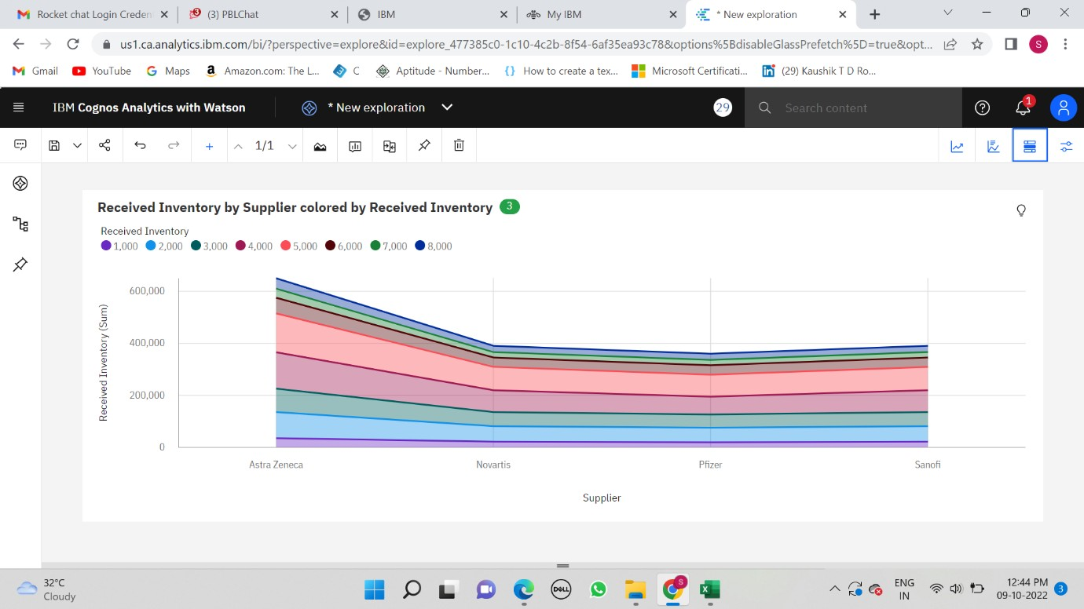

TASK 5: INVENTORY STOCK FOR WAREHOUSE LOCATIONS

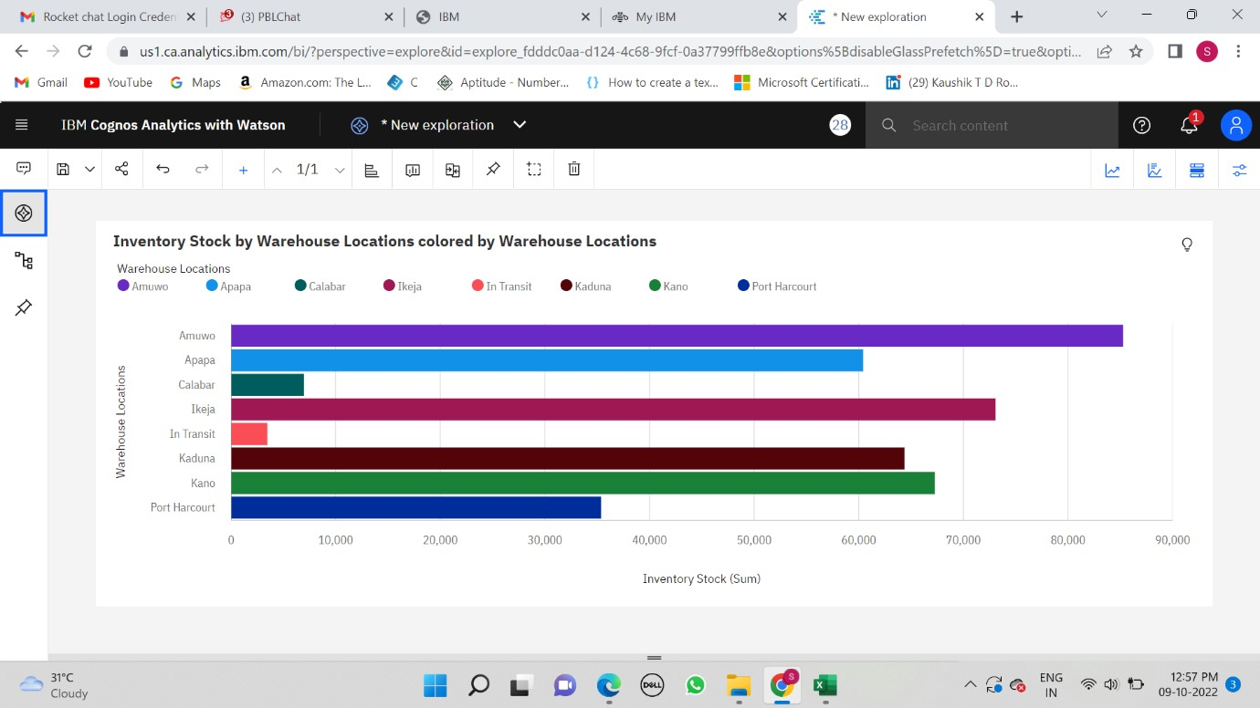

TASK 6: SALES TREND

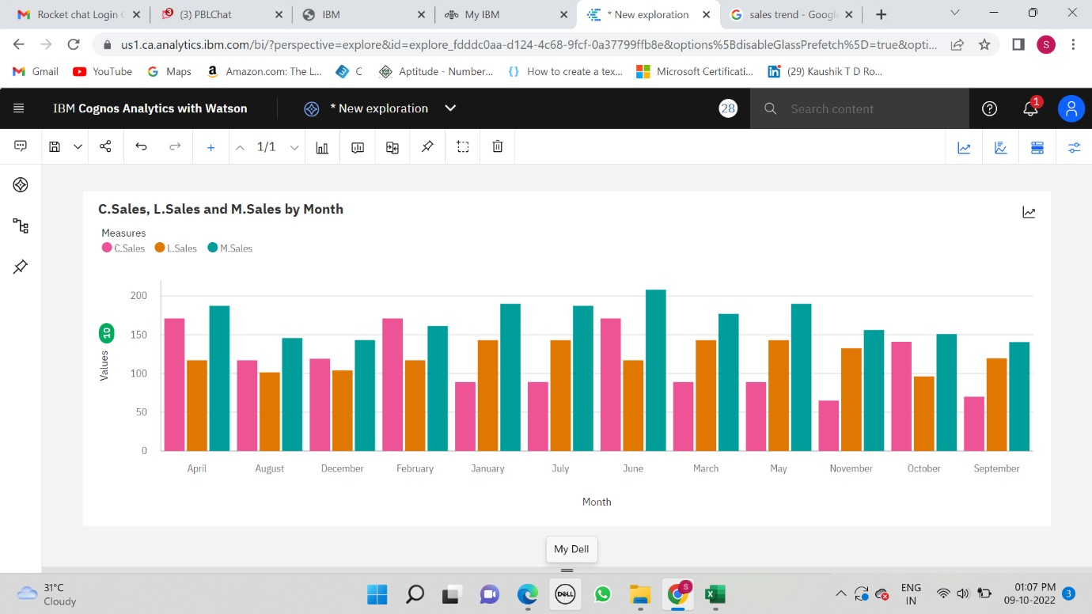

TASK 7:MONTHLY SALES

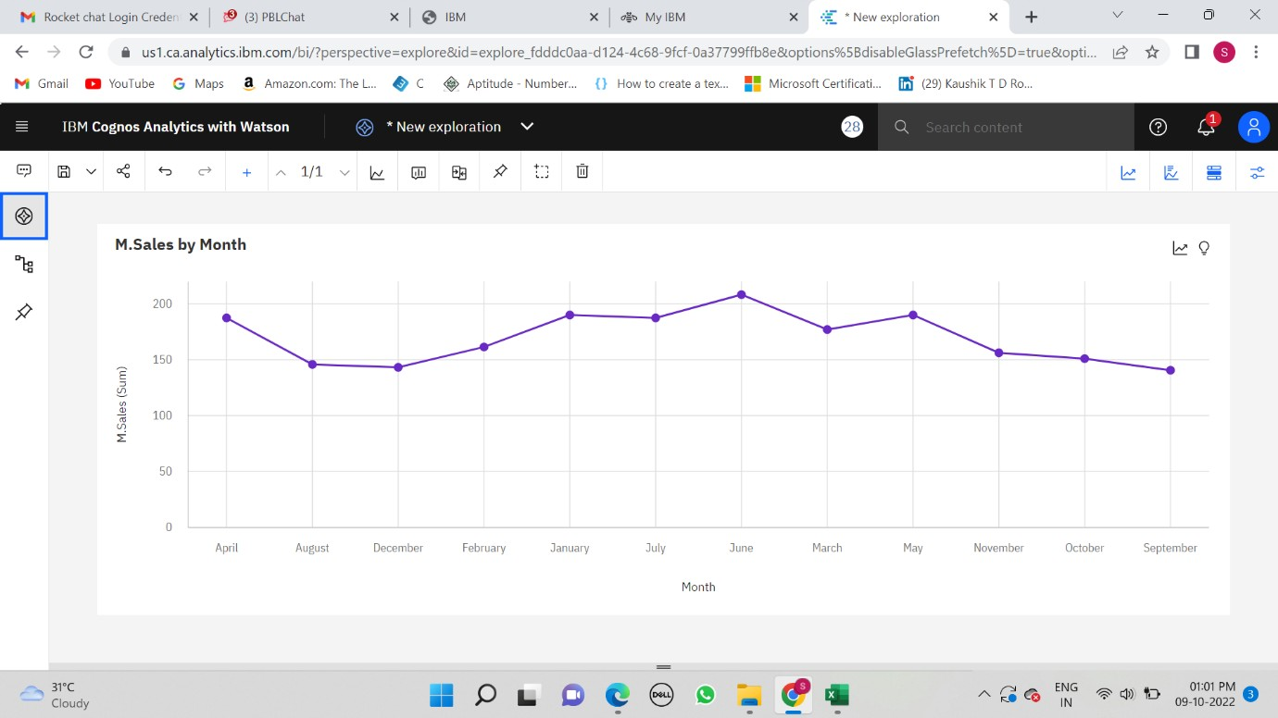

TASK 8: ACTUAL AND RECEIVED INVENTORY BY MONTH

