ESTIMATION OF CROP YIELD

USING DATA ANALYTICS

TEAM MEMBERS:

1.V.S.MUKHENDRA KUMAR

2.V.V.RAM MOHAN VARMA

3.MYPATI SUMAN

4.SAKAMURI MANOJ

TEAM ID: PNT2022TMID24269

FACULTY MENTOR: Ms.R.KANNAMMA

PROJECT REPORT

CONTENTS:

|  |  |
| --- | --- |
| S no | CONTENTS |
| *1* | ABSTRACT |
| 2 | INTRODUCTION |
| 3 | ARCHITECTURE |
| 4 | SOLUTION  REQUIREMENTS |
| 5 | PROJECT FLOW |
| 6 | WORKING WITH  DATA SET |
| 7 | IMPLEMENTATION |
| 8 | RESULTS |
| 9 | CONCLUSION |

ABSTRACT:

Agriculture is important for human survival because it serves the basic need. A well-known fact that the majority of population (≥55%) in India is in agriculture. Due to variations in climatic conditions, there exist bottlenecks for increasing the crop production in India. It has become challenging task to achieve desired targets in Agri based crop yield. Factors like climate, geographical conditions, economic and political conditions are to be considered which have direct impact on the production, productivity of the crops. Crop yield prediction is one of the important factors in agriculture practices. Farmers need information regarding crop yield before sowing seeds in their fields to achieve enhanced crop yield. The use of technology in agriculture has increased in recent year and data analytics is one such trend that has penetrated into the agriculture field being used for management of crop yield and monitoring crop health. The recent trends in the domain of agriculture have made the people to understand the significance of big data. The main challenge using big data in agriculture is identification of impact and effectiveness of big data analytics. Efforts are going to understand how big data analytics can be used to improve the productivity in agricultural practices. The analysis of data related to agriculture helps in crop yield prediction, crop health monitoring and other such related activities. In literature, there exist several studies related to the use of data analytics in the agriculture domain. The present study gives insights on various data analytics methods applied to crop yield prediction. The work also signifies the important lacunae points in the proposed area of research.

INTRODUCTION:

Crop production in India is one of the important sources

of income and India is one of the top countries to produce crops. As per this project we will be analyzing some important visualization, creating a dashboard and by going through these we will get most of the insights.

ARCHITECTURE:

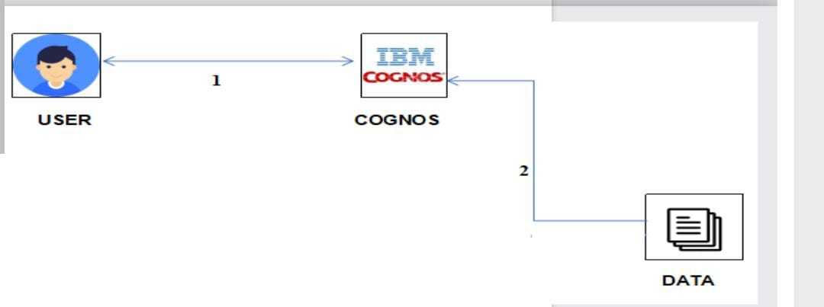

SOLUTION REQUIREMENTS:

Service used : IBM Cognos Analytics

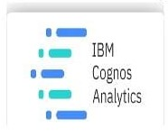

PROJECT FLOW:

Users create multiple analysis graphs/charts Using the analyzed chart creation of the Dashboard is done. Saving and Visualizing the final dashboarding the IBM Cognos Analytics

To accomplish this, we have to complete all the activities and tasks listed below

• IBM Cloud Account

• Login to Cognos Analytics

• Working with the Dataset

1. Understand the Dataset and Loading the Dataset

• Data visualization charts

1. Seasons with average productions
2. with years usage of Area and Production
3. Top 10 States with most area
4. State with crop production along with season (Text table)

* Dashboard Creation
* Export the Analytics

WORKING WITH DATA SET:

Let's understand the data we're working with and give a brief overview of what each feature represents or should represent

1. State Name - All the Indian State names.

2. District Name -Different District names.

3. Crop Year- contains the crop years.

4 Season - Different seasons for crop production.

5. Area-Total number of areas covered.

IMPLEMENTATION:

We implement the following in our project:

1. Seasons with average productions
2. With years usage of area and production
3. Top 10 states with most area
4. State with crop production
5. States with the crop production along with season(Texttable)
6. RESULTS:

1. Seasons with average productions:-

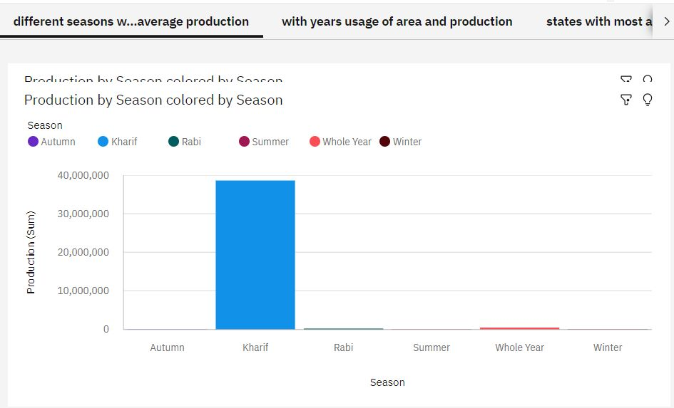

2. With years usage of area and productions:-

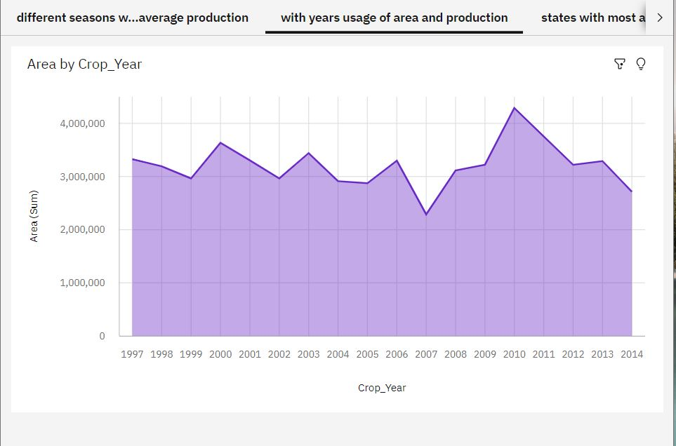

3. Top 10 states with most area:-

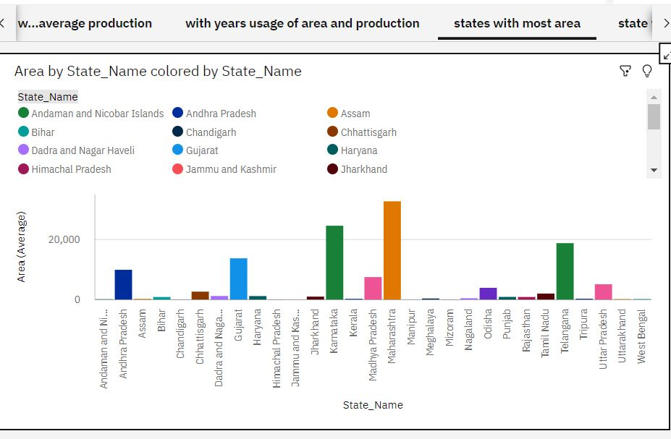

4. State with crop production:-

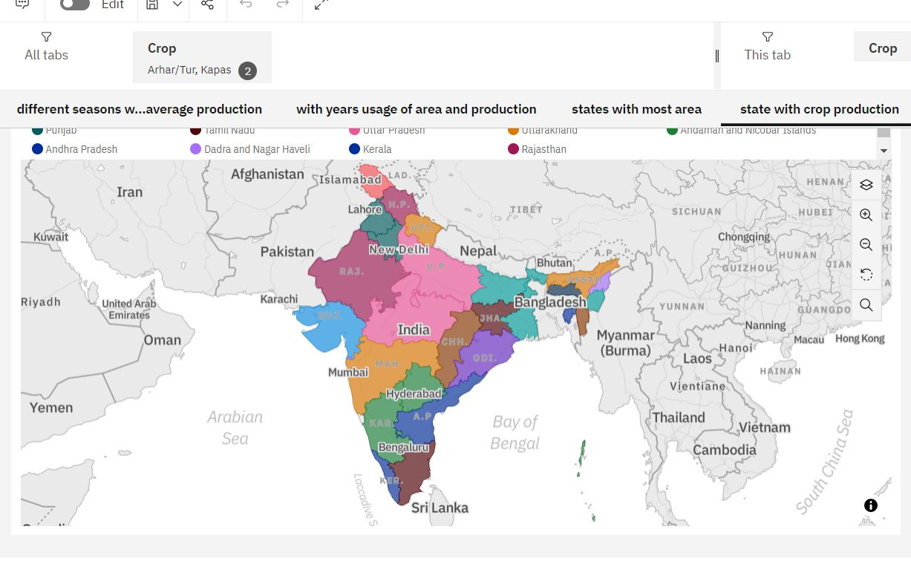

5. States with the crop production along with season(Text table)

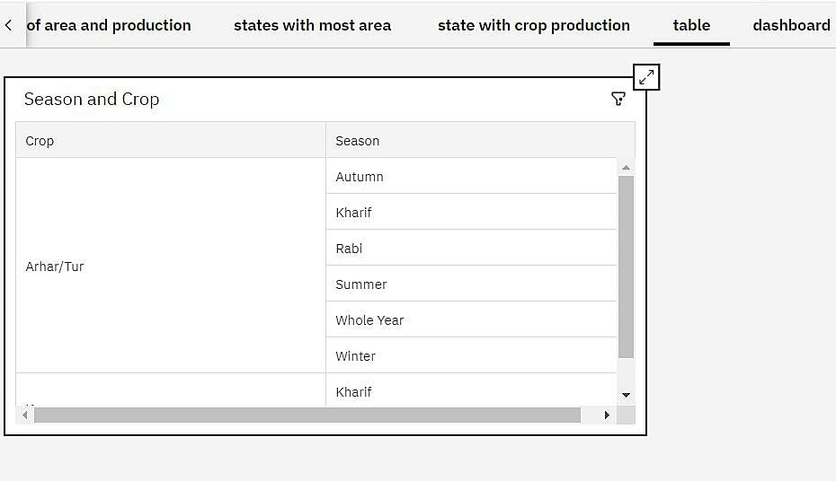

6.Dashboard:-

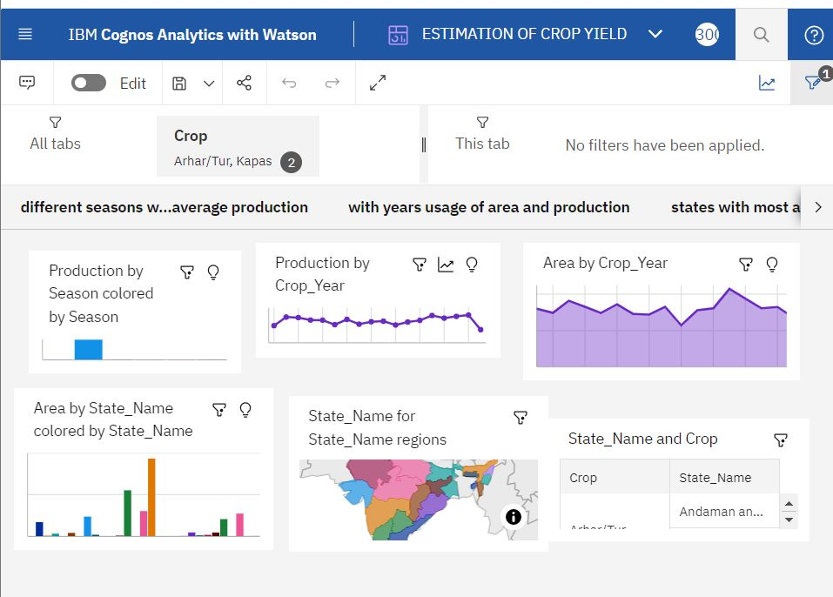

CONCLUSION:

A result of penetration of technology to agricultural field, there is a improvement in the productivity. The ovations have led to new concepts like digital agriculture, smart farming, precision agriculture etc. In the literature, it has been observed that analysis has been done on agriculture productivity hidden patterns discovery using data set related to seasons and crop yields data We have noticed and made analysis about different crops cultivated area and productions in different states and districts using IIIM Comes some of them are 1) Seasons with average productions In this analytics we come to know in which seasons the average production is more and in which reasons the production is less 2) Production by crop year In this analysis we come to know in which years the production is high and low 3) Production by District With this analytics we can aware of the districts with the selected crops cultivated and states too. 4) Production by Area From this we can know how much we should be cultivated and the production will be getting will be estimated. Finally created the dashboard and made analysis that which state and in which year with crop area and to what extent the production will be are analysed.

REFERENCES:

1. Https://WWW.ibm.com /***download*** /cas/WVJVQERV
2. David b.lobell.the use of satellite data for crop yeild analysis, field crop research-143