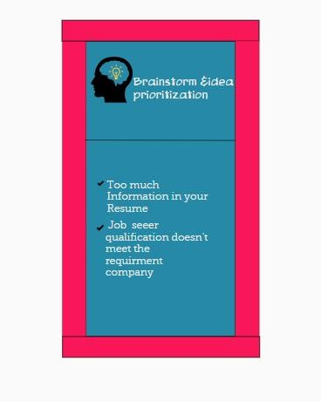

*PrOv iöing* proper



give proper instruction aDooë job



pr'oYide a online skill



Orgenizîng Łhø ßeam



 

Imponance



,:+.': .. ’’

’’’''' , 'Î

.

¢•ee

onfne



vtding ” a

Łna/ning

