PROJECT DESIGN PHASE – II Data Flow Diagram
Date | 13-10-2022
Team ID | B2-2M4E
Project Name |   Skill  And Job Recommender
Maximum Marks | 4 Marks

Data Flow Diagrams
- A Data Flow Diagram (DFD) is a traditional visual representation of the information flows within a system.
- A neat and clear DFD can depict the right amount of the system requirement graphically.
- It shows how data enters and leaves the system, what changes the information, and where data is stored.

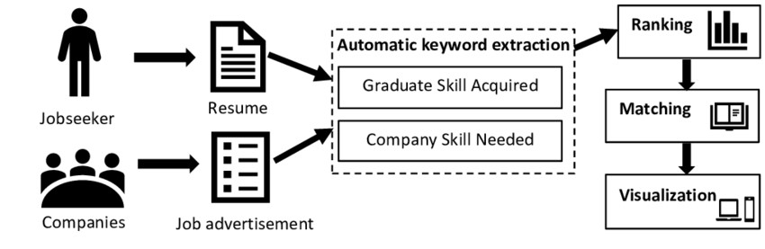

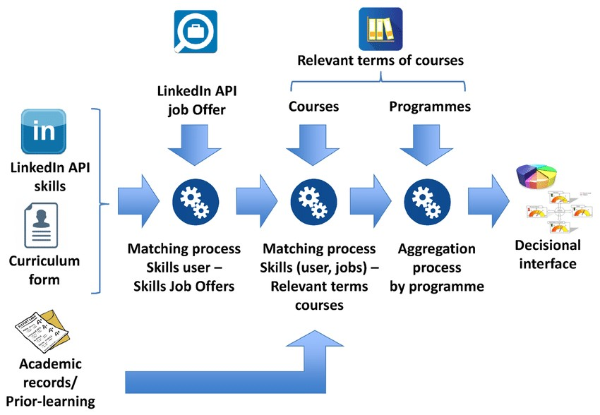
User Stories.
User Type | Functional Requireme  nt (Epic) | User  Story  Number | User Story / Task | Acceptance  criteria | Priority | Release
Customer  (Job  Seeker) | Registration (application) | USN-1 | As a user, I can register for the application by entering my email, password, and confirming my password. | I can access my account / dashboard | High | 5-10mins
 |  | USN-2 | As a user, I will receive confirmation email once I have registered for the application | I can receive confirmation email & click confirm | High | 6- 7mins
 |  | USN-3 | As a user, I can register for the application through Online | I can saw & access my  application through Login | Low | 15-20mins

