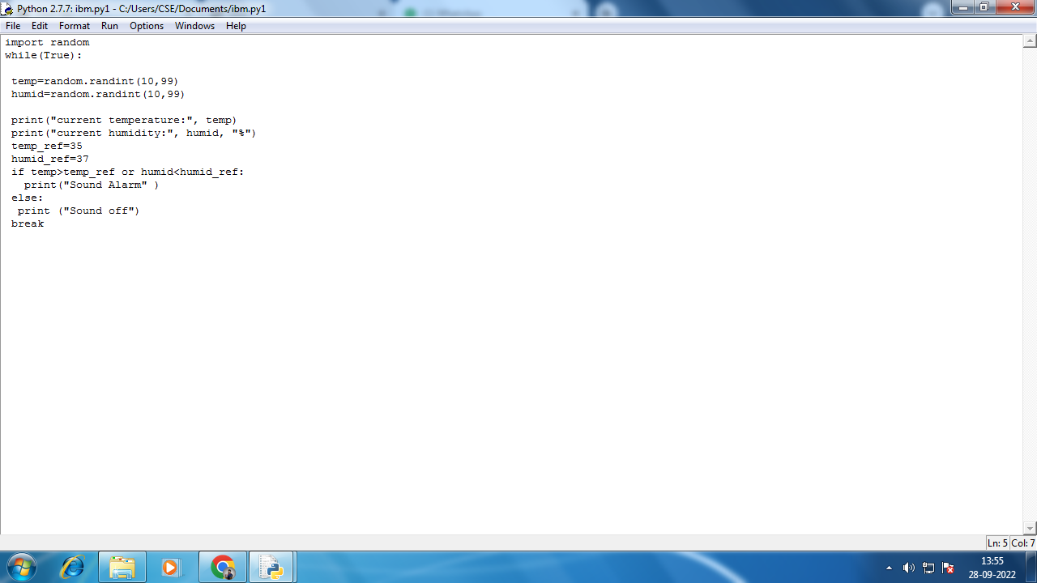

**Code:**

import random

while(True):

temp=random.randint(10,99)

humid=random.randint(10,99)

print("current temperature:", temp)

print("current humidity:", humid, "%")

temp_ref=35

humid_ref=37

if temp>temp_ref or humid<humid_ref:

print("Sound Alarm" )

else:

print ("Sound off")

break

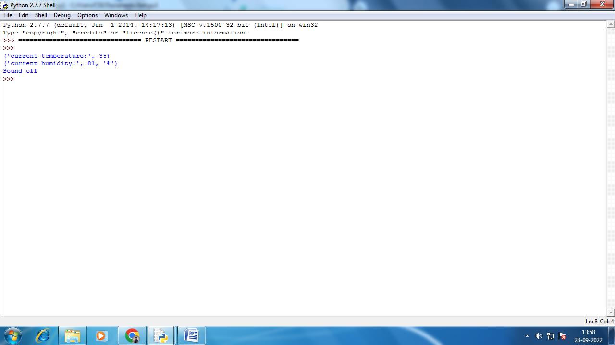

**Output:**

('current temperature:', 35)

('current humidity:', 81, '%')

Sound off