

**Code:**

import random

while(True):

temp=random.randint(10,99)

humid=random.randint(10,99)

print("current temperature:", temp)

print("current humidity:", humid, "%")

temp_ref=35

humid_ref=37

if temp>temp_ref or humid<humid_ref:

print("Sound Alarm")

else:

print ("Sound off")

break

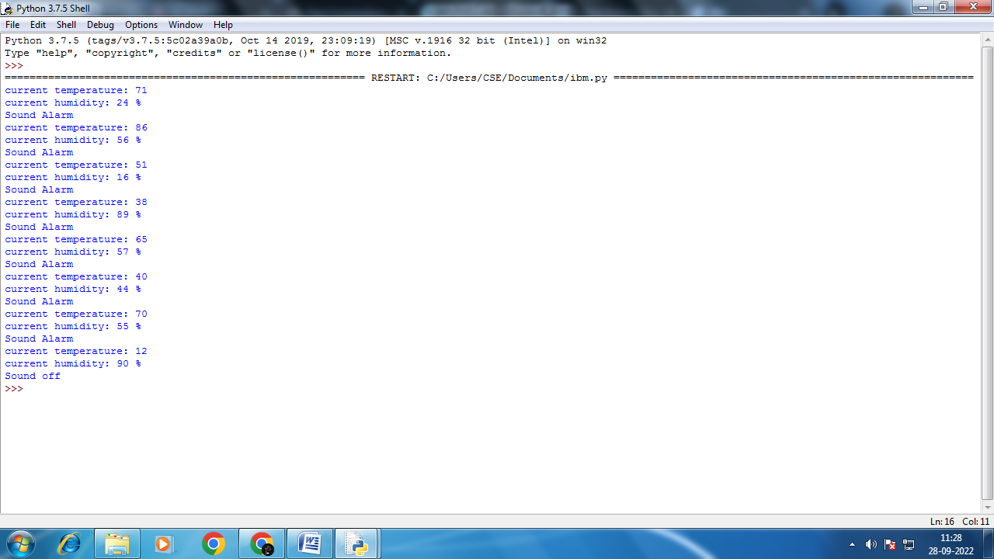

**Output:**

current temperature: 71

current humidity: 24 %

Sound Alarm

current temperature: 86

current humidity: 56 %

Sound Alarm

current temperature: 51

current humidity: 16 %

Sound Alarm

current temperature: 38

current humidity: 89 %

Sound Alarm

current temperature: 65

current humidity: 57 %

Sound Alarm

current temperature: 40

current humidity: 44 %

Sound Alarm

current temperature: 70

current humidity: 55 %

Sound Alarm

current temperature: 12

current humidity: 90 %

Sound off