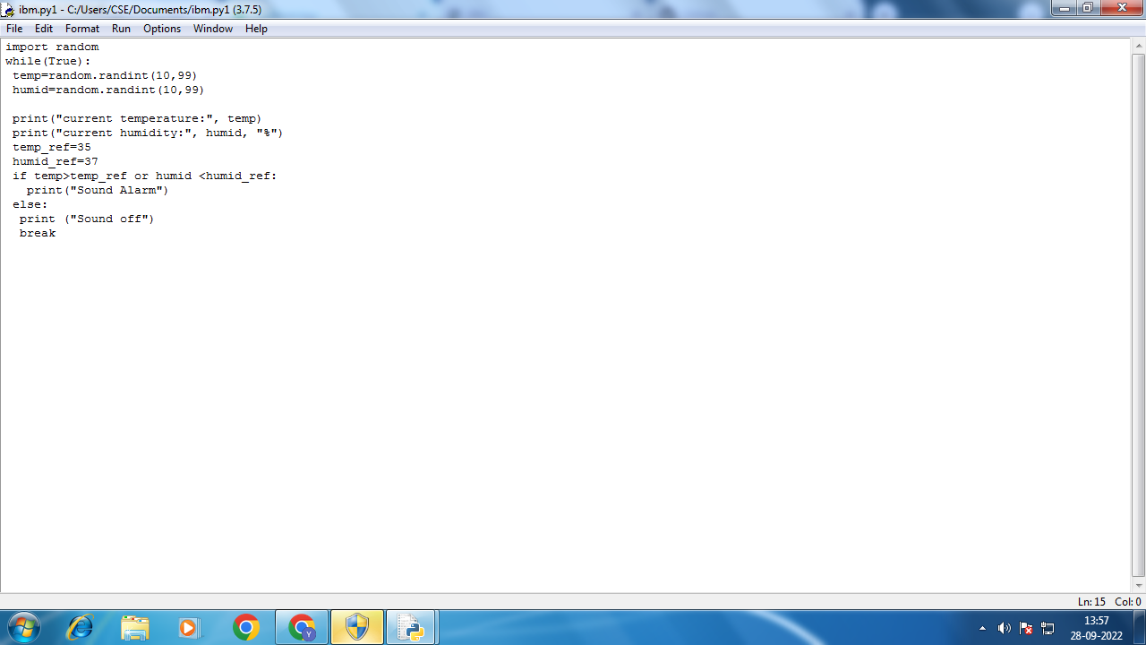

**Code:**

import random

while(True):

temp=random.randint(10,99)

humid=random.randint(10,99)

print("current temperature:", temp)

print("current humidity:", humid, "%")

temp_ref=35

humid_ref=37

if temp>temp_ref or humid <humid_ref:

print("Sound Alarm")

else:

print ("Sound off")

break

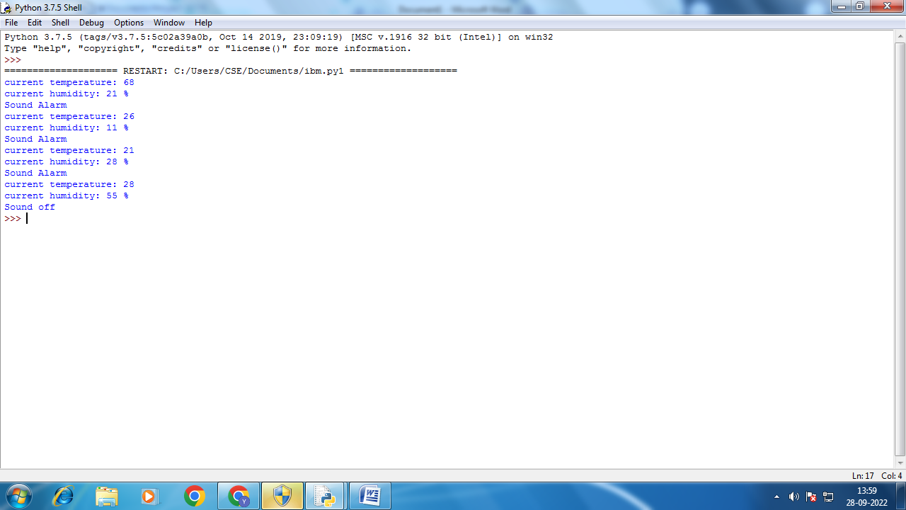

**Output:**

current temperature: 68

current humidity: 21 %

Sound Alarm

current temperature: 26

current humidity: 11 %

Sound Alarm

current temperature: 21

current humidity: 28 %

Sound Alarm

current temperature: 28

current humidity: 55 %

Sound off