A.ARUN PANDI

210519104016

Assignment question::

Using PIR sensor and tmp36(Temperature sensor), piezo alarm, please create a circuit with Arduino Uno with below functionalities.

1. Alarm should give one sound when there is a motion near PIR sensor
2. Alarm should sound with different sound when the temperature is above 60 degrees.

Arduino code :

float temp; int Buzz=A2; int sensor=12; int transistor=2; void setup()

{

Serial.begin(9600); pinMode(2,INPUT); pinMode(12,OUTPUT);

Serial.println("waiting for motion");

}

void loop()

{

double data=analogRead(A2); double n=data/1024;

double vout=n\*5;

double off=vout-0.5;

double temperature=off\*100;

Serial.print("Temperature data: ");

Serial.println(temperature);

if(temp>60)

{

digitalWrite(Buzz,HIGH); Serial.println("temperature detected"); tone(12,100); delay(1000); tone(12,200); delay(1000);

}

int val = digitalRead(2); if(val ==HIGH)

{

digitalWrite(transistor, HIGH); Serial.println("Motion Detected"); tone(12,100); //pin number, frequency, delay(optional) delay(1000); tone(12,200); delay(1000);

}

if(temp <= 60)

{

digitalWrite(Buzz,LOW);

Serial.println("No temperature detected"); noTone(12); delay(500);

}

if(val == LOW)

{

digitalWrite(transistor, LOW); Serial.println("NO Motion"); noTone(12); delay(500);

}

delay(1000);

}

SCREENSHOT :

Screenshot 1::

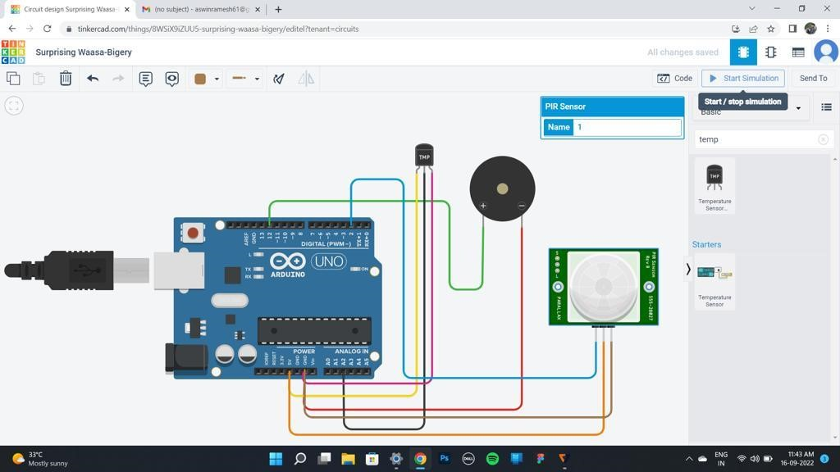

Screenshot 2 ::

