**Project Design Phase – Ⅱ**

**Solution requirements (functional and non-functional)**

|  |  |
| --- | --- |
| Date | 3 November 2022 |
| Team id | PNT2022TMID14015 |
| Project name | Fertilizer recommendation system for disease prediction |
| Maximum marks | 4 marks |

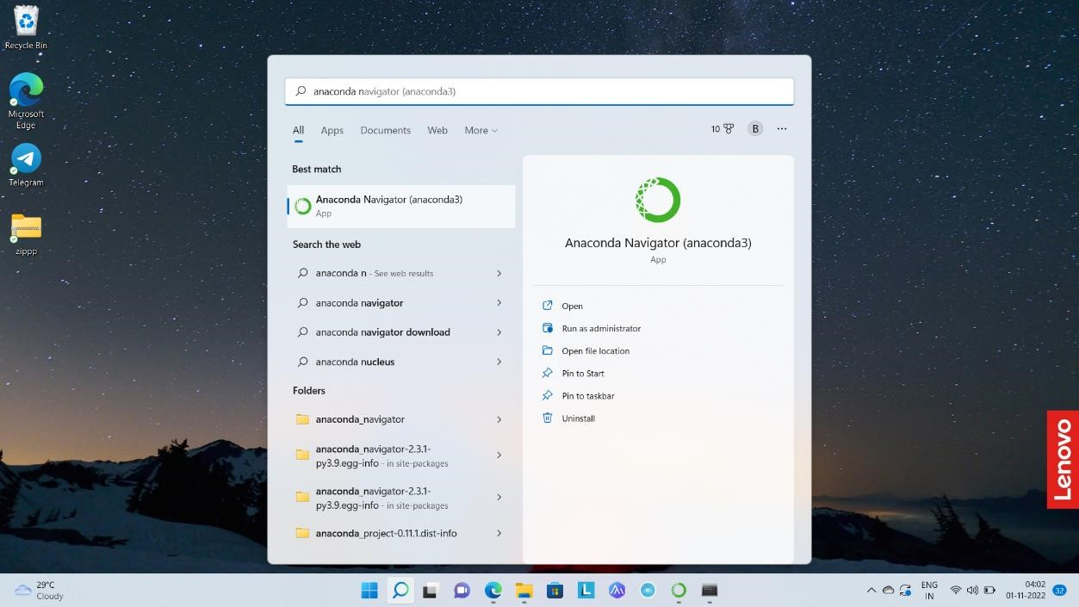

*Figure 1Anaconda navigator*

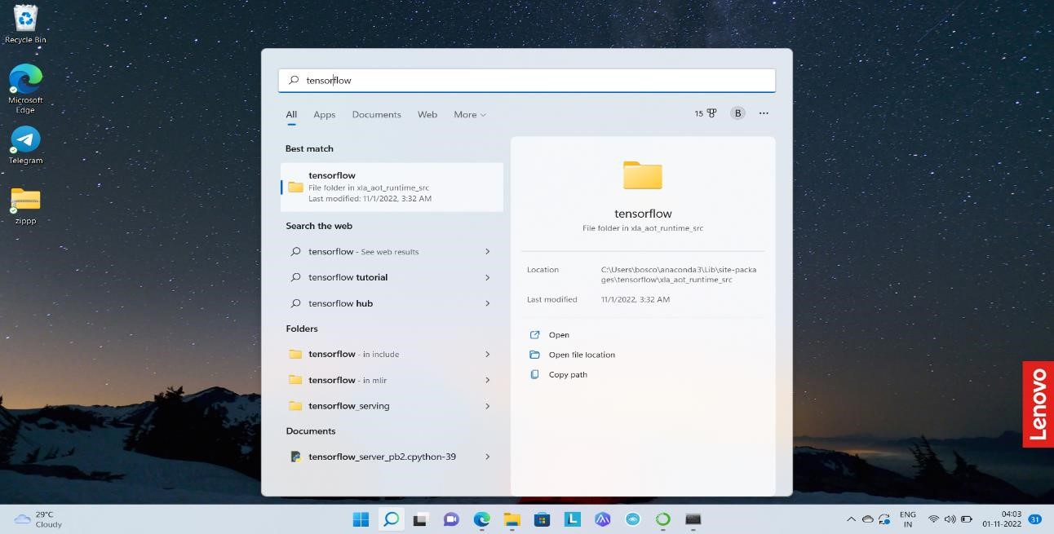

*Figure 2tensor flow*

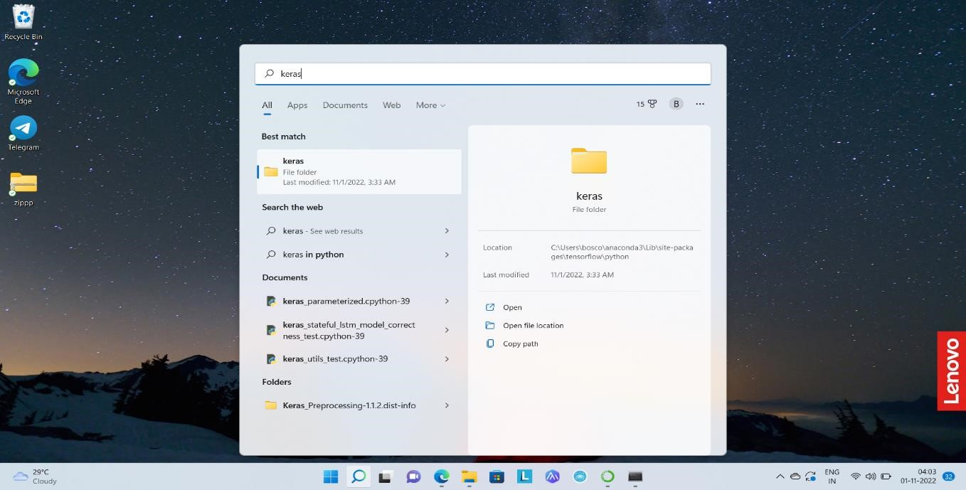

*Figure 3keras*

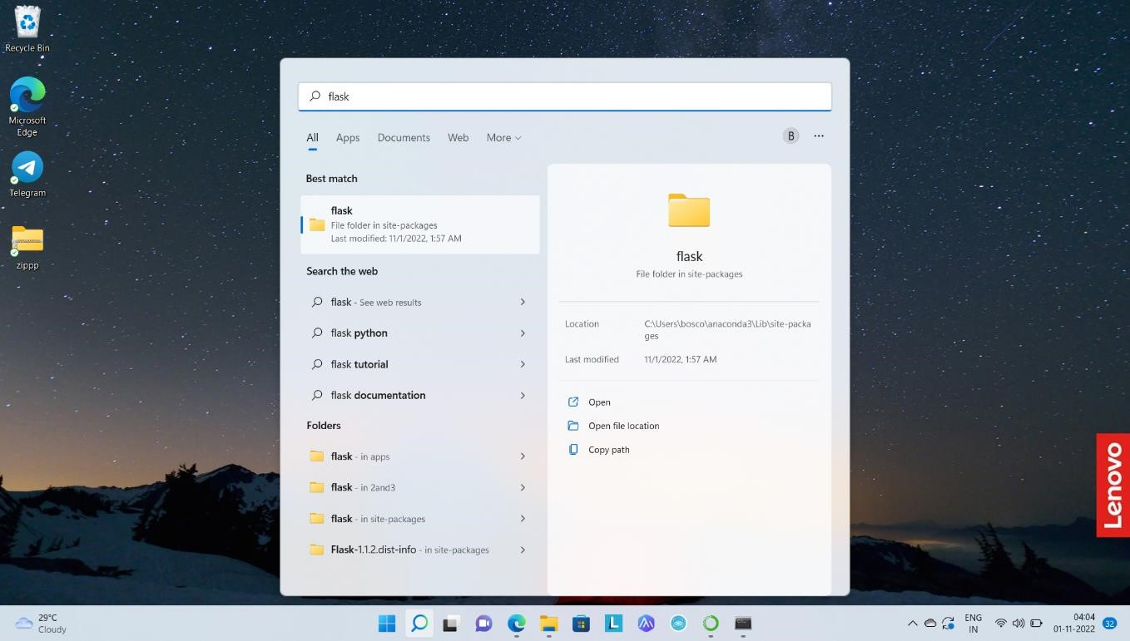

*Figure 4flask*