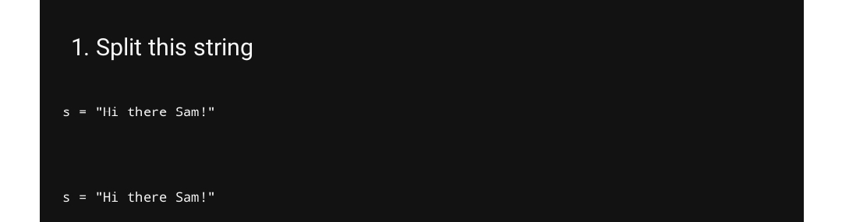

2. Use .format() to print the following string

planet = "Earth"

diameter = 12742

print( 'The diameter of {} is {} kilometers.' .format(planet,diameter));

3.In this nest dictionary grab the word "hello”

d = {'k1':[1,2,3,{'tricky':['oh','man','inception',{'target':[1,2,3,'hello']}]}]}

print(d['k1'][3]["tricky"][3]['target'][3])

4.1 Create an array of 10 zeros?

import numpy as np

array=np.zeros(10)

print("An array of 10 zeros:")

print(array)

4.2 Create an array of 10 fives?

import numpy as np

array=np.ones(10)*5

print("An array of 10 fives:")

print(array)

5. Create an array of all the even integers from 20 to 35

import numpy as np

array=np.arange(20,36,2)

print("Array of all the even integers from 30 to 70")

print(array)

6. Create a 3x3 matrix with values ranging from 0 to 8

import numpy as np

x = np.arange(0, 9).reshape(3,3)

print(x)

7. Concatenate a and b a = np.array([1, 2, 3]), b = np.array([4,-71])

a = np.array((1,2,3))

b = np.array((4,5,6))

np.stack((a,b),axis=1)

8. Create a dataframe with 3 rows and 2 columns

import pandas as pd

data = [['Dharani ', 10], ['Partha ', 11], ['Ragul', 14]]

df = pd.DataFrame(data, columns=['Name', 'Register no'])

df

9. Generate the series of dates from 1st Jan, 2023 to 10th Feb, 2023

import datetime

# The size of each step in days

day_delta = datetime.timedelta(days=1)

start_date = datetime.date.today()

end_date = start_date + 41*day_delta

for i in range((end_date - start_date).days):

print(start_date + i*day_delta)

10. Create 2D list to DataFrame lists-11, and 1, ‘aaa’, 221, 22, bbb, 25, 3, ccc, 243

import pandas as pd

lists = [[1, 'aaa', 22], [2, 'bbb', 25], [3, 'ccc', 24]]

ls = pd.DataFrame(data, columns=['Tag', 'Number'])

df