**ASSIGNMENT – 2**

**Churn_Modelling - Churn_Modelling.csv**

|  |  |
| --- | --- |
| **ASSIGNMENT DATE** |  |
| **STUDENT NAME** | Fargath Shahani.M |
| **STUDENT ROLL NO.** | 913219104004 |
| **MAXIMUM MARK** | 2 Marks |

In[1]:

**import**pandas**as**pd

**import**numpy**as**np

**from**matplotlib**import**pyplot**as**plt

**import**seaborn**as**sns**import** statistics**import**warnings

warnings**.**filterwarnings('ignore')

**from**scipy**import**stats

**import**statsmodels.api**as**sm

data**=**pd**.**read_csv('churn_modelling.csv')data**.**head(10)

|  |  |  |  |  |  |  |  |  |  |  |
| --- | --- | --- | --- | --- | --- | --- | --- | --- | --- | --- |
| Out[1]: | **RowNumber** | **CustomerId** | **Surname** | **CreditScore** | **Geography** | **Gender** | **Age** | **Tenure** | **Balance** | **NumOfProdu** |
|  | **0** 1 | 15634602 | Hargrave | 619 | France | Female | 42 | 2 | 0.00 |  |
|  | **1** 2 | 15647311 | Hill | 608 | Spain | Female | 41 | 1 | 83807.86 |  |
|  | **2** 3 | 15619304 | Onio | 502 | France | Female | 42 | 8 | 159660.80 |  |
|  | **3** 4 | 15701354 | Boni | 699 | France | Female | 39 | 1 | 0.00 |  |
|  | **4** 5 | 15737888 | Mitchell | 850 | Spain | Female | 43 | 2 | 125510.82 |  |
|  | **5** 6 | 15574012 | Chu | 645 | Spain | Male | 44 | 8 | 113755.78 |  |
|  | **6** 7 | 15592531 | Bartlett | 822 | France | Male | 50 | 7 | 0.00 |  |
|  | **7** 8 | 15656148 | Obinna | 376 | Germany | Female | 29 | 4 | 115046.74 |  |
|  | **8** 9 | 15792365 | He | 501 | France | Male | 44 | 4 | 142051.07 |  |
|  | **9** 10 | 15592389 | H? | 684 | France | Male | 27 | 2 | 134603.88 |  |

In[2]:

data**.**mode()

|  |  |  |  |  |  |  |  |  |  |  |
| --- | --- | --- | --- | --- | --- | --- | --- | --- | --- | --- |
| Out[2]: | **RowNumber** | **CustomerId** | **Surname** | **CreditScore** | **Geography** | **Gender** | **Age** | **Tenure** | **Balance** | **NumOfPro** |
|  | **0** 1 | 15565701 | Smith | 850.0 | France | Male | 37.0 | 2.0 | 0.0 |  |
|  | **1** 2 | 15565706 | NaN | NaN | NaN | NaN | NaN | NaN | NaN |  |
|  | **2** 3 | 15565714 | NaN | NaN | NaN | NaN | NaN | NaN | NaN |  |
|  | **3** 4 | 15565779 | NaN | NaN | NaN | NaN | NaN | NaN | NaN |  |
|  | **4** 5 | 15565796 | NaN | NaN | NaN | NaN | NaN | NaN | NaN |  |
|  | **...** ... | ... | ... | ... | ... | ... | ... | ... | ... |  |
|  | **9995** 9996 | 15815628 | NaN | NaN | NaN | NaN | NaN | NaN | NaN |  |
|  | **9996** 9997 | 15815645 | NaN | NaN | NaN | NaN | NaN | NaN | NaN |  |
|  | **9997** 9998 | 15815656 | NaN | NaN | NaN | NaN | NaN | NaN | NaN |  |
|  | **9998** 9999 | 15815660 | NaN | NaN | NaN | NaN | NaN | NaN | NaN |  |
|  | **9999** 10000 | 15815690 | NaN | NaN | NaN | NaN | NaN | NaN | NaN |  |

# 10000 rows × 14 columns

In[4]:

data**.**mean()

|  |  |  |  |  |  |  |  |  |
| --- | --- | --- | --- | --- | --- | --- | --- | --- |
| Out[4]: | RowNumber  CustomerId | | 5.000500e+03  1.569094e+07 | | | | | |
|  | CreditScore | | 6.505288e+02 | | | | | |
|  | Age | | 3.892180e+01 | | | | | |
|  | Tenure | | 5.012800e+00 | | | | | |
|  | Balance | | 7.648589e+04 | | | | | |
|  | NumOfProducts | | 1.530200e+00 | | | | | |
|  | HasCrCard | | 7.055000e-01 | | | | | |
|  | IsActiveMember | | 5.151000e-01 | | | | | |
|  | EstimatedSalary | | 1.000902e+05 | | | | | |
|  | Exited | | 2.037000e-01 | | | | | |
|  | dtype:float64 | |  | | | | | |
| In[5]: | data**.**median() | |  | | | | | |
| Out[5]: | RowNumberCustomerId | | 5.000500e+03  1.569074e+07 | | | | | |
|  | CreditScore | | 6.520000e+02 | | | | | |
|  | Age | | 3.700000e+01 | | | | | |
|  | Tenure | | 5.000000e+00 | | | | | |
|  | Balance | | 9.719854e+04 | | | | | |
|  | NumOfProducts | | 1.000000e+00 | | | | | |
|  | HasCrCard | | 1.000000e+00 | | | | | |
|  | IsActiveMember | | 1.000000e+00 | | | | | |
|  | EstimatedSalary | | 1.001939e+05 | | | | | |
|  | Exited | | 0.000000e+00 | | | | | |
|  | dtype:float64 | |  | | | | | |
| In[6]: | data**.**describe() | |  | | | | | |
| Out[6]: |  | **RowNumber** | **CustomerId** | **CreditScore** | **Age** | **Tenure** | **Balance** | **NumOfProducts** |
|  | **count** | 10000.00000 | 1.000000e+04 | 10000.000000 | 10000.000000 | 10000.000000 | 10000.000000 | 10000.000000 |
|  | **mean** | 5000.50000 | 1.569094e+07 | 650.528800 | 38.921800 | 5.012800 | 76485.889288 | 1.530200 |
|  | **std** | 2886.89568 | 7.193619e+04 | 96.653299 | 10.487806 | 2.892174 | 62397.405202 | 0.581654 |
|  | **min** | 1.00000 | 1.556570e+07 | 350.000000 | 18.000000 | 0.000000 | 0.000000 | 1.000000 |
|  | **25%** | 2500.75000 | 1.562853e+07 | 584.000000 | 32.000000 | 3.000000 | 0.000000 | 1.000000 |
|  | **50%** | 5000.50000 | 1.569074e+07 | 652.000000 | 37.000000 | 5.000000 | 97198.540000 | 1.000000 |
|  | **75%** | 7500.25000 | 1.575323e+07 | 718.000000 | 44.000000 | 7.000000 | 127644.240000 | 2.000000 |
|  | **max** | 10000.00000 | 1.581569e+07 | 850.000000 | 92.000000 | 10.000000 | 250898.090000 | 4.000000 |

In[7]:

data**.**info()

<class'pandas.core.frame.DataFrame'>RangeIndex: 10000 entries, 0 to 9999Datacolumns(total14columns):

# Column Non-NullCountDtype

1. RowNumber 10000non-nullint64
2. CustomerId 10000non-nullint64
3. Surname 10000non-nullobject
4. CreditScore 10000non-nullint64
5. Geography 10000non-nullobject
6. Gender 10000non-nullobject
7. Age 10000non-nullint64
8. Tenure 10000non-nullint64
9. Balance 10000non-nullfloat64
10. NumOfProducts 10000non-nullint64
11. HasCrCard 10000non-nullint64
12. IsActiveMember 10000non-nullint64
13. EstimatedSalary10000non-nullfloat64
14. Exited 10000non-nullint64dtypes: float64(2), int64(9), object(3)memoryusage:1.1+MB

In[8]:

Out[8]:

In[9]:

Out[9]:

In[10]:

Out[10]:

data**.**kurt(axis**=**1,skipna**=True**)

0 10.998778

|  |  |
| --- | --- |
| 1 | 10.997909 |
|  |  |
|  |  |
|  |  |
|  |  |
|  |  |
|  |  |
|  |  |
|  |  |
|  |  |
|  |  |

2 10.995886

3 10.998962

4 10.997675

...

9995 10.998908

9996 10.998551

9997 10.999788

9998 10.998530

9999 10.997973

Length:10000,dtype:float64

data**.**kurt(axis**=**0,skipna**=True**)

RowNumber -1.200000

|  |  |
| --- | --- |
| CustomerId | -1.196113 |
| CreditScore | -0.425726 |
| Age | 1.395347 |
| Tenure | -1.165225 |
| Balance | -1.489412 |
| NumOfProducts | 0.582981 |
| HasCrCard | -1.186973 |
| IsActiveMember | -1.996747 |
| EstimatedSalary | -1.181518 |
| Exited  dtype:float64 | 0.165671 |

sns**.**displot(data['Age'])

<seaborn.axisgrid.FacetGridat0x27cbda4dc40>

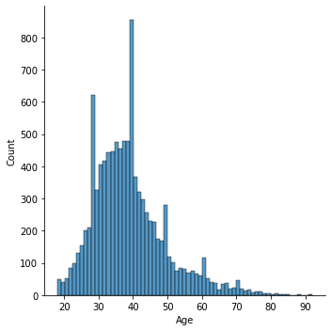

In[11]:

Out[11]:

In[12]:

Out[12]:

In[13]:

data**.**skew(axis**=**1,skipna**=True**)

sns**.**countplot(data['Age'])

<AxesSubplot:xlabel='Age',ylabel='count'>

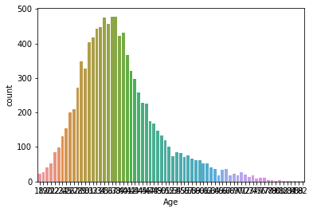

data**.**skew(axis**=**0,skipna**=True**)

RowNumber 0.000000

|  |  |
| --- | --- |
| CustomerId | 0.001149 |
| CreditScore | -0.071607 |
| Age | 1.011320 |
| Tenure | 0.010991 |
| Balance | -0.141109 |
| NumOfProducts | 0.745568 |
| HasCrCard | -0.901812 |
| IsActiveMember | -0.060437 |
| EstimatedSalary | 0.002085 |
| Exited  dtype:float64 | 1.471611 |

Out[13]:

|  |  |
| --- | --- |
| 0 | 3.316373 |
| 1 | 3.316193 |
| 2 | 3.315777 |
| 3 | 3.316411 |
| 4 | 3.316145  ... |
| 9995 | 3.316399 |
| 9996 | 3.316325 |
| 9997 | 3.316581 |
| 9998 | 3.316321 |
| 9999 | 3.316207 |
| Length: | 10000,dtype:float64 |

In[14]:

Out[14]:

In[15]:

Out[15]:

In[16]:

Out[16]:

|  |  |  |
| --- | --- | --- |
| 1 | False |  |
| 2 | False |  |
| 3 | False |  |
| 4 | False  ... |  |
| 9995 | False |  |
| 9996 | False |  |
| 9997 | False |  |
| 9998 | False |  |
| 9999  Length: | False  10000,dtype: | bool |

data**.**isnull()**.**any()

RowNumber False

CustomerId False

Surname False

CreditScore False

Geography False

Gender False

Age False

Tenure False

Balance False

NumOfProducts False

HasCrCard False

IsActiveMemberFalseEstimatedSalaryFalseExited False

dtype:bool

data**.**isnull()**.**sum()

RowNumber 0

CustomerId 0

Surname 0

CreditScore 0

Geography 0

Gender 0

Age 0

Tenure 0

Balance 0

NumOfProducts 0

HasCrCard 0

IsActiveMember 0

EstimatedSalary 0

Exited 0

dtype:int64

data**.**duplicated()

0 False

|  |  |  |
| --- | --- | --- |
| In[17]: | data**.**duplicated()**.**sum() | |
| Loading[MathJax | ]/extensions/Safe.js |  |

Out[17]:

In[18]:

Out[18]:

In[19]:

Out[19]:

In[20]:

Out[20]:

0

plt**.**scatter(data**.**Age,data**.**Balance)

<matplotlib.collections.PathCollectionat0x27cbe6bfbe0>

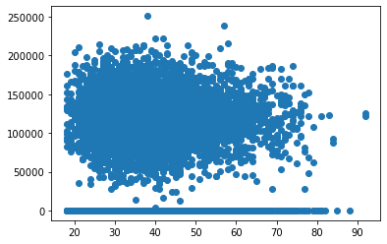

sns**.**scatterplot(x**=**data**.**Age,y**=**data**.**Balance)

<AxesSubplot:xlabel='Age',ylabel='Balance'>

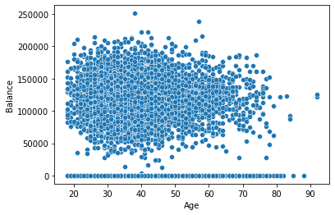

sns**.**displot(data['Age'])

<seaborn.axisgrid.FacetGridat0x27cbe6aedc0>



In[21]:

Out[21]:

In[22]:

data**.**corr()

sns**.**barplot(data['Age'])

<AxesSubplot:xlabel='Age'>

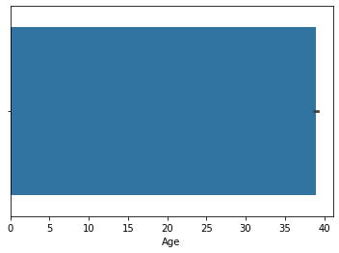

Out[22]:

**RowNumberCustomerIdCreditScore Age Tenure BalanceNumOfProductsHasCRowNumber** 1.000000 0.004202 0.005840 0.000783 -0.006495 -0.009067 0.007246 0.00

**CreditScore** 0.005840 0.005308 1.000000 -0.003965 0.000842 0.006268 0.012238 -0.00

**Age** 0.000783 0.009497 -0.003965 1.000000 -0.009997 0.028308 -0.030680 -0.01

**CustomerId** 0.004202 1.000000 0.005308 0.009497 -0.014883 -0.012419 0.016972 -0.01

**Tenure** -0.006495 -0.014883 0.000842 -0.009997 1.000000 -0.012254 0.013444 0.02

**Balance** -0.009067 -0.012419 0.006268 0.028308 -0.012254 1.000000 -0.304180 -0.01

**NumOfProducts** 0.007246 0.016972 0.012238 -0.030680 0.013444 -0.304180 1.000000 0.00

**HasCrCard** 0.000599 -0.014025 -0.005458 -0.011721 0.022583 -0.014858 0.003183 1.00

**IsActiveMember** 0.012044 0.001665 0.025651 0.085472 -0.028362 -0.010084 0.009612 -0.01

**EstimatedSalary** -0.005988 0.015271 -0.001384 -0.007201 0.007784 0.012797 0.014204 -0.00

**Exited** -0.016571 -0.006248 -0.027094 0.285323 -0.014001 0.118533 -0.047820 -0.00

In[23]:

Out[23]:

In[26]:

Out[26]:

sns**.**heatmap(data**.**corr(),annot**=True**)

<AxesSubplot:>

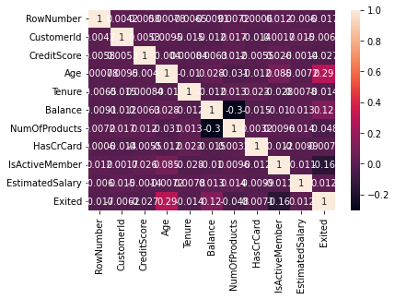

sns**.**pairplot(data)

<seaborn.axisgrid.PairGridat0x27ccdefd850>

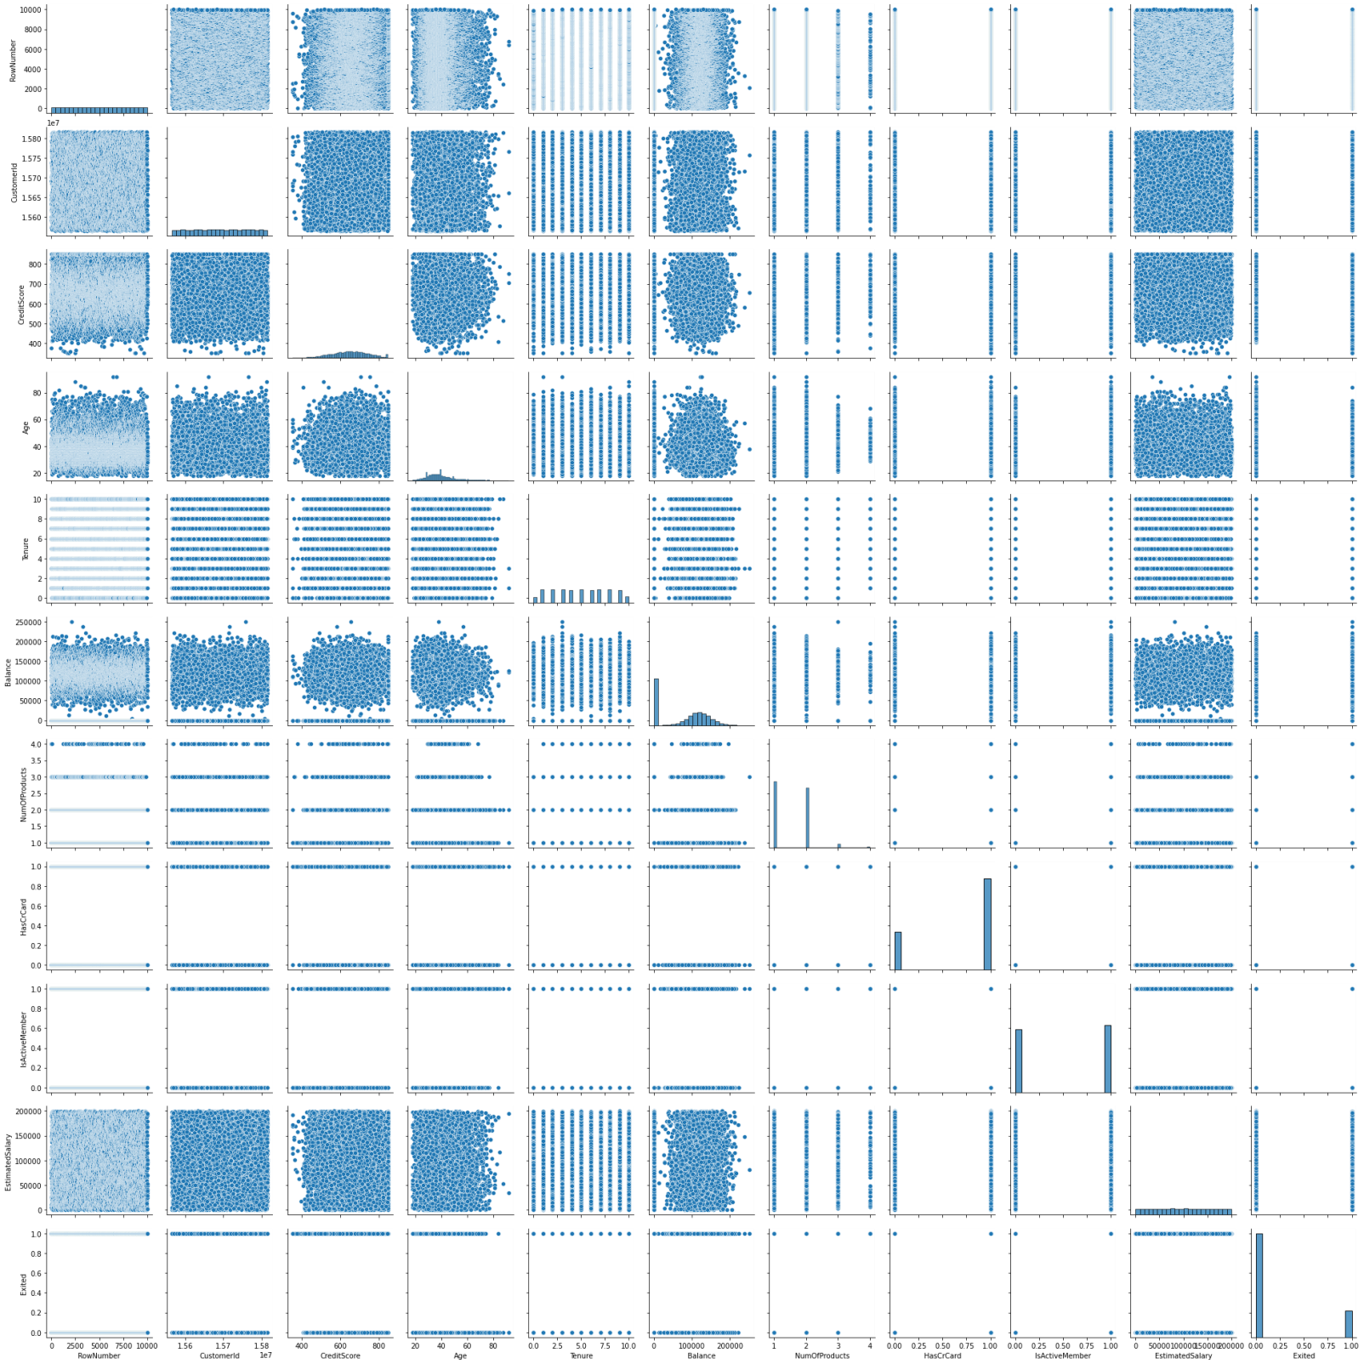

In[27]:

x**=**data**.**iloc[:,:**-**1]**.**valuesx

Out[27]:

In[28]:

[9998,15584532,'Liu',...,0,1,42085.58],

|  |  |  |
| --- | --- | --- |
| array([[1, | 15634602, | 'Hargrave',...,1,1,101348.88], |
| [2, | 15647311, | 'Hill',...,0,1,112542.58], |
| [3,  ..., | 15619304, | 'Onio',...,1,0,113931.57], |

[9999,15682355,'Sabbatini',...,1,0,92888.52],

[10000,15628319,'Walker',...,1,0,38190.78]],dtype=object)

y**=**data**.**iloc[:,4]**.**valuesy

Out[28]:

In[29]:

data**.**head(10)

array(['France','Spain','France',...,'France','Germany','France'],dtype=object)

|  |  |  |  |  |  |  |  |  |  |  |
| --- | --- | --- | --- | --- | --- | --- | --- | --- | --- | --- |
| Out[29]: | **RowNumber** | **CustomerId** | **Surname** | **CreditScore** | **Geography** | **Gender** | **Age** | **Tenure** | **Balance** | **NumOfProdu** |
|  | **0** 1 | 15634602 | Hargrave | 619 | France | Female | 42 | 2 | 0.00 |  |
|  | **1** 2 | 15647311 | Hill | 608 | Spain | Female | 41 | 1 | 83807.86 |  |
|  | **2** 3 | 15619304 | Onio | 502 | France | Female | 42 | 8 | 159660.80 |  |
|  | **3** 4 | 15701354 | Boni | 699 | France | Female | 39 | 1 | 0.00 |  |
|  | **4** 5 | 15737888 | Mitchell | 850 | Spain | Female | 43 | 2 | 125510.82 |  |
|  | **5** 6 | 15574012 | Chu | 645 | Spain | Male | 44 | 8 | 113755.78 |  |
|  | **6** 7 | 15592531 | Bartlett | 822 | France | Male | 50 | 7 | 0.00 |  |
|  | **7** 8 | 15656148 | Obinna | 376 | Germany | Female | 29 | 4 | 115046.74 |  |
|  | **8** 9 | 15792365 | He | 501 | France | Male | 44 | 4 | 142051.07 |  |
|  | **9** 10 | 15592389 | H? | 684 | France | Male | 27 | 2 | 134603.88 |  |

In[30]:

Out[30]:

In[32]:

x**=**data[["EstimatedSalary"]]y**=**data['CreditScore']model**=**sm**.**OLS(y,x)result**=**model**.**fit()result**.**summary()

sns**.**heatmap(data**.**corr(),annot**=True**)

<AxesSubplot:>



Out[32]:

In[33]:

Out[33]:

In[35]:

sns**.**barplot(x**=**"Age",y**=**"CreditScore",data**=**data)

OLS Regression Results

|  |  |  |
| --- | --- | --- |
| **Dep.Variable:** | CreditScore **R-squared (uncentered):** | 0.735 |
| **Model:** | OLS**Adj. R-squared (uncentered):** | 0.735 |
| **Method:** | Least Squares **F-statistic:** | 2.779e+04 |
| **Date:** | Mon, 26 Sep 2022 **Prob (F-statistic):** | 0.00 |
| **Time:** | 21:21:24 **Log-Likelihood:** | -72429. |
| **No. Observations:** | 10000 **AIC:** | 1.449e+05 |
| **Df Residuals:** | 9999 **BIC:** | 1.449e+05 |
| **Df Model:** | 1 |  |
| **CovarianceType:** | nonrobust  **coef std err t P>|t|[0.025 0.975]** |  |
| **EstimatedSalary** | 0.0049 2.93e-05 166.705 0.000 0.005 0.005 |  |

|  |  |  |  |
| --- | --- | --- | --- |
| **Omnibus:** | 1758.359 | **Durbin-Watson:** | 1.554 |
| **Prob(Omnibus):** | 0.000 | **Jarque-Bera (JB):** | 376.161 |
| **Skew:** | 0.004 | **Prob(JB):** | 2.08e-82 |
| **Kurtosis:** | 2.050 | **Cond. No.** | 1.00 |

# Notes:

1. R² is computed without centering (uncentered) since the model does not contain a constant.

# Standard Errors assume that the covariance matrix of the errors is correctly specified.

sns**.**lmplot(data**=**data,x**=**"Age",y**=**"CreditScore")

<seaborn.axisgrid.FacetGridat0x27cd6f87a00>

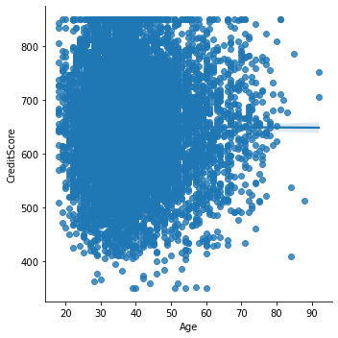

Out[35]:

In[36]:

qnt**=**data**.**quantile(q**=**(0.25,0.75))qnt

<AxesSubplot:xlabel='Age',ylabel='CreditScore'>

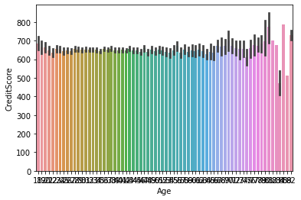

Out[36]:

**0.75** 7500.25 15753233.75 718.0 44.0 7.0 127644.24 2.0 1.0

In[37]:

iqr**=**qnt**.**loc[0.25]**-**qnt**.**loc[0.75]iqr

**RowNumber CustomerIdCreditScoreAge Tenure BalanceNumOfProductsHasCrCardIsActiveMe0.25** 2500.75 15628528.25 584.0 32.0 3.0 0.00 1.0 0.0

Out[37]:

In[39]:

data['Age']**=**np**.**where(data['Age']**>**87,40,data['Age'])data['Balance']**=**np**.**where(data['Balance']**>**618,316,data['Balance'])sns**.**boxplot(data['Balance'])

RowNumber -4999.5000

|  |  |
| --- | --- |
| CustomerId | -124705.5000 |
| CreditScore | -134.0000 |
| Age | -12.0000 |
| Tenure | -4.0000 |
| Balance | -127644.2400 |
| NumOfProducts | -1.0000 |
| HasCrCard | -1.0000 |
| IsActiveMember | -1.0000 |
| EstimatedSalary | -98386.1375 |
| Exited | 0.0000 |
| dtype:float64 |  |

Out[39]:

<AxesSubplot:xlabel='Balance'>

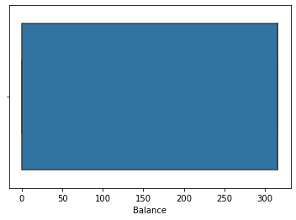

In[40]:

data**.**head(2)

Out[40]:

In[41]:

data['Gender']**.**replace({'Female':0,'Male':1},inplace**=True**)data**.**head(10)

**RowNumberCustomerIdSurname CreditScoreGeography Gender Age Tenure Balance NumOfProduct**

**0** 1 15634602 Hargrave 619 France Female 42 2 0.0

**1** 2 15647311 Hill 608 Spain Female 41 1 316.0

|  |  |  |  |  |  |  |  |  |  |  |
| --- | --- | --- | --- | --- | --- | --- | --- | --- | --- | --- |
| Out[41]: | **RowNumber** | **CustomerId** | **Surname** | **CreditScore** | **Geography** | **Gender** | **Age** | **Tenure** | **Balance** | **NumOfProduct** |
|  | **0** 1 | 15634602 | Hargrave | 619 | France | 0 | 42 | 2 | 0.0 |  |
|  | **1** 2 | 15647311 | Hill | 608 | Spain | 0 | 41 | 1 | 316.0 |  |
|  | **2** 3 | 15619304 | Onio | 502 | France | 0 | 42 | 8 | 316.0 |  |
|  | **3** 4 | 15701354 | Boni | 699 | France | 0 | 39 | 1 | 0.0 |  |
|  | **4** 5 | 15737888 | Mitchell | 850 | Spain | 0 | 43 | 2 | 316.0 |  |
|  | **5** 6 | 15574012 | Chu | 645 | Spain | 1 | 44 | 8 | 316.0 |  |
|  | **6** 7 | 15592531 | Bartlett | 822 | France | 1 | 50 | 7 | 0.0 |  |
|  | **7** 8 | 15656148 | Obinna | 376 | Germany | 0 | 29 | 4 | 316.0 |  |
|  | **8** 9 | 15792365 | He | 501 | France | 1 | 44 | 4 | 316.0 |  |
|  | **9** 10 | 15592389 | H? | 684 | France | 1 | 27 | 2 | 316.0 |  |

In[42]:

data['HasCrCard']**.**replace({1:'YES',0:'NO'},inplace**=True**)data**.**head(10)

|  |  |  |  |  |  |  |  |  |  |  |
| --- | --- | --- | --- | --- | --- | --- | --- | --- | --- | --- |
| Out[42]: | **RowNumber** | **CustomerId** | **Surname** | **CreditScore** | **Geography** | **Gender** | **Age** | **Tenure** | **Balance** | **NumOfProduct** |
|  | **0** 1 | 15634602 | Hargrave | 619 | France | 0 | 42 | 2 | 0.0 |  |
|  | **1** 2 | 15647311 | Hill | 608 | Spain | 0 | 41 | 1 | 316.0 |  |
|  | **2** 3 | 15619304 | Onio | 502 | France | 0 | 42 | 8 | 316.0 |  |
|  | **3** 4 | 15701354 | Boni | 699 | France | 0 | 39 | 1 | 0.0 |  |
|  | **4** 5 | 15737888 | Mitchell | 850 | Spain | 0 | 43 | 2 | 316.0 |  |
|  | **5** 6 | 15574012 | Chu | 645 | Spain | 1 | 44 | 8 | 316.0 |  |
|  | **6** 7 | 15592531 | Bartlett | 822 | France | 1 | 50 | 7 | 0.0 |  |
|  | **7** 8 | 15656148 | Obinna | 376 | Germany | 0 | 29 | 4 | 316.0 |  |
|  | **8** 9 | 15792365 | He | 501 | France | 1 | 44 | 4 | 316.0 |  |
|  | **9** 10 | 15592389 | H? | 684 | France | 1 | 27 | 2 | 316.0 |  |

In[45]:data**.**Age**.**uni

|  |  |  |
| --- | --- | --- |
| Loading[MathJax | /extensions/Safe.jsqu | e() |

In[43]:

**from**sklearn.preprocessing**import**OneHotEncoderoe_style**=**OneHotEncoder()oe_results**=**oe_style**.**fit_transform(data[['Age']])pd**.**DataFrame(oe_results**.**toarray(),columns**=**oe_style**.**categories_)**.**head()

|  |  |  |  |  |  |  |  |  |  |  |  |  |  |  |  |  |  |  |  |  |
| --- | --- | --- | --- | --- | --- | --- | --- | --- | --- | --- | --- | --- | --- | --- | --- | --- | --- | --- | --- | --- |
| Out[43]: |  | **18** | **19** | **20** | **21** | **22** | **23** | **24** | **25** | **26** | **27 ... 76** | **77** | **78** | **79** | **80** | **81** | **82** | **83** | **84** | **85** |
|  | **0** | 0.0 | 0.0 | 0.0 | 0.0 | 0.0 | 0.0 | 0.0 | 0.0 | 0.0 | 0.0... 0.0 | 0.0 | 0.0 | 0.0 | 0.0 | 0.0 | 0.0 | 0.0 | 0.0 | 0.0 |
|  | **1** | 0.0 | 0.0 | 0.0 | 0.0 | 0.0 | 0.0 | 0.0 | 0.0 | 0.0 | 0.0... 0.0 | 0.0 | 0.0 | 0.0 | 0.0 | 0.0 | 0.0 | 0.0 | 0.0 | 0.0 |
|  | **2** | 0.0 | 0.0 | 0.0 | 0.0 | 0.0 | 0.0 | 0.0 | 0.0 | 0.0 | 0.0... 0.0 | 0.0 | 0.0 | 0.0 | 0.0 | 0.0 | 0.0 | 0.0 | 0.0 | 0.0 |
|  | **3** | 0.0 | 0.0 | 0.0 | 0.0 | 0.0 | 0.0 | 0.0 | 0.0 | 0.0 | 0.0... 0.0 | 0.0 | 0.0 | 0.0 | 0.0 | 0.0 | 0.0 | 0.0 | 0.0 | 0.0 |
|  | **4** | 0.0 | 0.0 | 0.0 | 0.0 | 0.0 | 0.0 | 0.0 | 0.0 | 0.0 | 0.0... 0.0 | 0.0 | 0.0 | 0.0 | 0.0 | 0.0 | 0.0 | 0.0 | 0.0 | 0.0 |

# 5 rows × 68 columns

In[44]:

y**=**data['Age']

**from**sklearn.preprocessing**import**LabelEncoderle**=**LabelEncoder()data['Age']**=**le**.**fit_transform(data['Age'])data**.**head(10)

|  |  |  |  |  |  |  |  |  |  |  |  |
| --- | --- | --- | --- | --- | --- | --- | --- | --- | --- | --- | --- |
| Out[44]: |  | **RowNumber** | **CustomerId** | **Surname** | **CreditScore** | **Geography** | **Gender** | **Age** | **Tenure** | **Balance** | **NumOfProduct** |
|  |  | **0** 1 | 15634602 | Hargrave | 619 | France | 0 | 24 | 2 | 0.0 |  |
|  |  | **1** 2 | 15647311 | Hill | 608 | Spain | 0 | 23 | 1 | 316.0 |  |
|  |  | **2** 3 | 15619304 | Onio | 502 | France | 0 | 24 | 8 | 316.0 |  |
|  |  | **3** 4 | 15701354 | Boni | 699 | France | 0 | 21 | 1 | 0.0 |  |
|  |  | **4** 5 | 15737888 | Mitchell | 850 | Spain | 0 | 25 | 2 | 316.0 |  |
|  |  | **5** 6 | 15574012 | Chu | 645 | Spain | 1 | 26 | 8 | 316.0 |  |
|  |  | **6** 7 | 15592531 | Bartlett | 822 | France | 1 | 32 | 7 | 0.0 |  |
|  |  | **7** 8 | 15656148 | Obinna | 376 | Germany | 0 | 11 | 4 | 316.0 |  |
|  |  | **8** 9 | 15792365 | He | 501 | France | 1 | 26 | 4 | 316.0 |  |
|  |  | **9** 10 | 15592389 | H? | 684 | France | 1 | 9 | 2 | 316.0 |  |
|  |  |  |  |  |  |  |  |  |  |  |  |
|  |  | ] |  |  |  |  |  |  |  |  |  |

Out[45]:

In[46]:

dtype=int64)

x**=**data**.**iloc[:,0:13]**.**valuesx

|  |  |  |  |  |  |  |  |  |  |  |  |  |  |  |  |  |
| --- | --- | --- | --- | --- | --- | --- | --- | --- | --- | --- | --- | --- | --- | --- | --- | --- |
| array([24, | 23, | 21, | 25, | 26, | 32, | 11, | 9, | 13, | 6, | 16, | 7, | 17, | 27, | 40, | 14, | 20, |
| 28, | 18, | 15, | 22, | 33, | 43, | 31, | 19, | 1, | 48, | 38, | 8, | 3, | 37, | 57, | 4, | 12, |
| 10, | 47, | 30, | 34, | 39, | 55, | 29, | 36, | 54, | 2, | 49, | 61, | 44, | 35, | 62, | 41, | 50, |
| 5, | 42, | 52, | 45, | 46, | 0, | 64, | 51, | 56, | 53, | 58, | 59, | 67, | 66, | 60, | 63, | 65], |

Out[46]:

In[47]:

[9998,15584532,'Liu',...,'NO',1,42085.58],

|  |  |  |
| --- | --- | --- |
| array([[1, | 15634602, | 'Hargrave',...,'YES',1,101348.88], |
| [2, | 15647311, | 'Hill',...,'NO',1,112542.58], |
| [3,  ..., | 15619304, | 'Onio',...,'YES',0,113931.57], |

[9999,15682355,'Sabbatini',...,'YES',0,92888.52],

[10000,15628319,'Walker',...,'YES',0,38190.78]],dtype=object)

y**=**data**.**iloc[:,13:14]**.**valuesy

Out[47]:

In[48]:

array([[1],

[0],

[1],

...,

[1],

[1],

[0]],dtype=int64)

**from**sklearn.preprocessing**import**OneHotEncoderohe**=**OneHotEncoder()z**=**ohe**.**fit_transform(x[:,0:14])**.**toarray()

z

Out[48]:

|  |  |  |  |  |  |  |
| --- | --- | --- | --- | --- | --- | --- |
| array([[1., | 0., | 0., | ..., | 0., | 0., | 0.], |
| [0., | 1., | 0., | ..., | 0., | 0., | 0.], |
| [0., | 0., | 1., | ..., | 0., | 0., | 0.], |
| ...,  [0., | 0., | 0., | ..., | 0., | 0., | 0.], |
| [0., | 0., | 0., | ..., | 0., | 0., | 0.], |
| [0., | 0., | 0., | ..., | 0., | 0., | 0.]]) |

In[]:

*###split*

In[49]:

**from** sklearn.model_selection**import** train_test_splitx_train,x_test,y_train,y_test**=**train_test_split(x,y,test_size**=**0.2,random_state**=**0)x_train**.**shape,x_test**.**shape,y_train**.**shape,y_test**.**shape

Out[49]:

In[50]:

Out[50]:

In[51]:

((8000,13),(2000,13),(8000,1),(2000,1))

x_train

array([[7390,15676909,'Mishin',...,'YES',0,163830.64],

|  |  |  |
| --- | --- | --- |
| [9276, | 15749265, | 'Carslaw',...,'YES',1,57098.0], |
| [2996,  ..., | 15582492, | 'Moore',...,'YES',0,185630.76], |
| [3265, | 15574372, | 'Hoolan',...,'YES',0,181429.87], |
| [9846, | 15664035, | 'Parsons',...,'YES',1,148750.16], |
| [2733, | 15592816, | 'Udokamma',...,'YES',0,118855.26]], |

dtype=object)

x_test

Loading[MathJax]/extensions/Safe.js

Out[51]:

In[52]:

Out[52]:

In[53]:

Out[53]:

In[55]:

array([[9395,15615753,'Upchurch',...,'YES',1,192852.67],

[899,15654700,'Fallaci',...,'YES',0,128702.1],

[2399,15633877,'Morrison',...,'YES',1,75732.25],

...,

[9550,15772604,'Chiemezie',...,'YES',0,141533.19],

[2741,15787699,'Burke',...,'YES',1,11276.48],

[6691,15579223,'Niu',...,'YES',0,192950.6]],dtype=object)

y_train

array([[0],

[0],

[0],

...,

[0],

[0],

[1]],dtype=int64)

y_test

array([[0],

[1],

[0],

...,

[0],

[0],

[0]],dtype=int64)

**from**sklearn.preprocessing**import**scalex**=**data['Balance']

S**=**scale(x)S

Out[55]:

In[]:

array([-1.32842845,0.75276918,0.75276918,...,-1.32842845,

0.75276918,0.75276918])

*###independentvariables*

In[56]:

w**=**data**.**drop(data['Age'],axis**=**0)w

|  |  |  |  |  |  |  |  |  |  |  |  |
| --- | --- | --- | --- | --- | --- | --- | --- | --- | --- | --- | --- |
| Out[56]: |  | **RowNumber** | **CustomerId** | **Surname** | **CreditScore** | **Geography** | **Gender** | **Age** | **Tenure** | **Balance** | **NumOfPr** |
|  | **68** | 69 | 15638424 | Glauert | 661 | Germany | 0 | 17 | 5 | 316.0 |  |
|  | **69** | 70 | 15755648 | Pisano | 675 | France | 0 | 3 | 8 | 316.0 |  |
|  | **70** | 71 | 15703793 | Konovalova | 738 | Germany | 1 | 40 | 2 | 316.0 |  |
|  | **71** | 72 | 15620344 | McKee | 813 | France | 1 | 11 | 6 | 0.0 |  |
|  | **72** | 73 | 15812518 | Palermo | 657 | Spain | 0 | 19 | 0 | 316.0 |  |
|  | **...** | ... | ... | ... | ... | ... | ... | ... | ... | ... |  |
|  | **9995** | 9996 | 15606229 | Obijiaku | 771 | France | 1 | 21 | 5 | 0.0 |  |
|  | **9996** | 9997 | 15569892 | Johnstone | 516 | France | 1 | 17 | 10 | 316.0 |  |
|  | **9997** | 9998 | 15584532 | Liu | 709 | France | 0 | 18 | 7 | 0.0 |  |
|  | **9998** | 9999 | 15682355 | Sabbatini | 772 | Germany | 1 | 24 | 3 | 316.0 |  |
|  | **9999** | 10000 | 15628319 | Walker | 792 | France | 0 | 10 | 4 | 316.0 |  |

# 9932 rows × 14 columns

]

In[57]:y**=**data**.**iloc[

|  |  |  |
| --- | --- | --- |
|  |  | ,**-**1]**.**values |
| Loading[MathJax | /extensions/Safe.js: |

y

Out[57]:

In[]:

array([1,0,1,...,1,1,0],dtype=int64)

Loading[MathJax]/extensions/Safe.js