**Assignment -1**

Applied Data Science

|  |  |
| --- | --- |
| Assignment Date | 19 September 2022 |
| Student Name | Ms. Subavarshini |
| Student Roll Number | 721719104081 |
| Maximum Marks | 2 Marks |

**1.Split the string.**

**2. Use .format() to print the following string.**

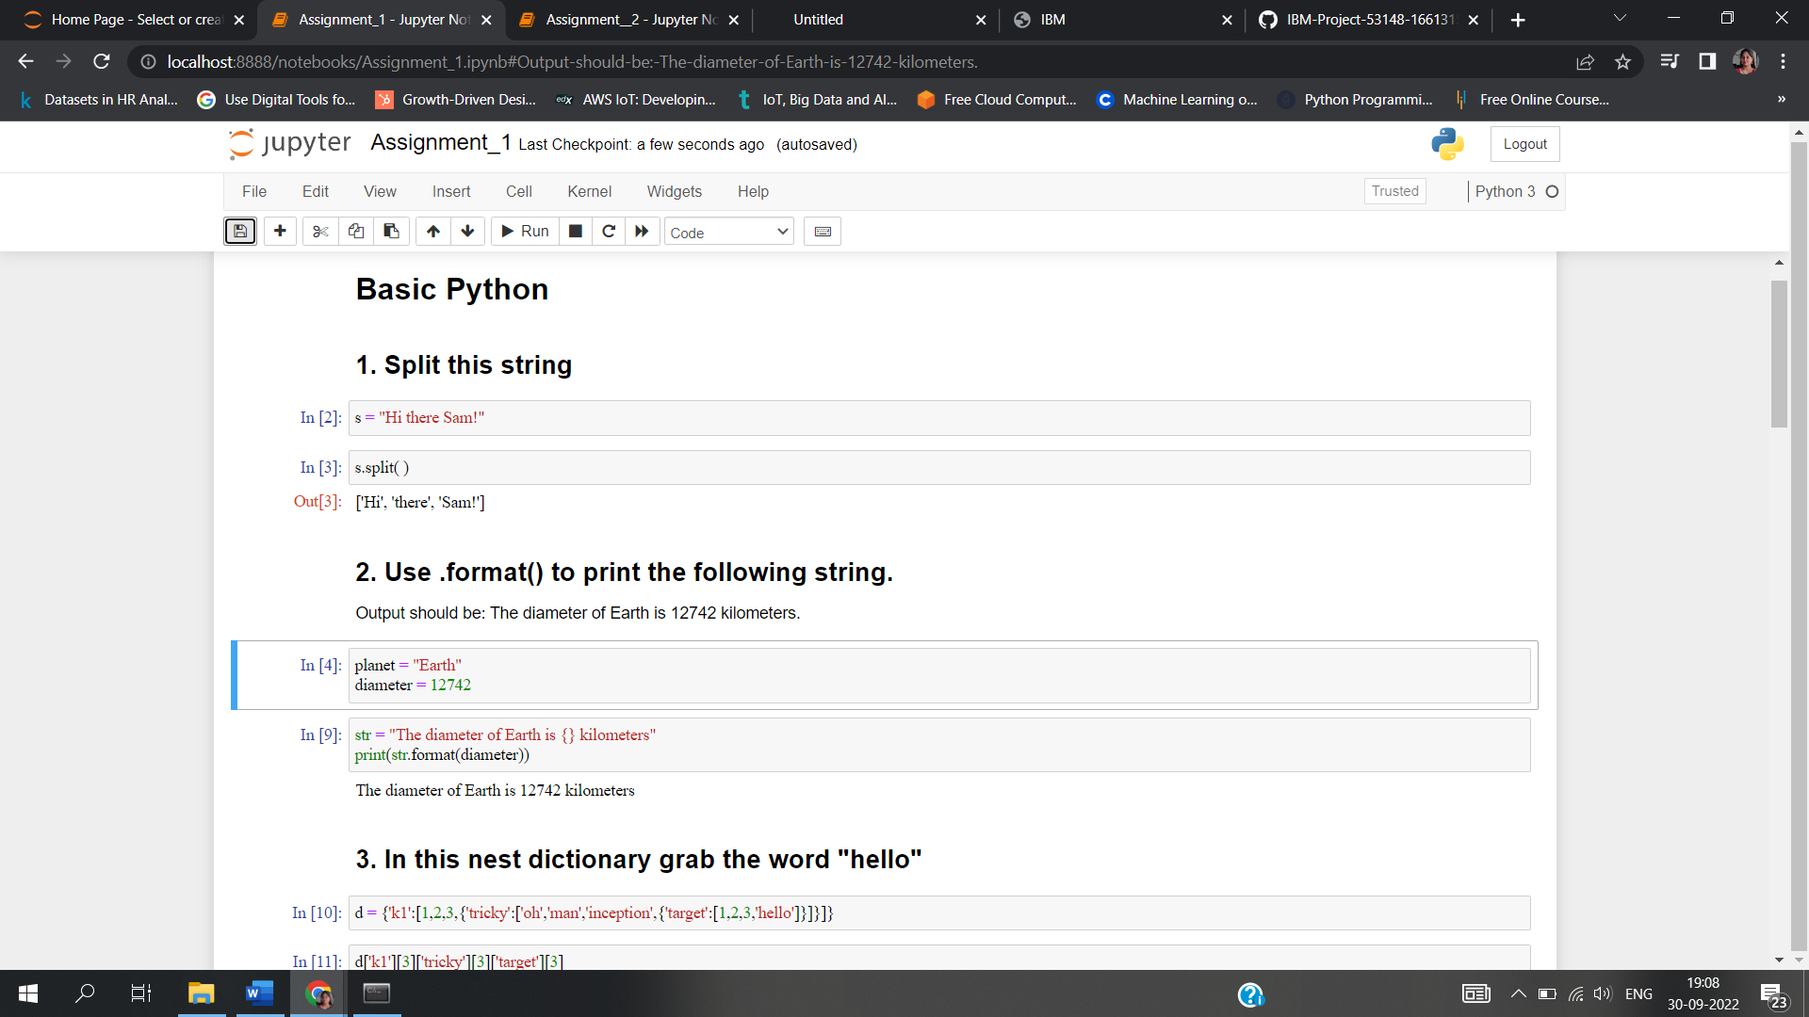

**3. In this nest dictionary grab the world “hello”.**

**4.1 Create an array of 10 zeroes.**

**4.2 Create an array of 10 fives.**

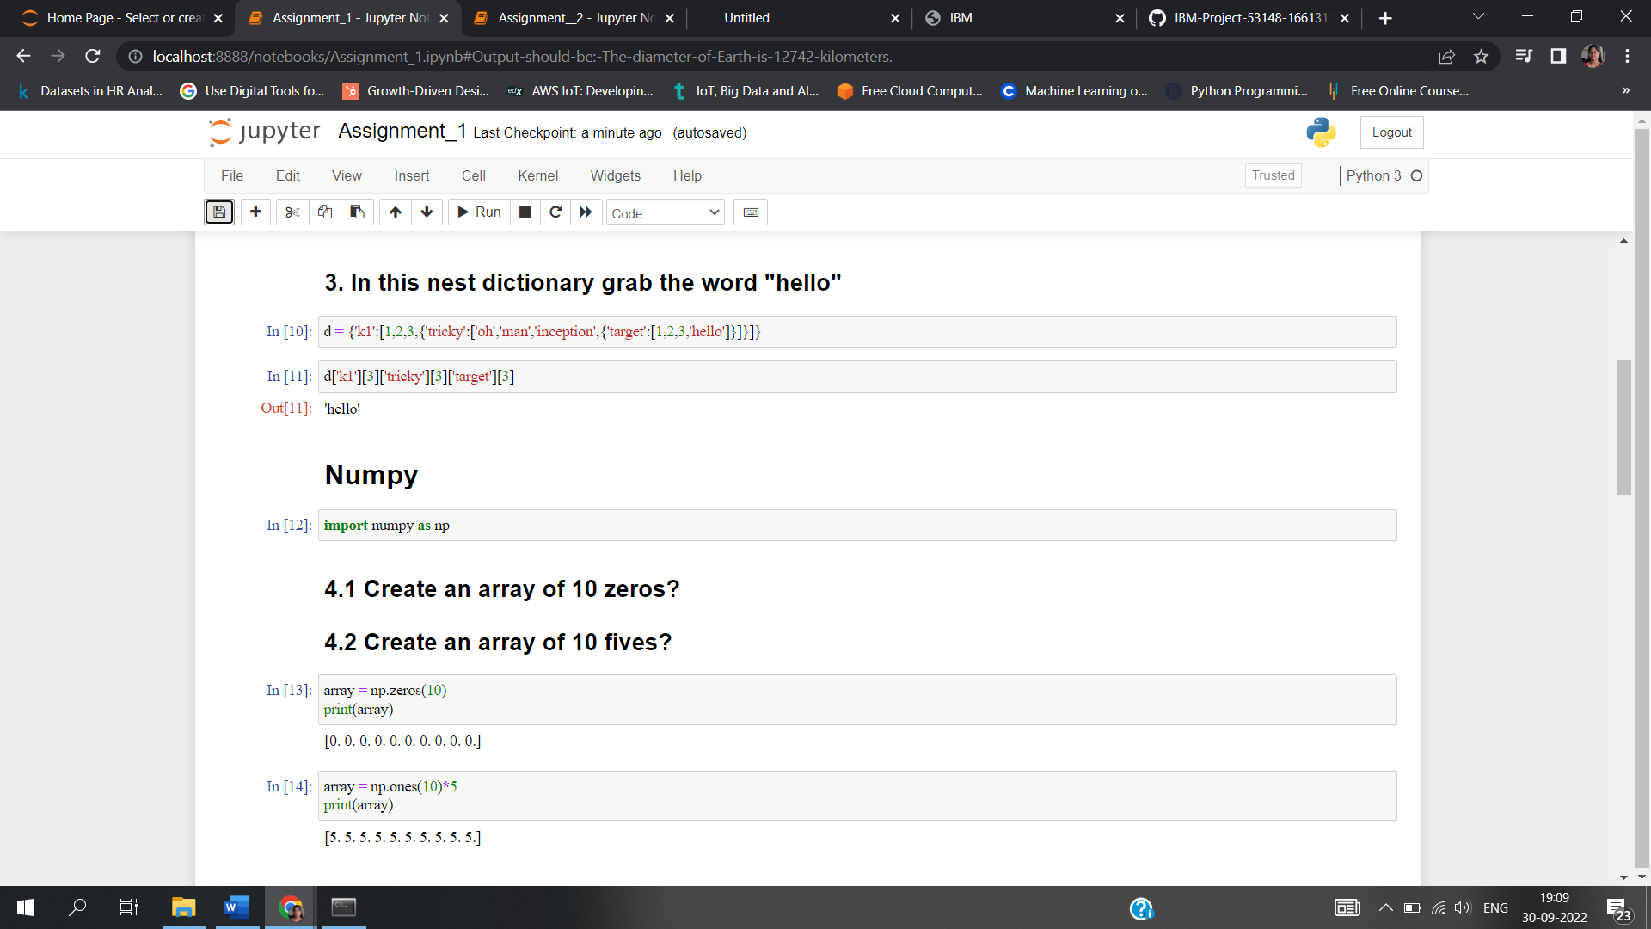

**5. Create an array of all the even integers from 20 to 35.**

## 6. Create a 3x3 matrix with values ranging from 0 to 8.

## 7. Concatinate a and b[¶](http://localhost:8888/notebooks/Assignment_1.ipynb#7.-Concatinate-a-and-b)

## a = np.array([1, 2, 3]), b = np.array([4, 5, 6])

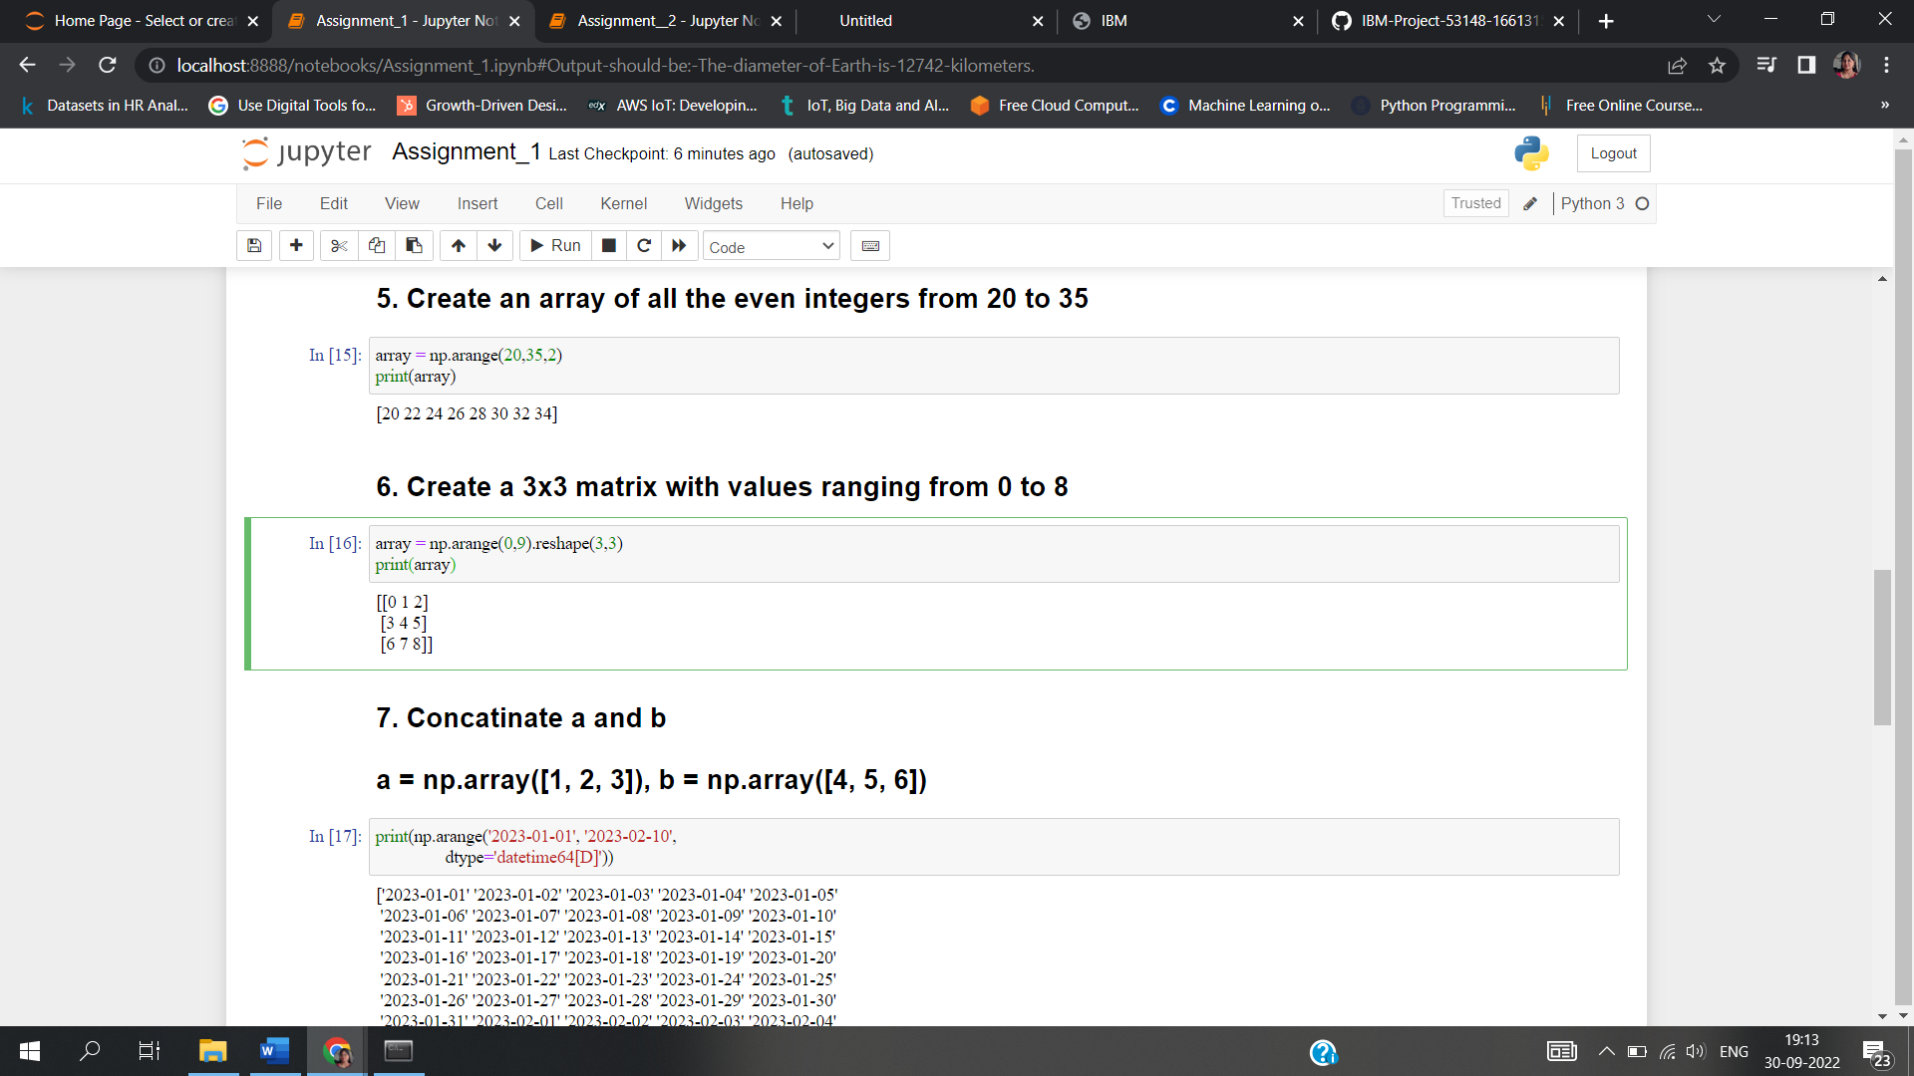

# Pandas

## 8. Create a dataframe with 3 rows and 2 columns

## 9. Generate the series of dates from 1st Jan, 2023 to 10th Feb, 2023.

## 10. Create 2D list to DataFrame

