**Project tittle:-PERSONAL EXPENSE TRACKER APPLICATION**

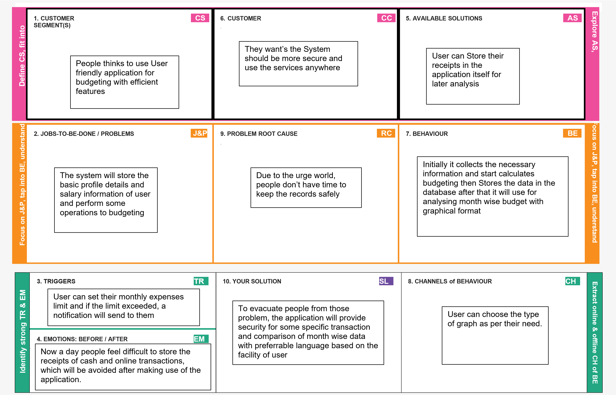 **Team id:-PNT2022TMID48024**