ASSIGMENT LINK

<https://us1.ca.analytics.ibm.com/bi/?perspective=explore&pathRef=.my_folders%2Fassignment%2B1&subView=model000001836405f42c_00000004>

R&D SPENDING

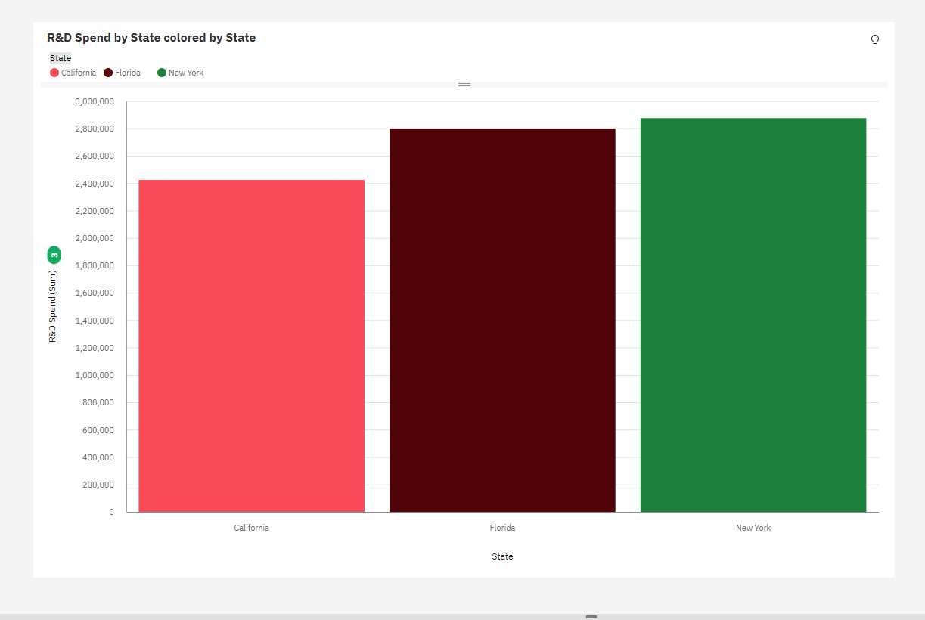

ADMINISTRATION SPENGING

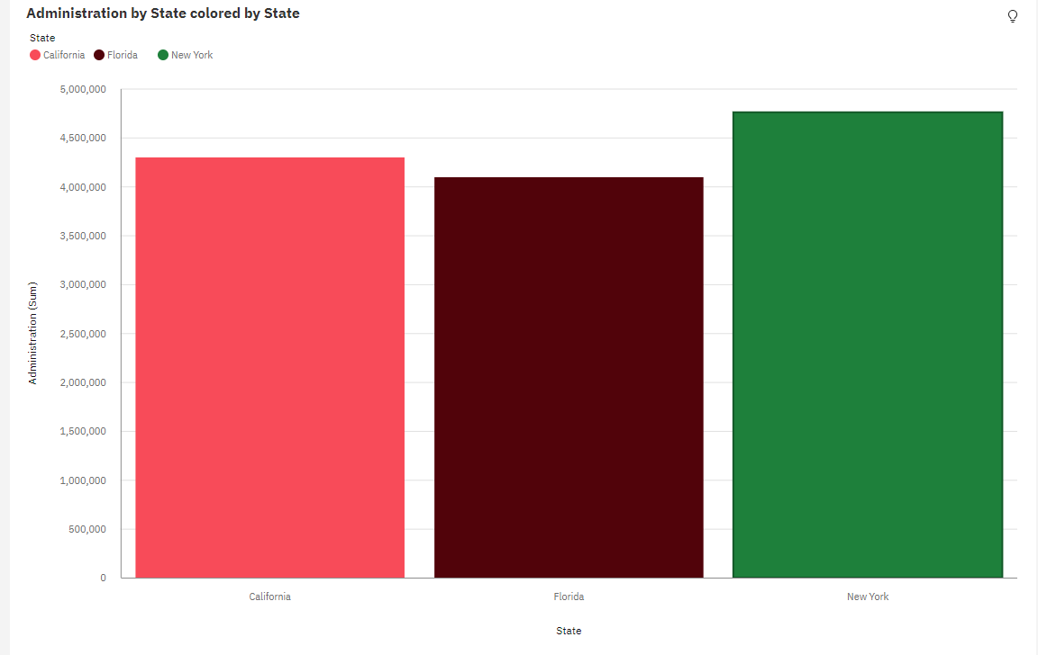

MARKETING SPENDING

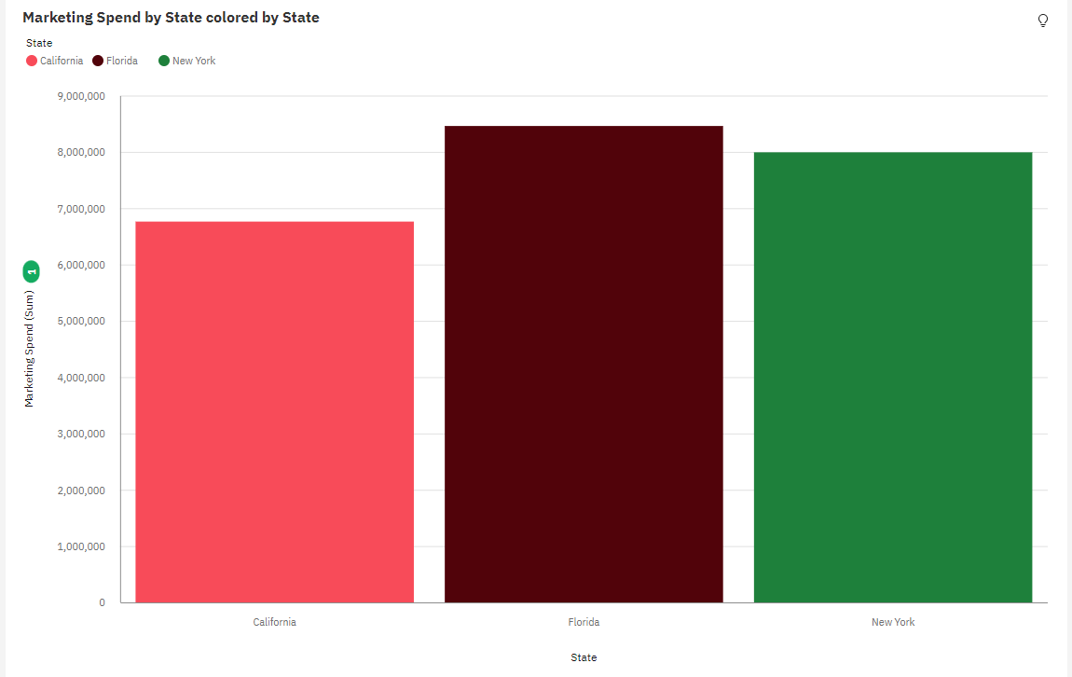

STATE

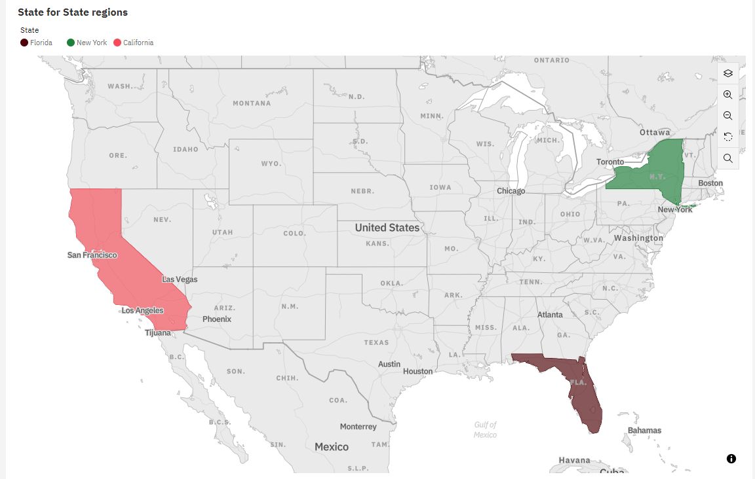

PROFIT

