## Before you collaborate

### A little bit of preparation goes a long way with this session. Here’s what you need to do to get going.

**10 minutes**

## 1

**Define your problem statement**

### What problem are you trying to solve? Frame your problem as a How Might We statement. This will be the focus of your brainstorm.

**5 minutes**

## 2

**Brainstorm**

### Write down any ideas that come to mind that address your problem statement.

**10 minutes**

**3**

## Group ideas

### Take turns sharing your ideas while clustering similar or related notes as you go. In the last 10 minutes, give each cluster a sentence-like label. If a cluster is bigger than six sticky notes, try and see if you and break it up into smaller sub-groups.

**TIP**

You can select a sticky note and hit the pencil [switch to sketch] icon to start drawing!

**20 minutes**

## 4

**Prioritize**

### Your team should all be on the same page about what's important moving forward. Place your ideas on this grid to determine which ideas are important and which are feasible.

**20 minutes**

## After you collaborate

You can export the mural as an image or pdf to share with members of your company who might find it helpful.

Brainstorm

& idea prioritization

#### Team gathering

Ringing alarm in mobile when forest fires are detected

**Aravinth**

Attaching GPS trackers to each camera to find fire location

**Suresh**

#### Rajkumar

Mobile applications for alerting Sensor based fire detection Preparedness measures for controlling fire

A mobile application which would alarm forest authorities

Sending the data to forest department in which direction the fires are spreading.

C02 sensor can be depolyed at certain distance in forest to detect ignition

fire fighters should be anytime ready if there is forest fire

Make sure the system is accurate and available all time 24/7 to prevent loss of lives

## Quick add-ons

Pay close attention to weather and drought conditions, which can affect the flammability of vegetation

Keeping resources ready during vulnearble seasons and areas.

**PROBLEM**

**How might we implement a system to detect forest fires early and intimate the concerned authorities.**

Smoke and gas sensors to detect early fires

Use this template in your own brainstorming sessions so your team can unleash their imagination and start shaping concepts even if you're not sitting in the same room.

Ringing alarm in mobile when forest fires are detected

Define who should participate in the session and send an invite. Share relevant information or pre-work ahead.

1. **Set the goal**

Think about the problem you'll be focusing on solving in the brainstorming session.

#### Learn how to use the facilitation tools

Use the Facilitation Superpowers to run a happy and productive session.

# 

A mobile application which would alarm forest authorities

HD cameras to detect fires even during summers

Make sure that every vehicle in the forest has atleast a fire extinguisher to put out an early

fire

Make sure the system is accurate and available all time 24/7 to prevent loss of lives

C02 sensor can be depolyed at certain distance in forest to detect ignition

satellite based remote sensing technology is better in locating forest fires

Smoke and gas sensors to detect early fires

Pay close attention to weather and drought conditions, which can affect the flammability of vegetation

fire fighters should be anytime ready if there is forest fire

Data for future reference

Automatically open the valves of fire extinguisher when fire detected

**TIP**

Add customizable tags to sticky notes to make it easier to find, browse, organize, and categorize important ideas as themes within your mural.

# 

Information about the occurrence of fires is stored in the cloud for future prediction.

Creating a database to find frequency of occurrence of forest fires

Locating forest fires

Attaching GPS trackers to each camera to find fire location

Fire detection using cameras

# 

HD cameras to detect fires even during summers

thermal imaging can be utilized for detecting hot spot

Miscellaneous ideas

Automatically open the valves of fire extinguisher when fire detected

watch towers can deployed at certain distance from each other in forest to send alert

Make sure the system is accurate and available all time 24/7 to prevent loss of lives

thermal imaging can be utilized for detecting hot spot

watch towers can deployed at certain distance from each other in forest to send alert

Keeping resources ready during vulnearble seasons and areas.

The intensity and occurrence of fires at a place is directly sent to government for future reference

Creating a database to find frequency of occurrence of forest fires

Sending the data to forest department in which direction the fires are spreading.

Infrared and thermal cameras can be used to detect forest fires

A mobile application which would alarm forest authorities

Infrared and thermal cameras can be used to detect forest fires

Smoke and gas sensors to detect early fires

Make sure that every vehicle in the forest has atleast a fire extinguisher to put out an early

fire

Infrared and thermal cameras can be used to detect forest fires

Information about the occurrence of fires is stored in the cloud for future prediction.

Attaching GPS trackers to each camera to find fire location

1. **Share the mural**

**Share a view link** to the mural with stakeholders to keep them in the loop about the outcomes of the session.

#### Export the mural

Export a copy of the mural as a PNG or PDF to attach to emails, include in slides, or save in your drive.

**10 minutes** to prepare

**1 hour** to collaborate

**2-8 people** recommended

[**Open article**](https://support.mural.co/en/articles/2113740-facilitation-superpowers)

# 

The intensity and occurrence of fires at a place is directly sent to government for future reference

satellite based remote sensing technology is better in locating forest fires

## Key rules of brainstorming

To run an smooth and productive session

## Keep moving forward

#### Strategy blueprint

Define the components of a new idea or strategy.

#### [Open the template](https://app.mural.co/template/e95f612a-f72a-4772-bc48-545aaa04e0c9/984865a6-0a96-4472-a48d-47639307b3ca)

**Customer experience journey map**

Understand customer needs, motivations, and

Stay in topic. Defer judgment.

Make sure that every vehicle in the forest has atleast a fire extinguisher to put out an early

fire

Encourage wild ideas. Listen to others.

## Importance

##### If each of these tasks could get

satellite based remote sensing

Information about the occurrence of fires is stored in the cloud for future prediction.

Creating a database to find frequency of occurrence of forest fires

obstacles for an experience.

[**Open the template**](https://app.mural.co/template/b7114010-3a67-4d63-a51d-6f2cedc9633f/c1b465ab-57af-4624-8faf-ebb312edc0eb)

**Strengths, weaknesses, opportunities & threats**

Go for volume. If possible, be visual.

##### done without any

difficulty or cost, which would have the most positive impact?

technology is

better in locating forest fires

Identify strengths, weaknesses, opportunities, and threats (SWOT) to develop a plan.

#### [Open the template](https://app.mural.co/template/6a062671-89ee-4b76-9409-2603d8b098be/ca270343-1d54-4952-9d8c-fbc303ffd0f2)

watch towers can deployed at certain distance from each other in forest to send alert

[**Share template feedback**](https://muralco.typeform.com/to/CiqaHVat?typeform-source=app.mural.co)

Sending the data to forest department in which direction the fires are spreading.

Pay close attention to weather and drought conditions, which can affect the flammability of vegetation

Automatically open the valves of fire extinguisher when fire detected

[**Share template feedback**](https://muralco.typeform.com/to/CiqaHVat?typeform-source=app.mural.co)

## Feasibility

##### Regardless of their importance, which tasks are more feasible than others? (Cost, time, effort, complexity, etc.)

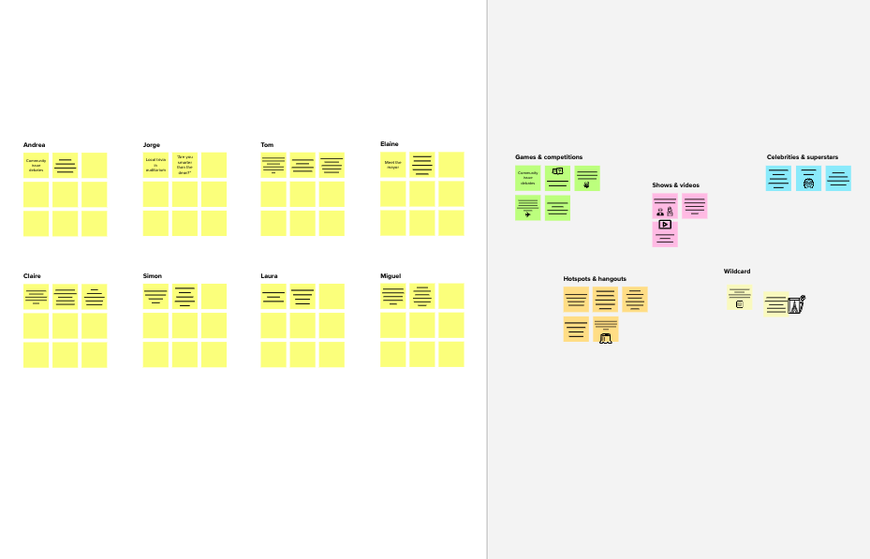

**Template**

**Need some inspiration?**

See a finished version of this template to kickstart your work.

[**Open example**](https://app.mural.co/template/e5a93b7b-49f2-48c9-afd7-a635d860eba6/93f1b98d-b2d2-4695-8e85-7e9c0d2fd9b9)