**Assignment -1**

Internet of Things (IoT)

**Question-1:**

Make smart home with atleast 2 sensors and led, buzzer. in tinkercad

ANSWER

CODE

#include <Servo.h>

int output1Value = 0; int sen1Value = 0; int sen2Value = 0; int const gas_sensor = A1; int const LDR = A0;

int limit = 400;

long readUltrasonicDistance(int triggerPin, int echoPin)

{

pinMode(triggerPin, OUTPUT); // Clear the trigger digitalWrite(triggerPin, LOW); delayMicroseconds(2);

// Sets the trigger pin to HIGH state for 10 microseconds digitalWrite(triggerPin, HIGH); delayMicroseconds(10); digitalWrite(triggerPin, LOW); pinMode(echoPin,

INPUT);

// Reads the echo pin, and returns the sound wave travel time in microseconds return pulseIn(echoPin, HIGH);

}

Servo servo_7;

void setup()

{

|  |  |
| --- | --- |
| Serial.begin(9600); | //initialize serial communication |
| pinMode(A0, INPUT); | //LDR |
| pinMode(A1,INPUT); | //gas sensor |
| pinMode(13, OUTPUT); | //connected to relay |

servo_7.attach(7, 500, 2500); //servo motor

|  |  |
| --- | --- |
| pinMode(8,OUTPUT); | //signal to piezo buzzer |
| pinMode(9, INPUT); | //signal to PIR |
| pinMode(10, OUTPUT); | //signal to npn as switch |
| pinMode(4, OUTPUT); | //Red LED |
| pinMode(3, OUTPUT); | //Green LED |

}

void loop()

{

//------light intensity control ----- //

//

int val1 = analogRead(LDR); if (val1 > 500)

{

digitalWrite(13, LOW);

Serial.print("Bulb ON = ");

Serial.print(val1);

}

else

{

digitalWrite(13, HIGH);

Serial.print("Bulb OFF = ");

Serial.print(val1);

}

//

//------ light & fan control ------- //

//

sen2Value = digitalRead(9); if (sen2Value == 0)

{

digitalWrite(10, LOW); //npn as switch OFF digitalWrite(4, HIGH); // Red LED ON,indicating no motion digitalWrite(3, LOW); //Green

LED OFF, since no Motion detected

Serial.print(" || NO Motion Detected " );

}

if (sen2Value == 1)

{

digitalWrite(10, HIGH);//npn as switch ON

delay(3000); digitalWrite(4, LOW); // RED LED OFF digitalWrite(3,

HIGH);//GREEN LED ON , indicating motion detected

Serial.print(" || Motion Detected! " );

}

delay(300);

//

// ------- Gas Sensor ------- //

//

int val = analogRead(gas_sensor); //read sensor value

Serial.print("|| Gas Sensor Value = ");

Serial.print(val); //Printing in serial monitor

//val = map(val, 300, 750, 0, 100);

if (val > limit)

{

tone(8, 650);

}

delay(300); noTone(8);

//

//------- servo motor---------- //

//

sen1Value = 0.01723 * readUltrasonicDistance(6, 6);

if (sen1Value < 100)

{

servo_7.write(90);

Serial.print(" || Door Open! ; Distance = ");

Serial.print(sen1Value);

Serial.print("\n");

}

else

{

servo_7.write(0);

Serial.print(" || Door Closed! ; Distance = ");

Serial.print(sen1Value);

Serial.print("\n");

}

delay(10); // Delay a little bit to improve simulation performance

}

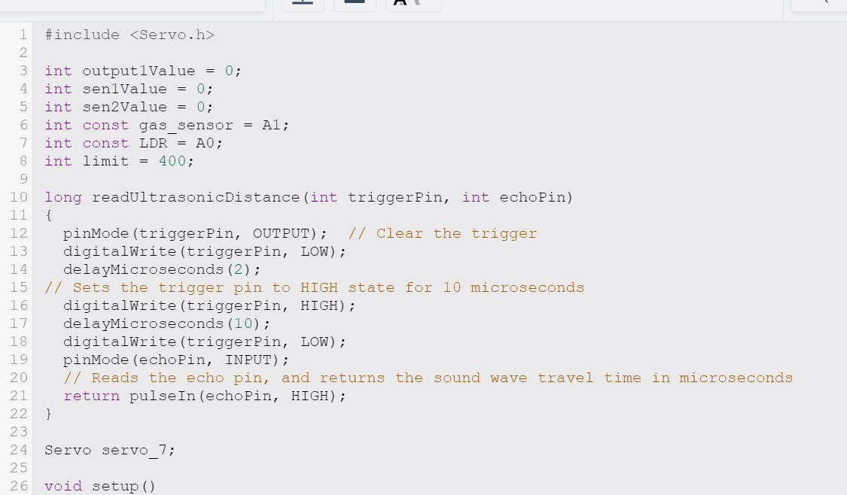

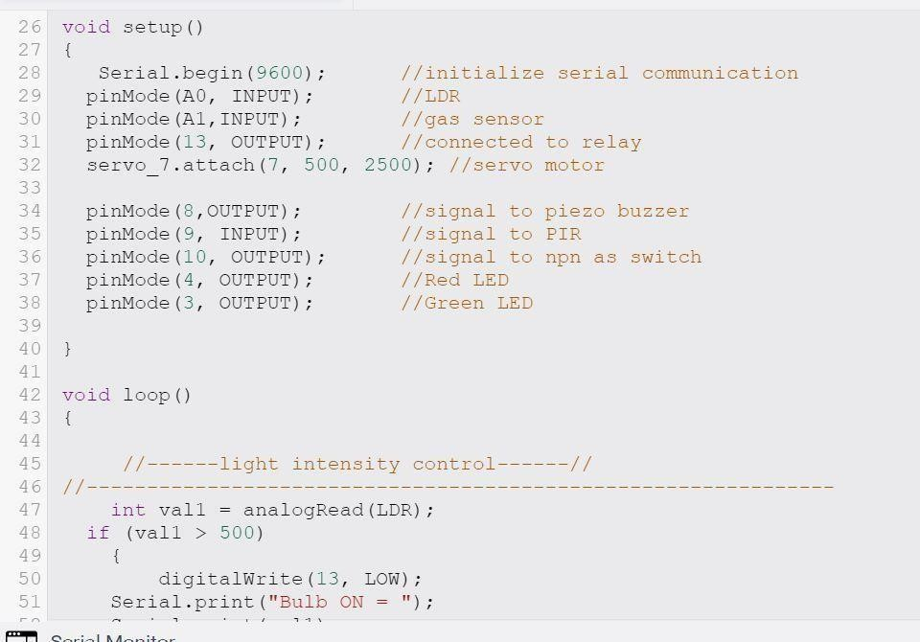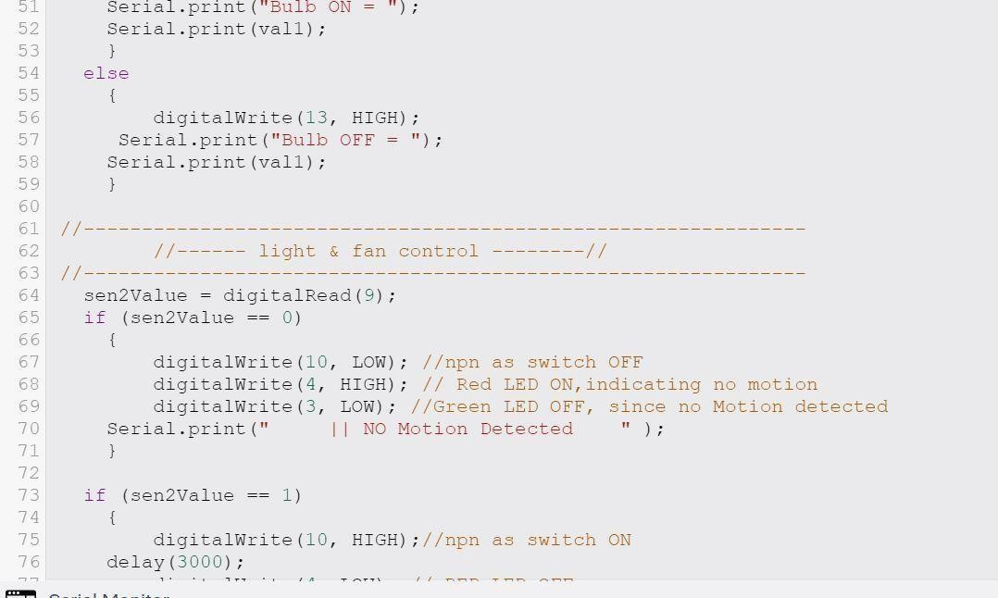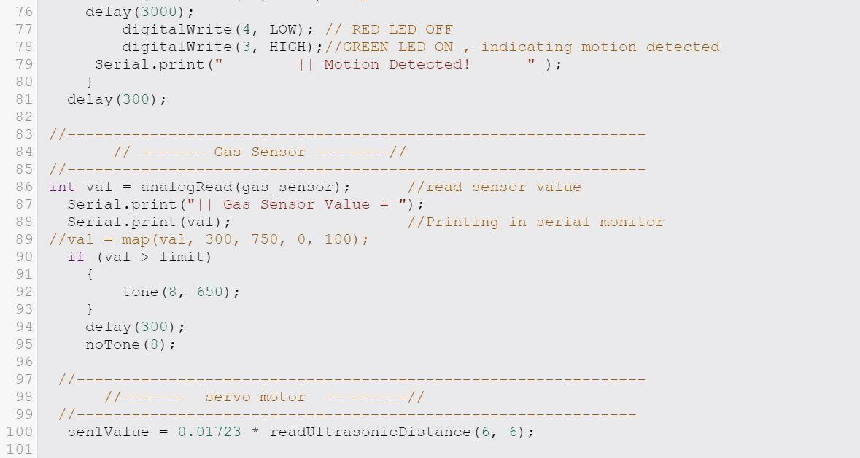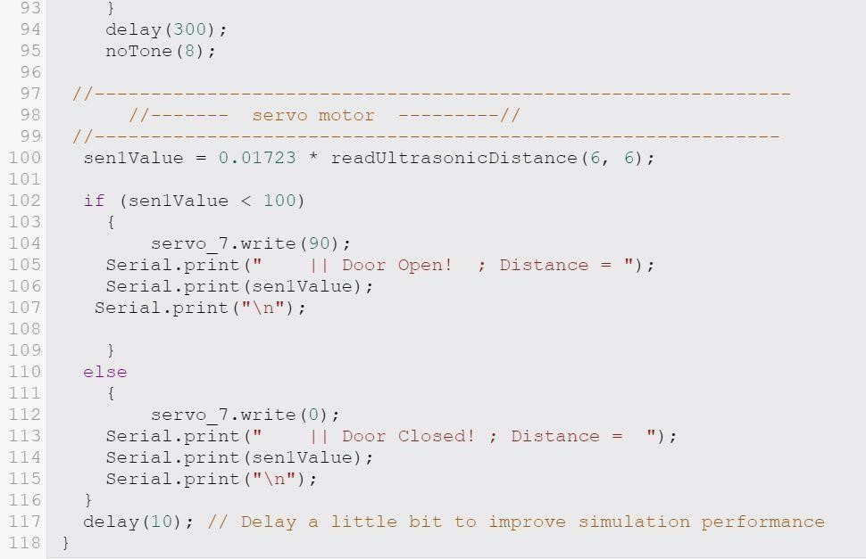

OUTPUT

