**ASSIGNMENT-3**

|  |  |
| --- | --- |
| Date | 19 September 2022 |
| Team ID | PNT2022TMID50454 |
| Project Name | Project – Nutrition Assistant Application |
| Maximum Marks | 2 Marks |

**QUESTION:**

1.Create a Bucket in IBM object storage.

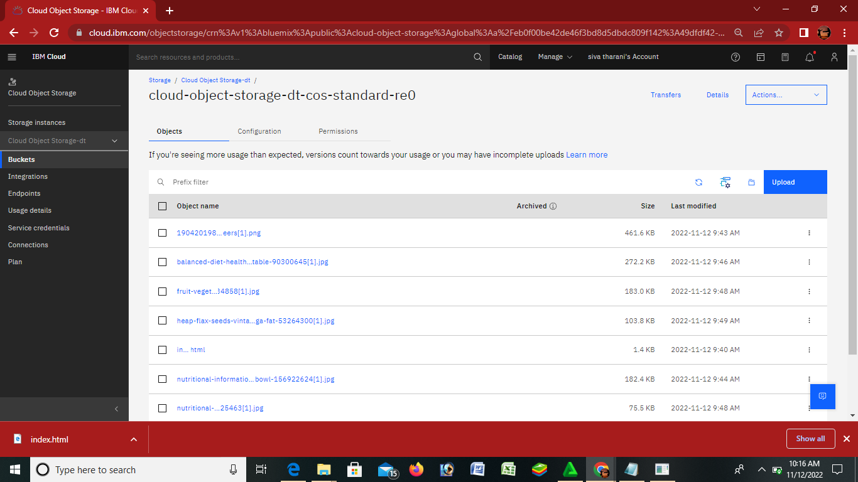

2. Upload an 5 images to ibm object storage and make it public. write html code to displaying all the 5 images.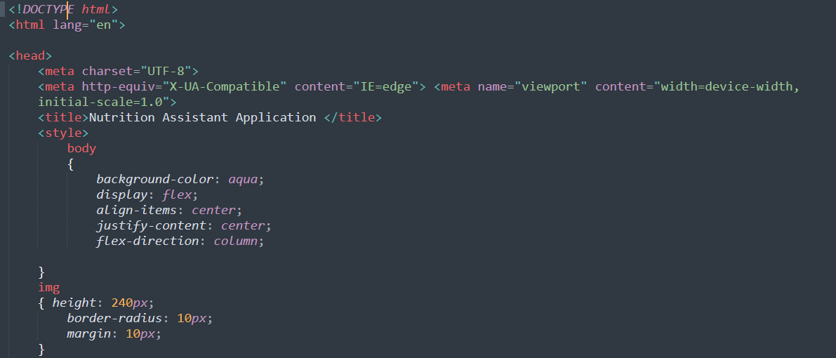

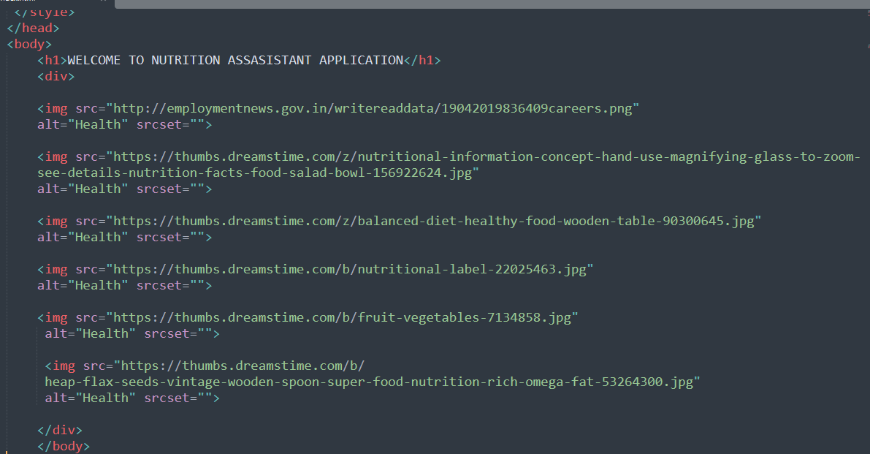

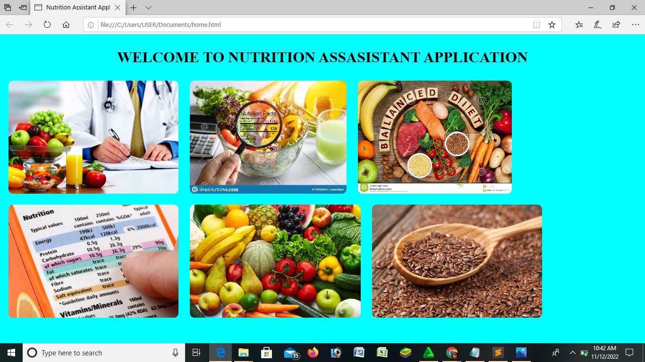

3.Upload a css page to the object storage and use the same page in your HTML code. 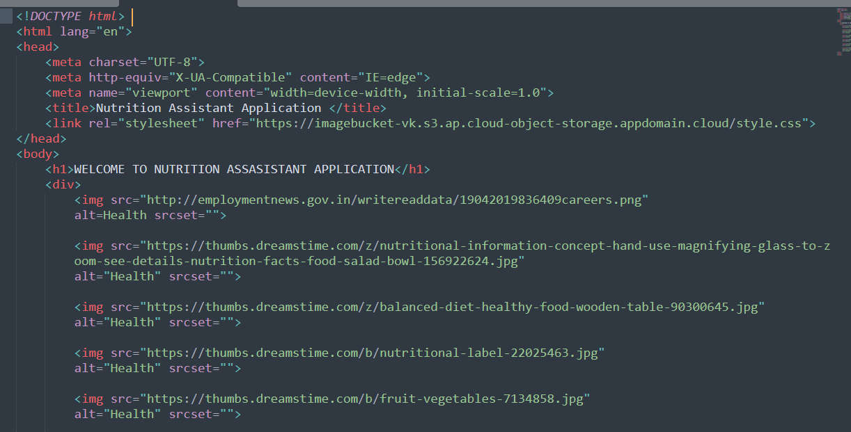

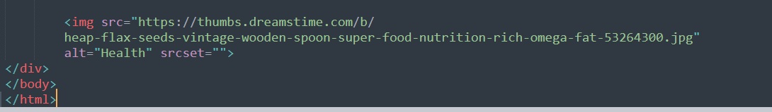



**4.Design** **a** **chatbot** **using** **IBM** **Watson** **assistant** **for** **hospital.** **Ex:** **User** **comes** **with** **query** **to** **know** **the** **branches** **for** **that** **hospital** **in** **your** **city.** **Submit** **the** **web** **URL** **of** **that** **chat** **bot** **as** **a** **assignment.**

**Url** **:-**[**chatbot** **link**](https://web-chat.global.assistant.watson.appdomain.cloud/preview.html?backgroundImageURL=https%3A%2F%2Feu-gb.assistant.watson.cloud.ibm.com%2Fpublic%2Fimages%2Fupx-2187bdc6-3463-4336-a0e5-105ac4d979db%3A%3A31897cd3-e620-4527-80d8-c93d7c618899&integrationID=fd3649a9-27f7-43a9-96c0-5ca4d5bbf885&region=eu-gb&serviceInstanceID=2187bdc6-3463-4336-a0e5-105ac4d979db) **<-** **click**

**Image-**

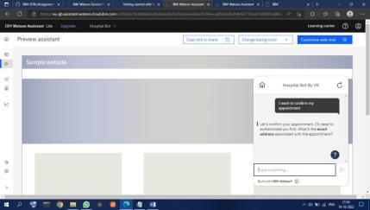

**5** **.Create** **Watson** **assistant** **service** **with** **10** **steps** **and** **use** **3** **conditions** **in** **it.** **Load** **t** **hat** **script** **in** **HTML** **page**

