PROJECT OBJECTIVES

ABSTRACT

The Internet of things (IoT) is the system of gadgets, vehicles, and home machines that contain hardware,

programming, actuators, and network which enables these things to interface, collaborate and trade

information. IoT includes broadening Internet network past standard device, for example, work areas,

workstations, cell phones and tablets, to any scope of generally stupid or non-web empowered physical device

and ordinary articles. Installed with innovation, these gadgets can convey and connect over the Internet, and

they can be remotely observed and controlled [1]. The meaning of the Internet of things has advanced because

of union of numerous innovations, ongoing examination, AI, ware sensors, and implanted frameworks.

Conventional fields of installed frameworks, remote sensor systems, control frameworks computerization

(counting home and building mechanization), and others all add to empowering the Internet of things. A gas

spill alludes to a hole of petroleum gas or different vaporous item from a pipeline or other regulation into any

territory where the gas ought not be available. Since a little hole may steadily develop a hazardous convergence

of gas, spills are perilous. Notwithstanding causing flame and blast dangers, holes can slaughter vegetation,

including huge trees, and may discharge amazing ozone harming substances to the environment.

Keywords: IOT, MQ5 sensor, Arduino module, GSM networks.

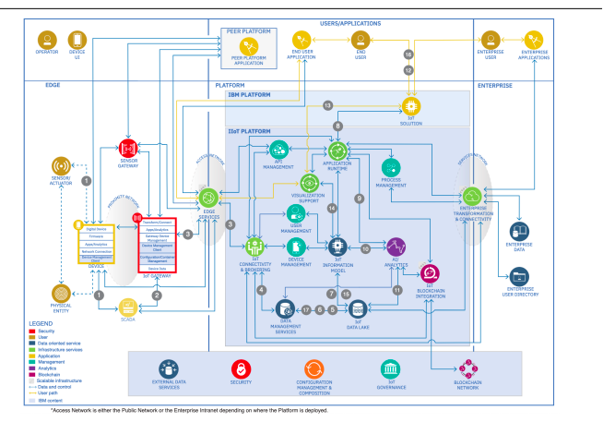

I.INTRODUCTION

The Internet of Things is a developing theme of specialized, social, and monetary centrality.

Customer items, tough goods, cars and trucks, modern and utility segments, sensors, and other

regular articles are being joined with Internet availability and amazing information systematic

capacities that guarantee to change the manner in which we work, live, and play. Projections for the effect of IoT on the Internet and economy are amazing, with some foreseeing upwards of 100 billion

associated IoT gadgets and a worldwide financial effect of more than $11 trillion by 2025. The Internet

of Things (IoT) is an essential theme in innovation industry, strategy, and designing circles [1]. This

innovation is encapsulated in a wide range of arranged items, frameworks, and sensors, which

exploit headways in processing power, gadgets scaling down, and organize interconnections to offer

new capacities. The expansive scale usage of IoT gadgets guarantees to change numerous parts of the

manner in which we live. For shoppers, new IoT items like Internet-empowered machines, home

mechanization parts, and vitality the executive’s gadgets are pushing us toward a dream of the "savvy

home'', offering greater security and vitality effectiveness. IoT frameworks like arranged vehicles,

savvy traffic frameworks, and sensors implanted in streets and scaffolds draw us nearer to "brilliant

urban areas'', which help limit clog and vitality utilization.

II. METHODS AND MATERIAL

System: Input, Output, Function, Success, Failure Input: Sensor data signal which is not regular or

Change in Signal

Output: End User get informed with alert buzzer and

Display to LCD

Functions:

1. Access ():- In this module we are going to access the feature provided by the module which Will

include Sensor data access.

2. Control ():-In this module we are controlling the Alert System by using System which is connected to

hardware or sensor data.

3. Broadcast ():-In this module we are going to broadcast the alert Display to LCD.

4. Success Conditions:

1. If such data which is received through sensors are not stable or are more than threshold it will predict

that there is leakage situation

5. Failure Conditions: Desired output is not generated due to following failures.

1. Software Failure

2. Hardware Failure

3. Network Connection Failure

HARDWARE INFORMATION:

1.Arduino Uno

The Arduino Uno is a microcontroller board based on the ATmega328 (datasheet). It has 14 digital

input/output pins (of which 6 can be used as PWM outputs), 6 analog inputs, a 16 MHz ceramic

resonator, a USB connection, a power jack, an ICSP header, and a reset button. It contains everything

needed to support the microcontroller; simply connect it to a computer with a USB cable or power it

with a AC-to-DC adapter or battery to get started. The Uno differs from all preceding boards in that it

does not use the FTDI USB-to-serial driver chip. Instead, it features the Atmega16U2 (Atmega8U2 up

to version R2) programmed as a USB-to-serial converter.

2.LCD (Liquid Crystal Display)

LCD stands for Liquid Crystal Display. LCD is finding wide spread use replacing LEDs (seven segment LEDs

or other multi segment LEDs) because of the

following reasons:

1. The declining prices of LCDs.

2. The ability to display numbers, characters and graphics. This is in contrast to LEDs, which are

limited to numbers and a few characters.

3. Incorporation of a refreshing controller into the LCD, thereby relieving the CPU of the task of

refreshing the LCD. In contrast, the LED must be refreshed by the CPU to keep displaying the data.

3.BUZZER

A buzzer or beeper is an audio signalling device, which may be mechanical, electromechanical,

or piezoelectric. Typical uses of buzzers and beepers include alarm devices, timers and confirmation of

user input such as a mouse click or keystroke. The first electric buzzer was invented in 1831 by Joseph

Henry. They were mainly used in early doorbells until they were phased out in the early 1930s in favor

of musical chimes, which had a softer tone. Piezoelectric buzzers, or piezo buzzers, as they are

sometimes called, were invented by Japanese manufacturers and fitted into a wide array of

products during the 1970s to 1980s. This advancement mainly came about because of

cooperative efforts by Japanese manufacturing companies. In 1951, they established the Barium

Titanate Application Research Committee, which allowed the companies to be "competitively

4.Bluetooth Module:

SIM900 GSM Module – This means the module supports communication in 900MHz band. We are

from India and most of the mobile network providers in this country operate in the 900MHz band. If you

are from another country, you have to check the mobile network band in your area. A majority of

United States mobile networks operate in 850MHz band (the band is either 850MHz or 1900MHz).

Canada operates primarily on 1900 MHz band.

IV. PROPOSED SYSTEM

We design and develop an propose system which include some safety factors. A safety has been a major

issue in today’s day to day life. LPG and CNG i.e. petroleum gas and compressed natural gas are most

commonly used in residential and commercial places for cooking purpose and in various vehicles as a

replacement for costly fuels like diesel, petrol [7]. These gases are filled in cylinders which are easily

un-damageable. But leakage can take place through pipes or regulators or knobs which may cause

accidents like suffocation, uneasiness or sometimes .

V. CONCLUSION

The advantage of this simple gas leak detector is its simplicity and its ability to warn about the leakage of

the LPG gas [11]. This system uses GSM technique to send alert massage to respective person if no one is

there in the house and then gas leaks occurs, GSM module is there to send immediate messages to the

respective person regarding the gas leak [13]. The main advantage of this system is that it off the

regulator knob of the cylinder automatically when gas leakage detected.