ANALYTICS FOR HOSPITALS HEALTH-CARE DATA

ASSIGNMENT-1

R&D SPEND BY STATE COLORED BY STATE

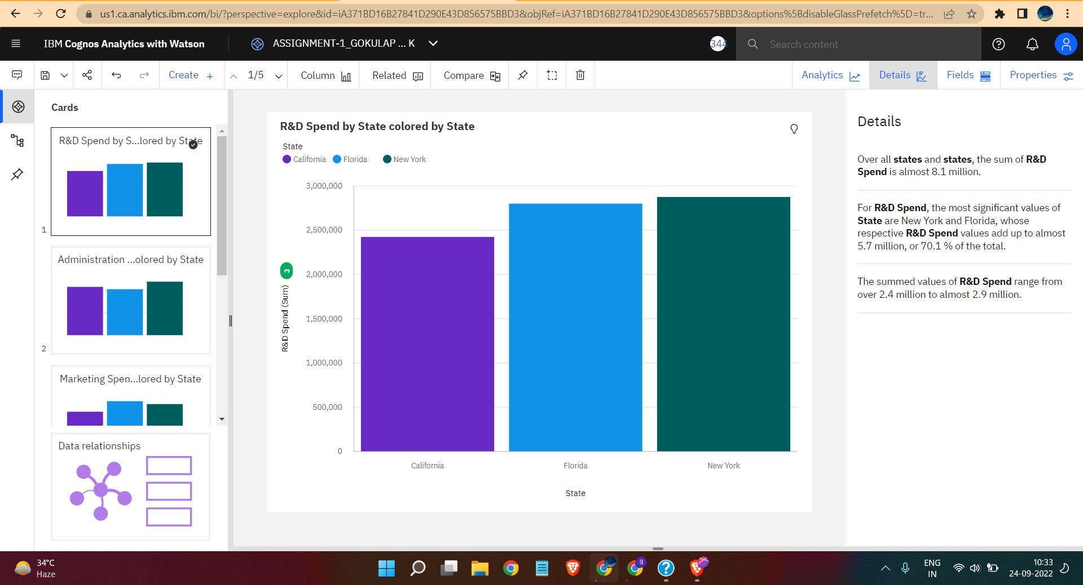

ADMINISTRARTION BY STATE COLORED BY STATE

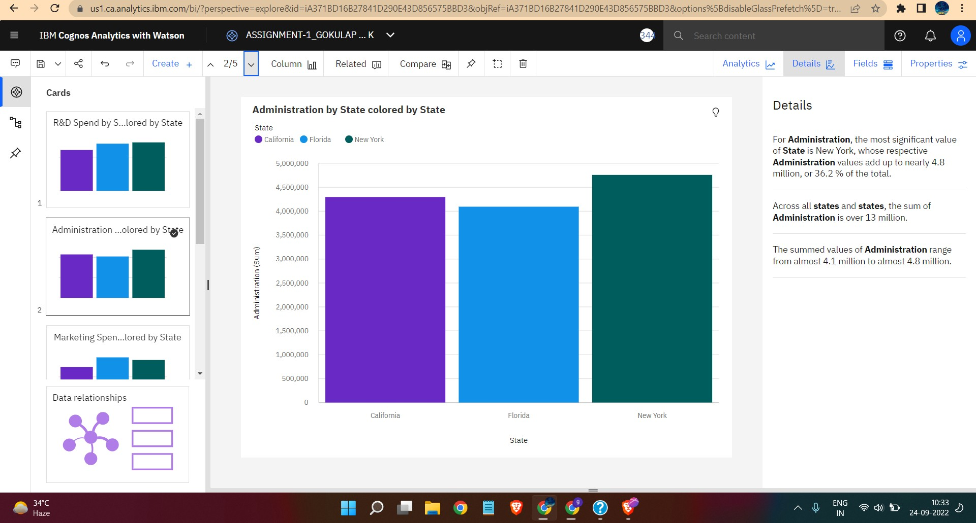

MARKETING SPEND BY STATE COLORED BY STATE

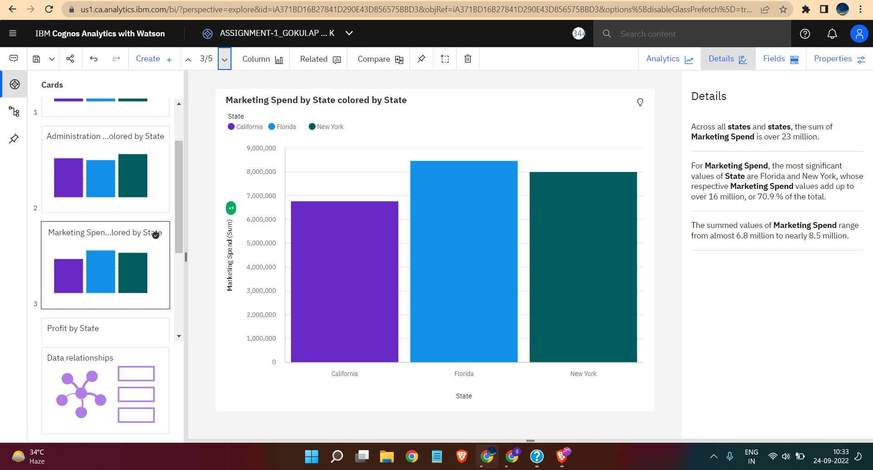

PROFIT BY STATE

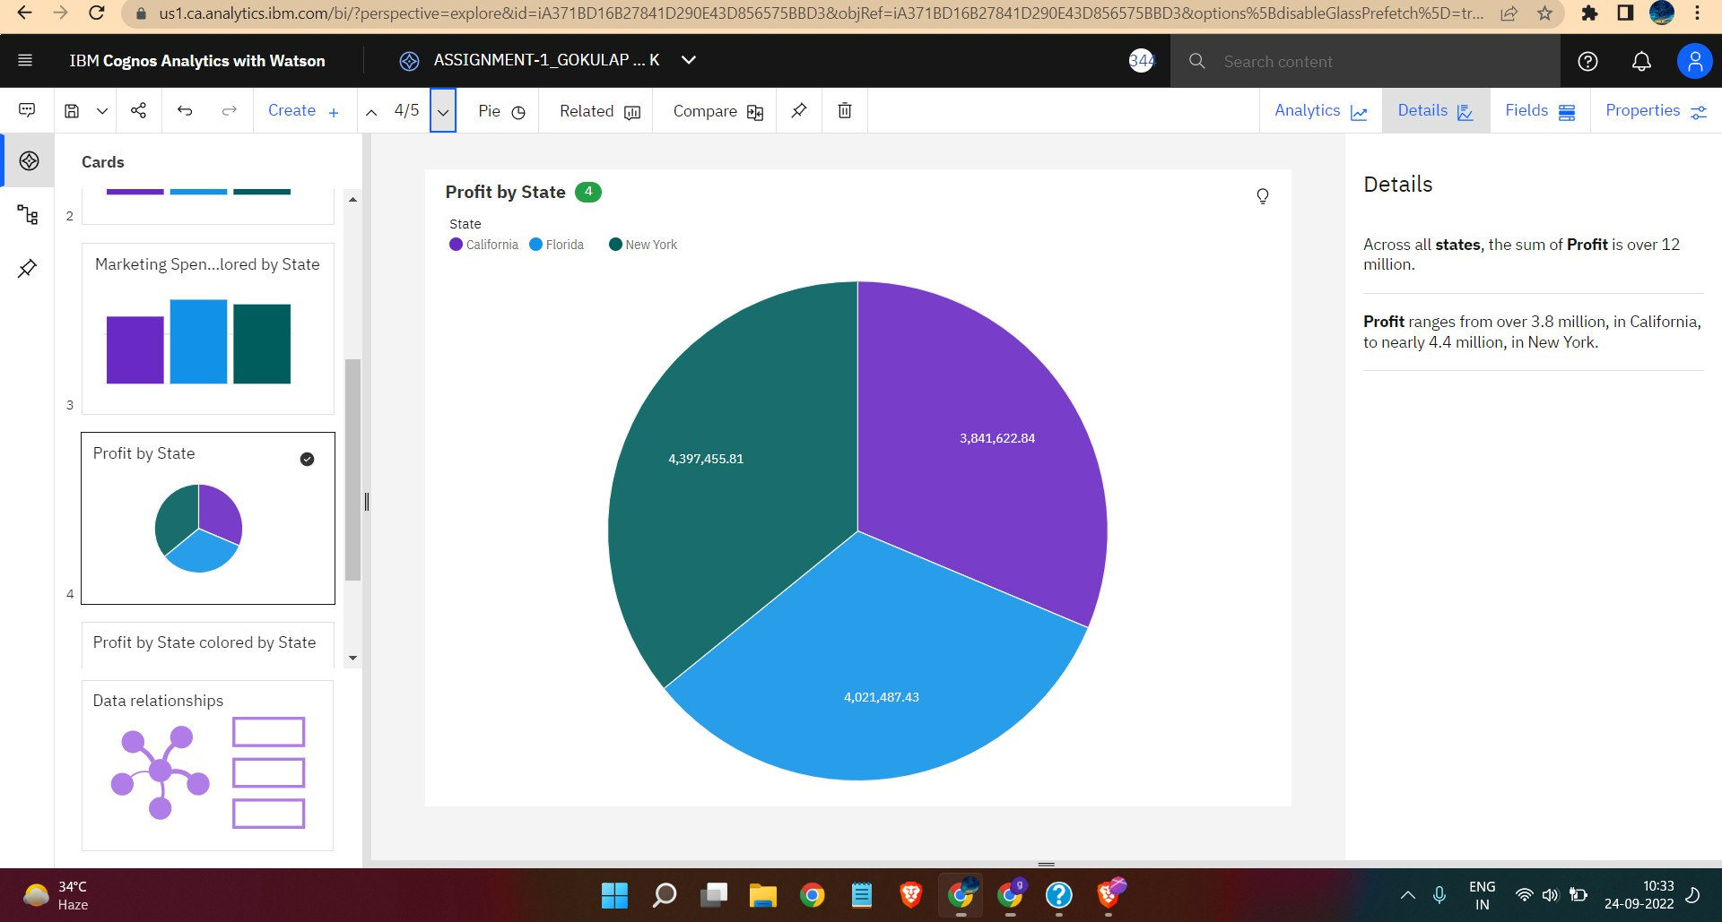

PROFIT BY STATE COLORED BY STATE

