**Project Planning Phase Project Planning Template (**

**Product Backlog, Sprint Planning, Stories, Story points)**

|  |  |
| --- | --- |
| Date | 18October 2022 |
| Team ID | PNT2022TMID43271 |
| Project Name | AI based discourse for banking industry |
| Maximum Marks | 8 Marks |

## Introduction

## A [project roadmap](https://www.projectmanagementools.com/monitoring/product-roadmap-template/) shows the overview of the project’s strategic pace, where the project I actually headed in the long run. It determines the direction and expectations of the development team, to the company. Sometimes it can be used as a strict project plan, but in agile development, a roadmap provides direction, guidance, and a clear view of where the project stands.

## Agile Project Planning

Our world, on the whole, is going agile, as per the modern approach. Almost 71% of worldwide organizations have adopted agile project planning and it has immensely reduced the market time of the projects as compared to the traditional approach.

## Examples of Agile Project Planning

1. **Agile Milestones Template**
2. **Sprint Project management template**

## Agile Milestones Template

An agile milestone is like a check post to identify what is delivered at the end of a sprint or a release. It marks a specific stage in the development, which the team looks up to mark the progress. It is a result that shows how much work is done and how much is needed. E.g. a company is developing an app, the milestones can be front-end development, graphics, code, database development, etc.

Each phase delivers a milestone and a team can keep adding to the milestones until the final app is developed. In agile planning, the team uses milestones to keep a measure of their performance and keep [track of the project](https://www.projectmanagementools.com/project-quality/multiple-project-tracking-template/). By using agile milestones the likelihood of achieving deliverables right on time becomes more possible.

These milestones can also be shared with the stakeholders to keep them in the loop, with the team’s performance and proceeding of the plan. They can look at the milestones and identify that the team is right on track because all the milestones are being accomplished in due time. These milestones can be used at multiple points in the cycle of a project, most commonly at the end of each sprint or at the end of each release.

A **fixed date**milestone is used in traditional software development, but in [agile methodology](https://www.wrike.com/project-management-guide/faq/what-is-agile-methodology-in-project-management/), the team needs to keep things **flexible** due to the ever-changing nature of the plan.

## Sprint Project Management Template

The [sprint project planning](https://www.projectmanagementools.com/tag/sprint-templates/) is done very initially when the project planning is being kicked off. Whereas new sprints can also be added as the project continues. The sprints need to stay within the original release plan. N

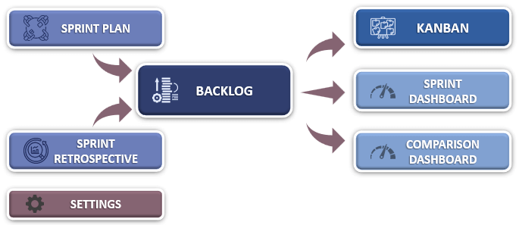

## **Purpose of project planning**

Project planning communicates [deliverables](https://www.workfront.com/project-management/knowledge-areas/scope-management/deliverables), timing and schedules, along with team roles and responsibilities. During the planning phase of a project, the [project manager](https://www.workfront.com/project-management/career/project-manager) is forced to think through potential risks and hang-ups that could occur during the project.

These early considerations can prevent future issues from affecting the overall success of the project, or at times, cause a project to fail. Too little planning causes chaos and frustration and too much planning causes a lot of administrative tasks, not allowing enough time for creative work.

Ultimately, the planning phase of project management determines how smoothly your projects move through the life cycle. That’s why it’s so important to spend ample time at the beginning of a project and get your planning right.

## **What is a project plan?**

A [project plan](https://www.workfront.com/project-management/life-cycle/planning/project-plan) is a set of documents that can change over the course of a project. The plan provides an overall direction for the project, so drafting this is a key aspect of the project planning phase. If unexpected issues arise, such as delivery delays, the plan can be adjusted by the project manager.

Project plans are coordinated by the project manager, with input from stakeholders and team members. Plan components cover the “what” and “how” of a project.

Plans include details related to:

* Timelines and stages
* [Metrics](https://www.workfront.com/project-management/metrics)
* Activities
* Milestones
* Deliverables

#### 1. Create a scope statement

A scope statement documents what the project will produce and what it will not. Once a project manager understands the stakeholder requirements, they need to define the scope. This is a crucial step because the scope will serve as the foundation of the project plan.

By outlining [project scope](https://www.workfront.com/project-management/knowledge-areas/scope-management/project-scope) boundaries during the planning phase, a project manager can minimize the chance of unauthorized tasks popping up. A clear and accurate scope statement helps gain buy-in from stakeholders, while also minimizing risk.

Formalizing these decisions in a project charter document may help to cement the business case for the project. When project managers take the time to meet with key stakeholders from the very beginning, they can feed cross-department insights into the scope statement.

#### 2. Create a statement of work

A statement of work contains project details including [project timelines](https://www.workfront.com/project-management/knowledge-areas/time-management/project-timeline), requirements, and components. It’s an essential document that projects both the client and agency as it is a legally binding document that details the amount a client will pay for certain deliverables.

A sow can also help prevent [scope creep](https://www.workfront.com/project-management/knowledge-areas/scope-management/scope-creep) and shifting project requirements, which can individually, and combined, derail the progress of a project.

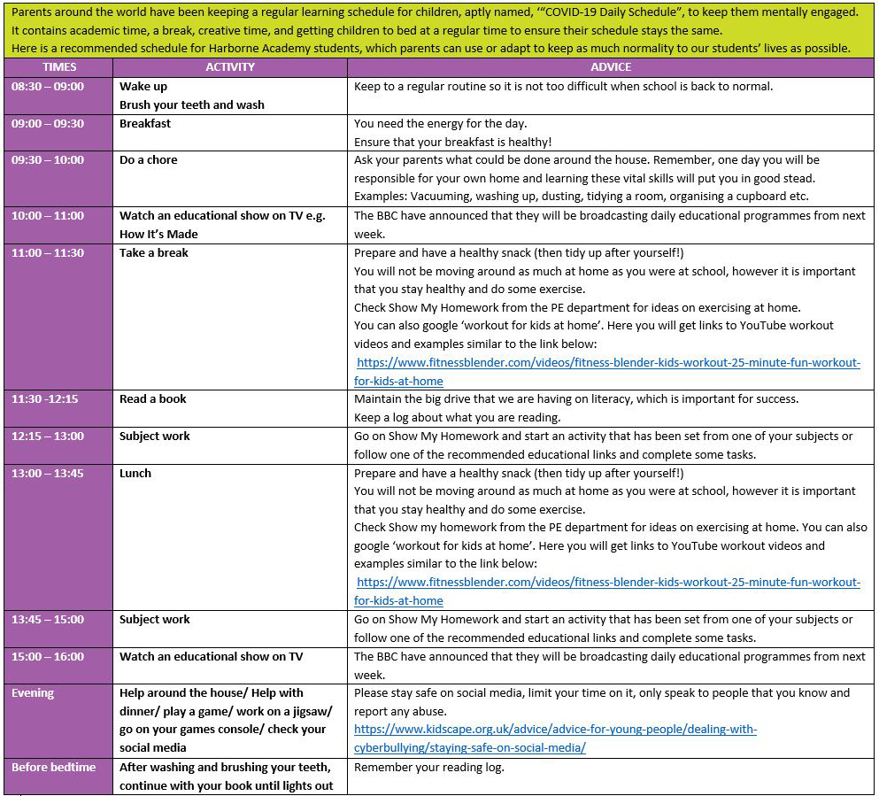 **Conclusion**

Optimize your product team's efficiency with this Sprint Planning template. Log tasks – as well as key details like task owners, attachments, dates, and more – and organize them into sprints with the Select data type and row grouping.

With built-in Gantt and Calendar views, it's easy to transform your task list into an interactive timeline or calendar and give your team more ways to visualize their sprint progress.