**Project Design Phase-I**

**Solution architecture**

|  |  |
| --- | --- |
| Date | 19 September 2022 |
| Team ID | PNT2022TMID43271 |
| Project Name | AI based discourse for Banking industry |
| Maximum Marks | 4 Marks |

**Solution architecture**

The solution architecture and design process phase determines how to best design the solution, choosing the depth of the project, the schedule, hardware, and software to best satisfy both project and business requirements.

This is also where the team determines how the integration (hardware and/or software) of any required physical security subsystem into a single interface can improve efficiencies and decisions and reduce cost and risk. An architectural team is assigned, with architects, subject matter experts, and engineers from various disciplines, hardware and software vendors, and the customer.

This team works iteratively to determine success criteria, goals and objectives, and budget restraints as well as update project requirements and new procedural details, if necessary, and to document the architectural conceptual design and develop a presentation detailing the viability and benefits for key executives to obtain cost approval.

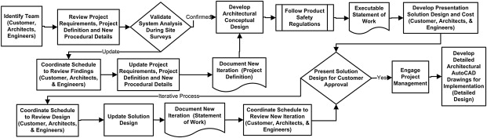

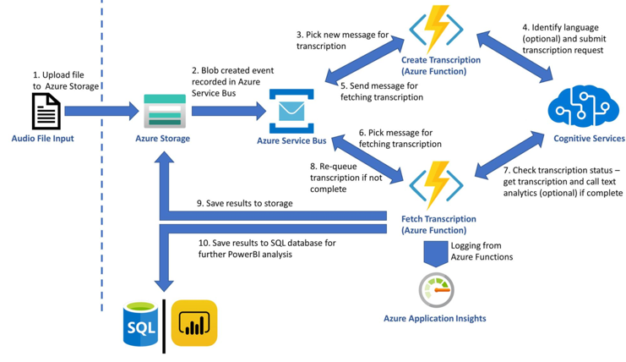

**Conclusion**

This team works iteratively to determine success criteria, goals and objectives, and budget restraints as well as update project requirements and new procedural details, if necessary, and to document the architectural conceptual design and develop a presentation detailing the viability and benefits for key executives to obtain cost approval.