**SMART HOME**

**NAME : SUBHASH SAHADEVAN**

**ROLL NO : 961619104042**

**COLLEGE : MARTHANDAM COLLEGE OF ENGINEERING AND TECHNOLOGY**

**DIGRAM** 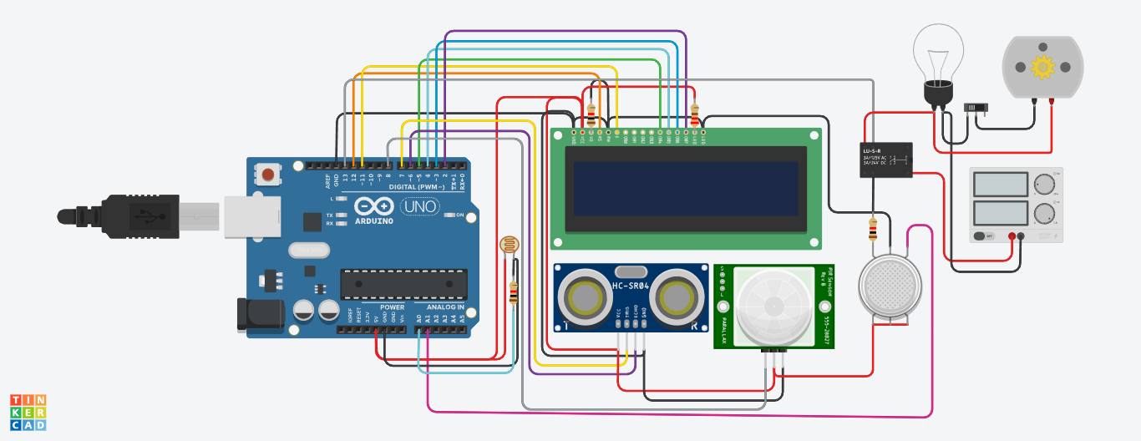

**COMPONENT USED:**

**1.** ARDUINO

**2.** 16X2 DISPLAY

**3.** ULTRASONIC SENSOR

**4.**PIR SENSOR

**5.** GAS SENSOR

**6.** PHOTORESISTOR

**7.** RELAY

**8.**BULB

**9.** DC MOTOR

**10.** SLIDE SWITCH

**CODE**

#include <LiquidCrystal.h> LiquidCrystal lcd(2,3,4,5,6,7); #include <SoftwareSerial.h> SoftwareSerial mySerial(9, 10);

int gasValue = A0; // smoke / gas sensor connected with analog pin A1 of the arduino / mega.

int data = 0;

int buzzer = 13;

int G_led = 8; // choose the pin for the Green LED int R_led = 9; // choose the pin for the Red Led void setup()

{

pinMode(buzzer,OUTPUT);

pinMode(R_led,OUTPUT); // declare Red LED as output

pinMode(G_led,OUTPUT); // declare Green LED as output randomSeed(analogRead(0));

mySerial.begin(9600); // Setting the baud rate of GSM Module Serial.begin(9600); // Setting the baud rate of Serial Monitor (Arduino) lcd.begin(16,2);

pinMode(gasValue, INPUT); lcd.print (" Gas Leakage "); lcd.setCursor(0,1);

lcd.print (" Detector Alarm "); delay(3000);

lcd.clear();

}

void loop()

{

data = analogRead(gasValue); Serial.print("Gas Level: "); Serial.println(data);

lcd.print ("Gas Scan is ON"); lcd.setCursor(0,1); lcd.print("Gas Level: "); lcd.print(data);

delay(1000);

if ( data > 90) //

{

digitalWrite(buzzer, HIGH); digitalWrite(R_led, HIGH); // Turn LED on. digitalWrite(G_led, LOW); // Turn LED off. SendMessage();

Serial.print("Gas detect alarm"); lcd.clear();

lcd.setCursor(0,0); lcd.print("Gas Level Exceed"); lcd.setCursor(0,1);

lcd.print("SMS Sent"); delay(1000);

}

else

{

digitalWrite(buzzer, LOW); digitalWrite(R_led, LOW); // Turn LED off. digitalWrite(G_led, HIGH); // Turn LED on. Serial.print("Gas Level Low");

lcd.clear(); lcd.setCursor(0,0);

lcd.print("Gas Level Normal"); delay(1000);

}

lcd.clear();

}

void SendMessage()

{

Serial.println("I am in send");

mySerial.println("AT+CMGF=1"); //Sets the GSM Module in Text Mode delay(1000); // Delay of 1000 milli seconds or 1 second

mySerial.println("AT+CMGS=\"+91xxxxxxxxxx\"\r"); // Replace x with mobile number delay(1000);

mySerial.println("Excess Gas Detected.");// The SMS text you want to send mySerial.println(data);

delay(100);

mySerial.println((char)26);// ASCII code of CTRL+Z delay(1000);