Assignment -1

|  |  |
| --- | --- |
| Assignment Date | 19 September 2022 |
| Student Name | Preethi B |
| Student Roll Number | 2019504048 |
| Maximum Marks | 2 Marks |

Question-1:

Home Automation using Tinker cad: Design:

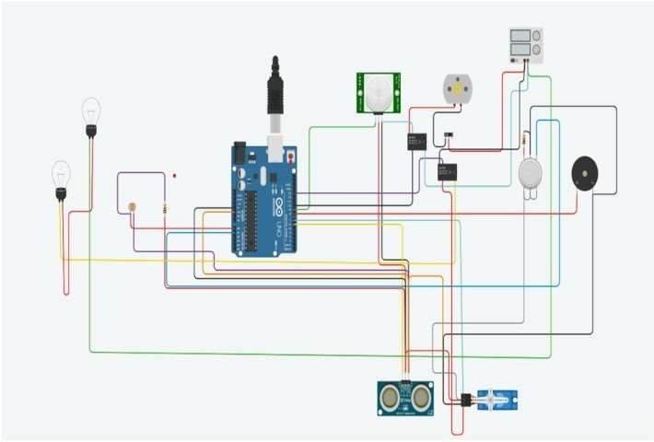

Components Required:

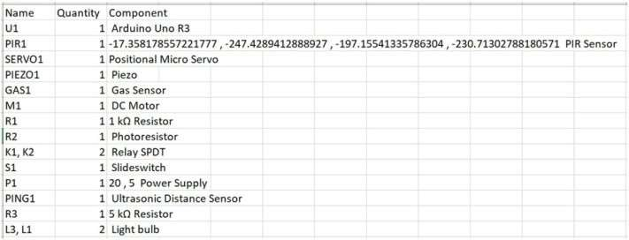

Schematic:

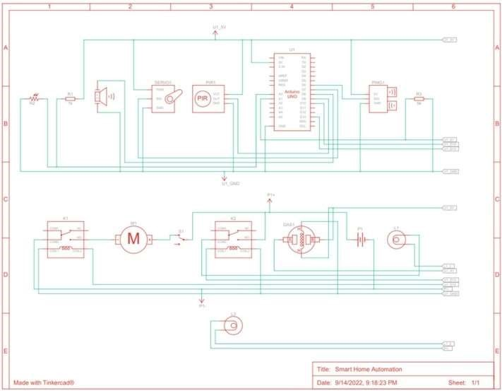

Code:

#include <Servo.h>

int output1Value = 0;

int sen1Value = 0; int sen2Value = 0; int const gas_sensor = A1; int const LDR = A0; int limit = 400;

long readUltrasonicDistance(int triggerPin, int echoPin) { pinMode(triggerPin, OUTPUT); // Clear the trigger digitalWrite(triggerPin, LOW); delayMicroseconds(2); digitalWrite(triggerPin, HIGH);

delayMicroseconds(10); digitalWrite(triggerPin, LOW); pinMode(echoPin, INPUT);

return pulseIn(echoPin, HIGH);

}

Servo servo_7;

void setup()

{

Serial.begin(9600); //initialize serial communication pinMode(A0, INPUT); //LDR pinMode(A1,INPUT); //gas sensor

pinMode(13, OUTPUT); //connected to relay servo_7.attach(7, 500, 2500); //servo motor

pinMode(8,OUTPUT); //signal to piezo buzzer

pinMode(9, INPUT); //signal to PIR pinMode(10, OUTPUT); //signal to npn as switch pinMode(4, OUTPUT); //Red LED pinMode(3, OUTPUT); //Green LED

}

void loop() {

int val1 = analogRead(LDR);

if (val1 < 500)

{

digitalWrite(13, LOW); Serial.print("Bulb ON = "); Serial.print(val1);

}

else

{

digitalWrite(13, HIGH); Serial.print("Bulb OFF = "); Serial.print(val1);

}

sen2Value = digitalRead(9); if (sen2Value == 0)

{

digitalWrite(10, LOW); //npn as switch OFF digitalWrite(4, HIGH); // Red LED ON,indicating no motion digitalWrite(3, LOW); //Green LED OFF, since no Motion detected

Serial.print(" || NO Motion Detected " );

}

if (sen2Value == 1)

{

digitalWrite(10, HIGH);//npn as switch ON delay(3000);

digitalWrite(4, LOW); // RED LED OFF digitalWrite(3, HIGH);//GREEN LED ON , indicating motion detected

Serial.print(" || Motion Detected! " );

}

delay(300);

int val = analogRead(gas_sensor); //read sensor value

Serial.print(val); //Printing in serial monitor

//val = map(val, 300, 750, 0, 100); if (val > limit)

{

tone(8, 650);

} delay(300); noTone(8);

sen1Value = 0.01723 * readUltrasonicDistance(6, 6);

if (sen1Value < 100)

{

servo_7.write(90);

Serial.print(" || Door Open! ; Distance = "); Serial.print(sen1Value); Serial.print("\n");

}

else

{

servo_7.write(0);

Serial.print(" || Door Closed! ; Distance = "); Serial.print(sen1Value);

Serial.print("\n");

}

delay(10); // Delay a little bit to improve simulation performance

}