**Project Design Phase-II**

**Data Flow Diagram & User Stories**

|  |  |
| --- | --- |
| Date | 27 October 2022 |
| Team ID | PNT2022TMID22148 |
| Project Name | Smart fashion cloud application development |
| Maximum Marks | 4 Marks |

**Data Flow Diagrams:**

A Data Flow Diagram (DFD) is a traditional visual representation of the information flows within a system. A neat and clear DFD can depict the right amount of the system requirement graphically. It shows how data enters and leaves the system, what changes the information, and where data is stored.

DFD of Smart fashion cloud application

**Example:** [**(Simplified)**](https://developer.ibm.com/patterns/visualize-unstructured-text/)

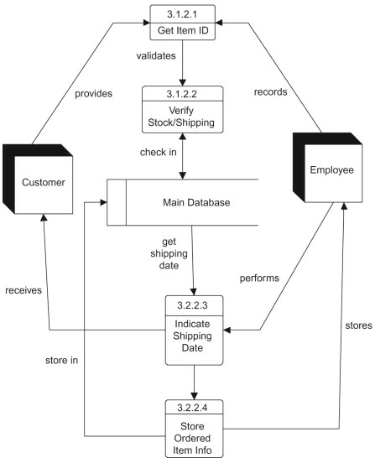

**[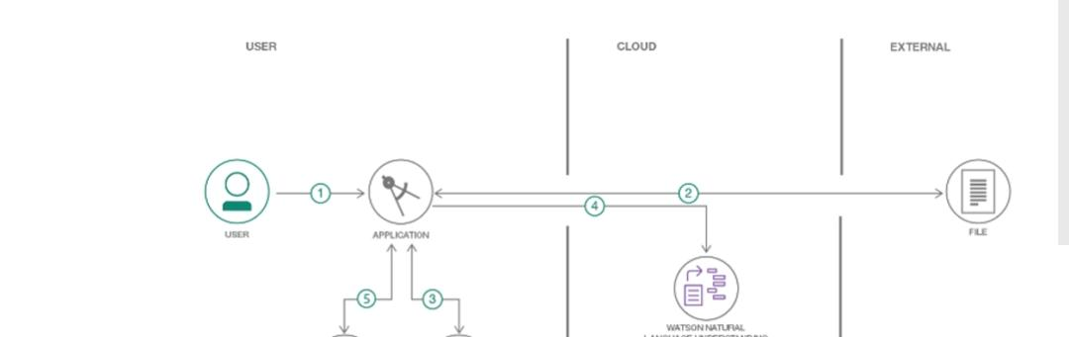](https://developer.ibm.com/patterns/visualize-unstructured-text/)**

cloud



* User selects data file to process and load
* Kubernetes containerized applications to run on a cluster of host
* The Docker clients talk to the Docker daemon, which does dose the heavy lifting of building, running, and distributing your Docker containers.

**User Stories**

Use the below template to list all the user stories for the product.

| **User Type** | **Functional Requirement (Epic)** | **User Story Number** | **User Story / Task** | **Acceptance criteria** | **Priority** | **Release** |
| --- | --- | --- | --- | --- | --- | --- |
| Customer (Mobile user) | Registration | USN-1 | As a user, I can register for the application by entering my email, password, and confirming my password. | I can access my account / dashboard | High | Sprint-1 |
|  |  | USN-2 | As a user, I will receive confirmation email once I have registered for the application | I can receive confirmation email & click confirm | High | Sprint-1 |
|  |  | USN-3 | As a user, I can register for the application through Facebook | I can register & access the dashboard with Facebook Login | Low | Sprint-2 |
|  |  | USN-4 | As a user, I can register for the application through Gmail | I can check my mail confirmation | Medium | Sprint-1 |
|  | Login | USN-5 | As a user, I can log into the application by entering email & password | I can login | High | Sprint-1 |
|  | Dashboard | USN-6 | As a user, I can use a dashboard to monitor the overall health of a specific process | I can see and add items in cart | High | Sprint-2 |
| Customer (Web user) |  | USN-7 | As a user, I can use the online customer service, which is used for the process of answering customer questions digitally using tools such as email, social media, live chat, and messaging apps. | I can use the chatbot for easy accessing | High | Sprint-3 |
| Customer Care Executive |  | USN-8 | This is a professional responsible for communicating the how’s and why’s regarding service expectations within a company. It includes answering phones, responding to customer questions and assisting with customer issues | I can use bot assistant | High | Sprint-3 |
| Administrator |  | USN-9 | It involves the planning of work assignment and supervising staff, requesting office equipment and repairs. | I can check with the admin team if any issue arises |  | Sprint-4 |
|  |  |  |  |  |  |  |
|  |  |  |  |  |  |  |