Theft Alarm
What will happen when a thief comes. The Theft Alarm will be detected by PIR sensor and it give signal to LED to glow, buzzer to produce sound, LCD to display a message (means alert by light, sound, message)
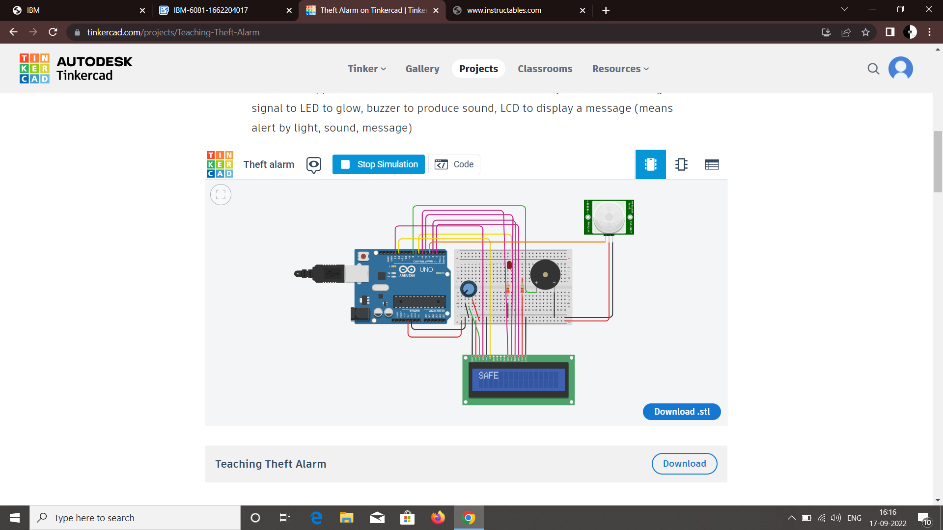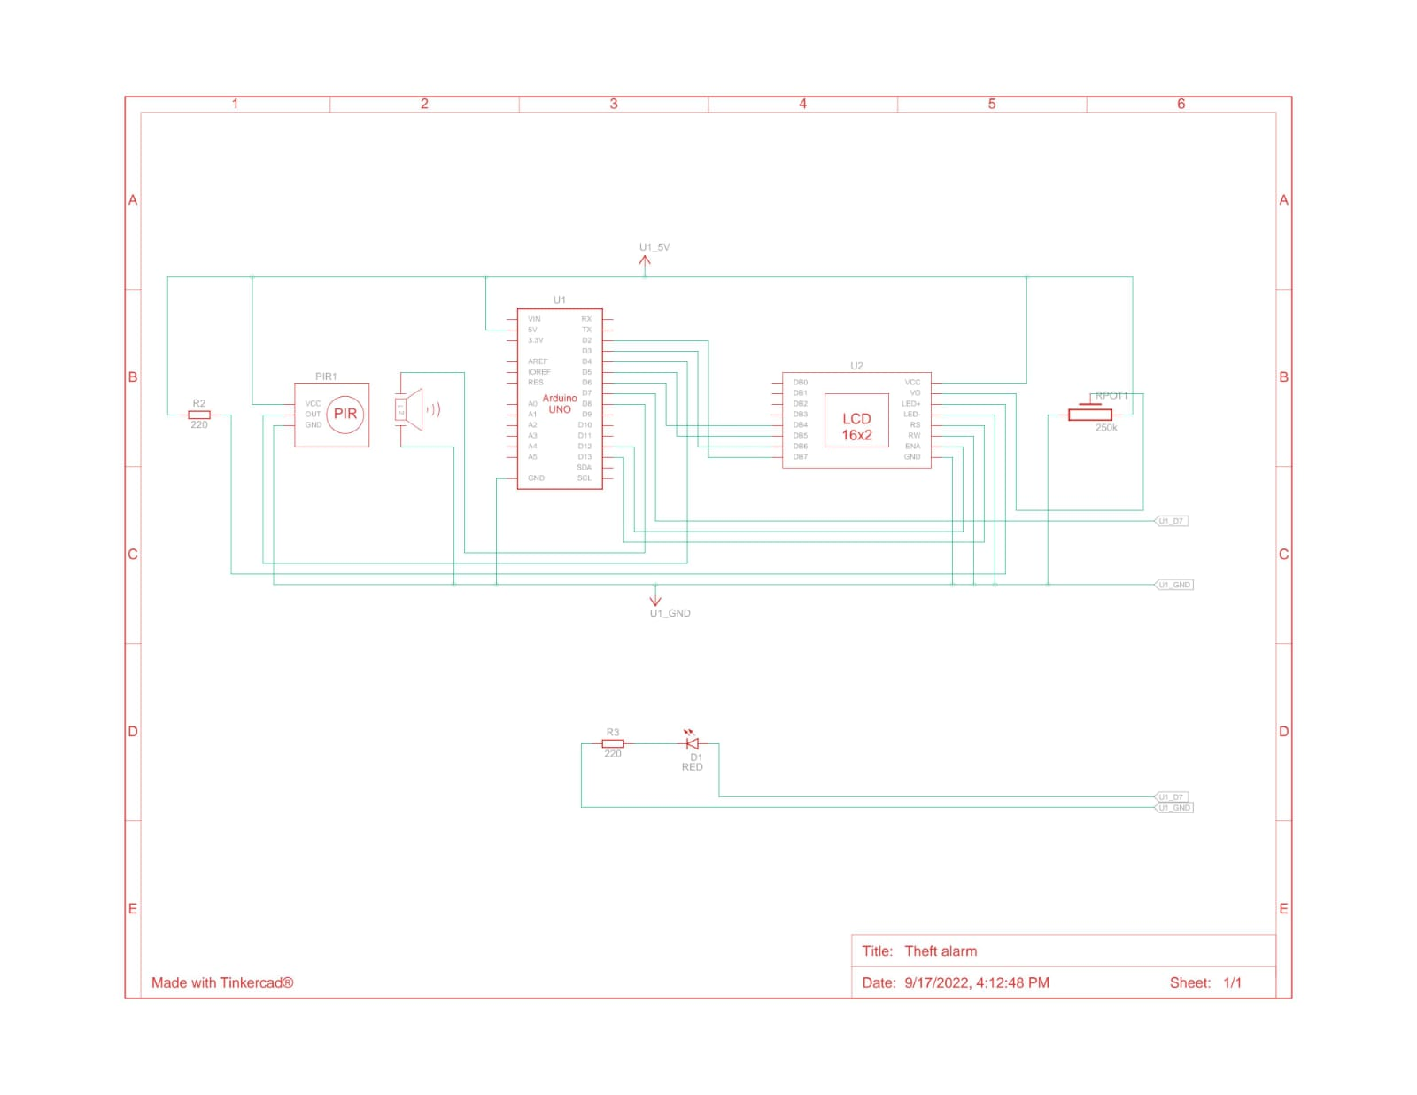
CODE :
#include <LiquidCrystal.h>
LiquidCrystal lcd(13,12,6,5,3,2);
int led=7;
int PIR=4;
int buzzer=8;
int PIRstatus;

void setup()
{
lcd.begin(16,2);
pinMode(led, OUTPUT);
pinMode(buzzer, OUTPUT);
pinMode(PIR, INPUT);
lcd.clear();

}
void loop()
{
PIRstatus=digitalRead(PIR);
if (PIRstatus==HIGH){
lcd.clear();
digitalWrite(led,HIGH);
digitalWrite(buzzer,HIGH);
tone(buzzer, 300, 10000); //tone(pin, frequency, Duration)
lcd.setCursor(0, 1);
lcd.print("ALERT");

delay(7000);
lcd.clear();
}
else
{
lcd.setCursor(0, 0);
lcd.print("SAFE");
digitalWrite(led, LOW);
digitalWrite(buzzer, LOW);
}
delay(1000);
}

