**INSTALLATION OF PYTHON 3.9.8**

|  |  |
| --- | --- |
| Date | 02 November2022 |
| Team Id | PNT2022 TMID17061 |
| Project | Smart crop protection |

**Step 1**: **Type python in google and click on the first link**

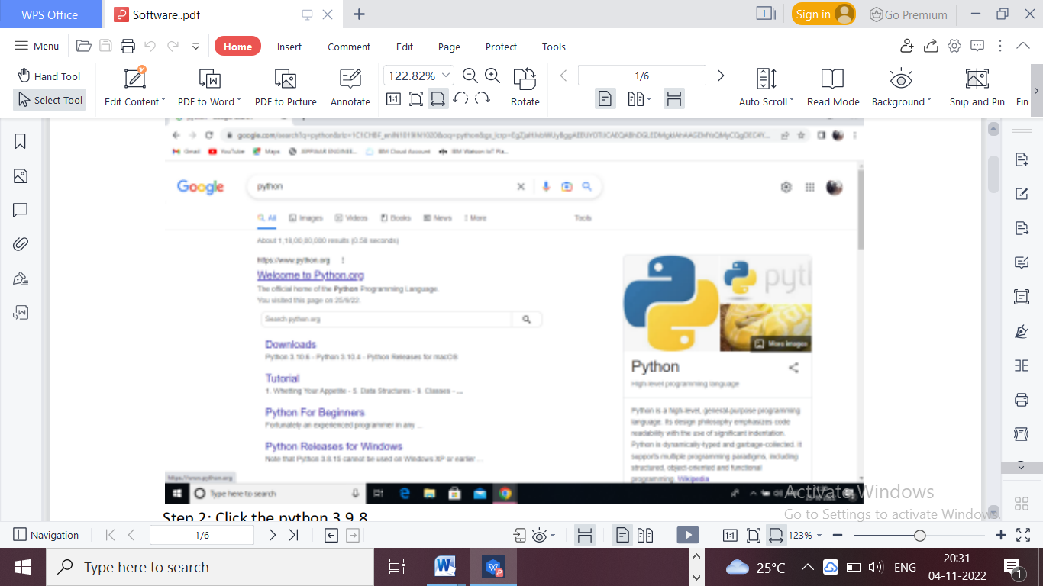

**Step 2: Click the python 3.9.8**

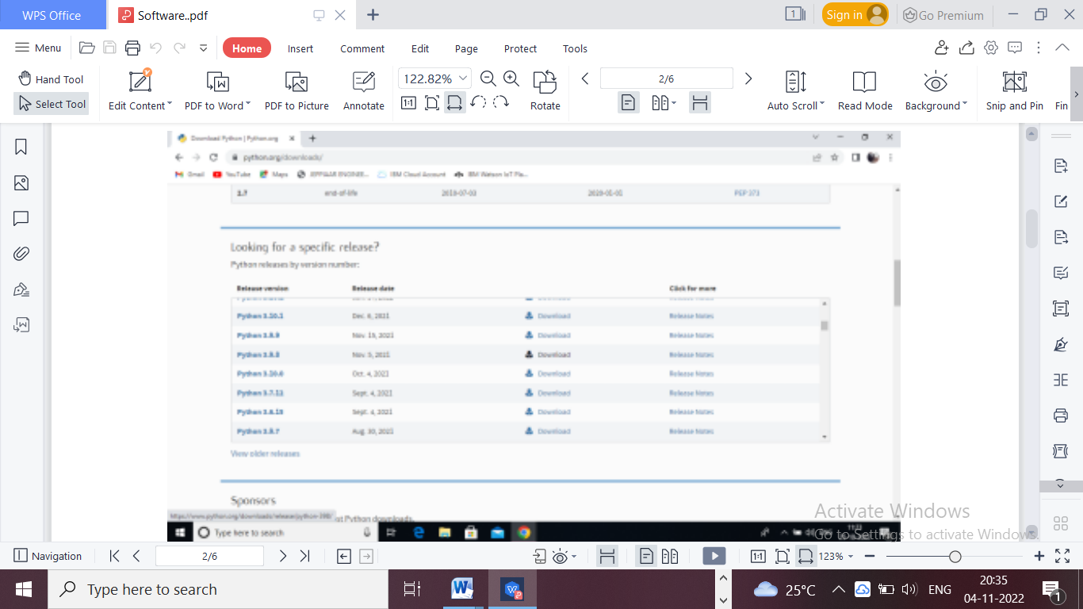

**Step 3: Scroll down to reach Files and click on “Window installer (64 bit)**

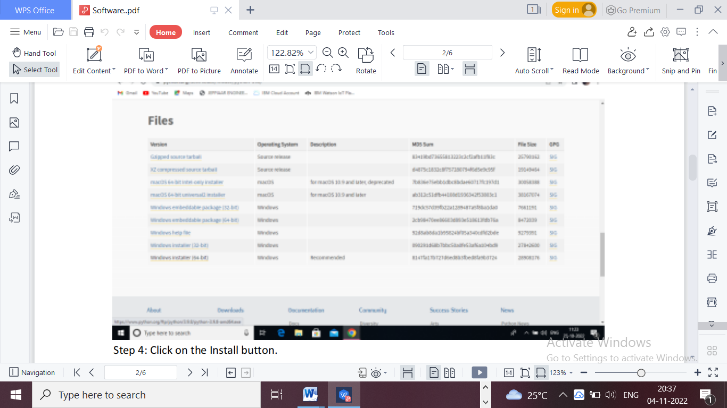

**Step 4: Click on the Install button.**

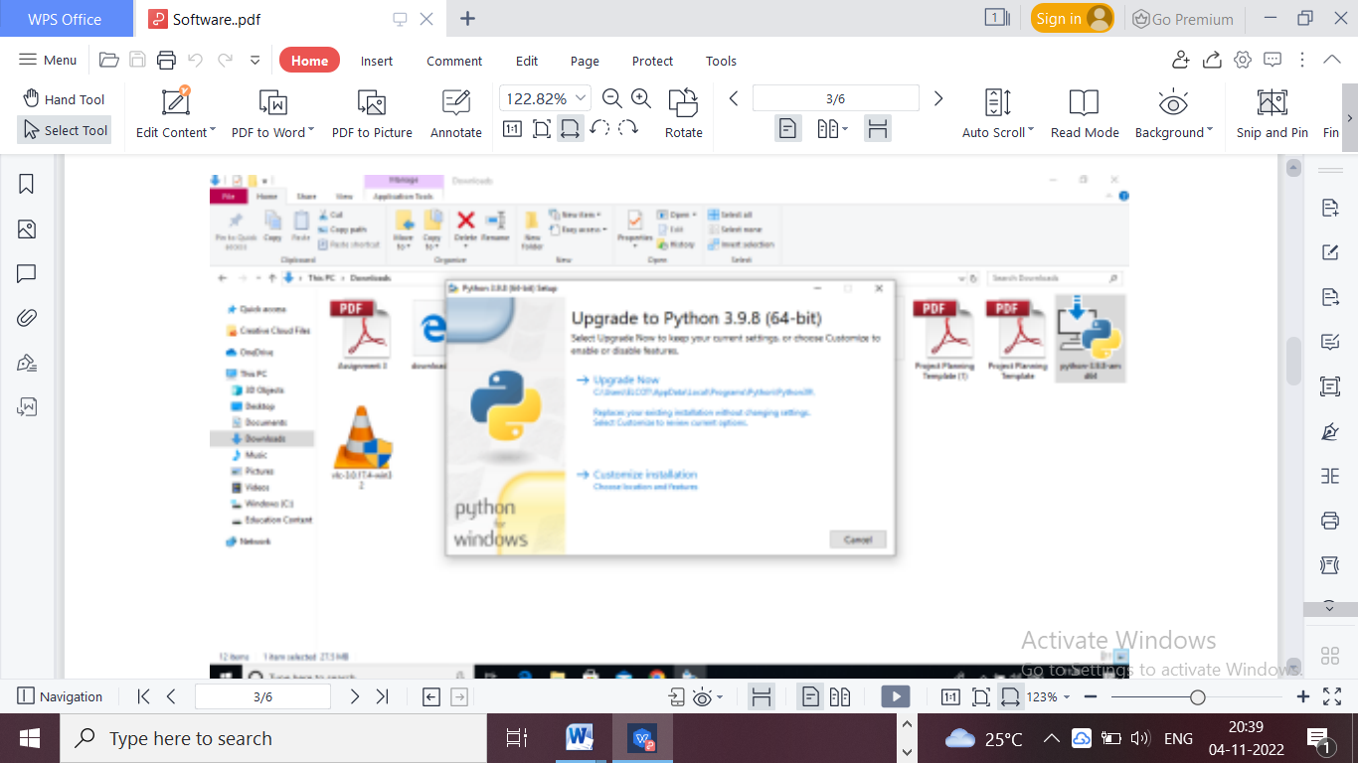

**Step 5: Installation on progress**

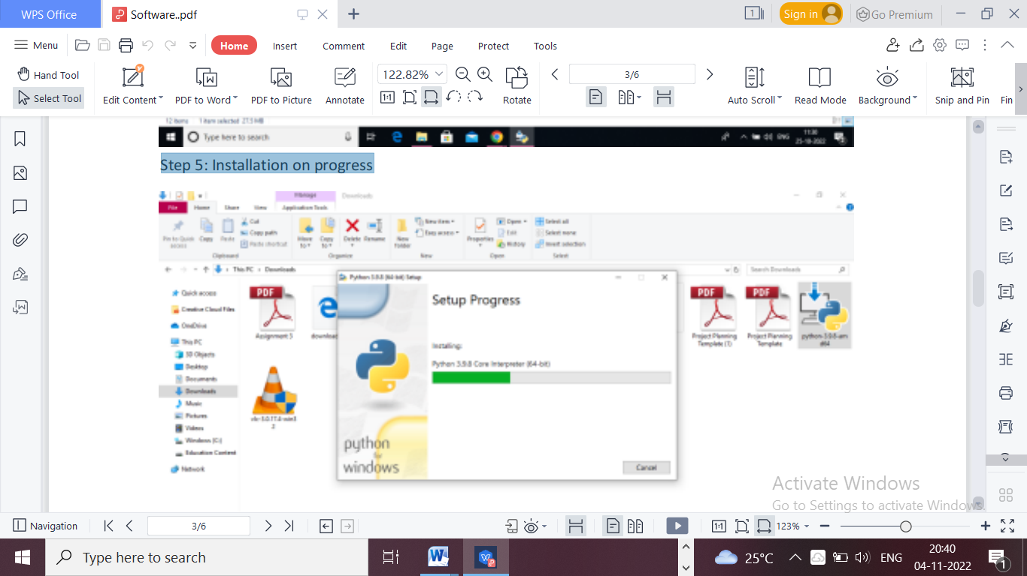

**Step 6:Close the button**

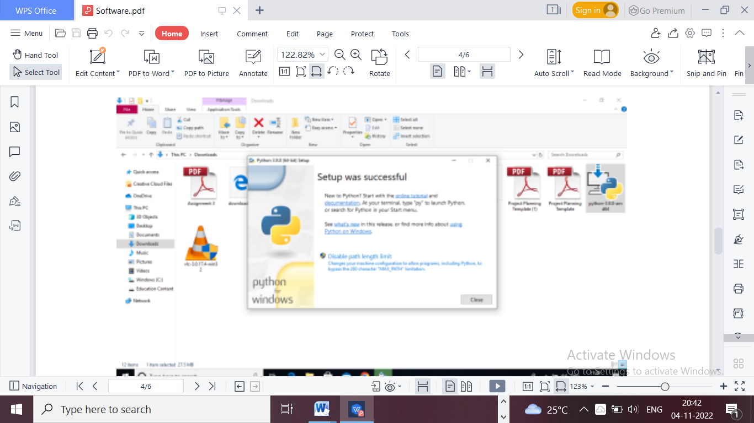

**Step 7: Search IDLE**

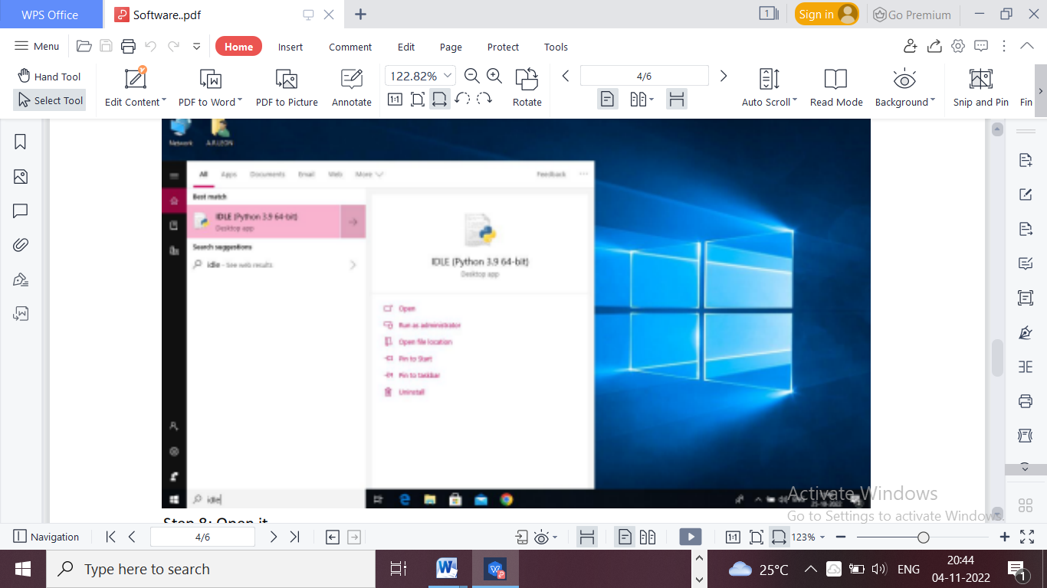

**Step 8: Open it**

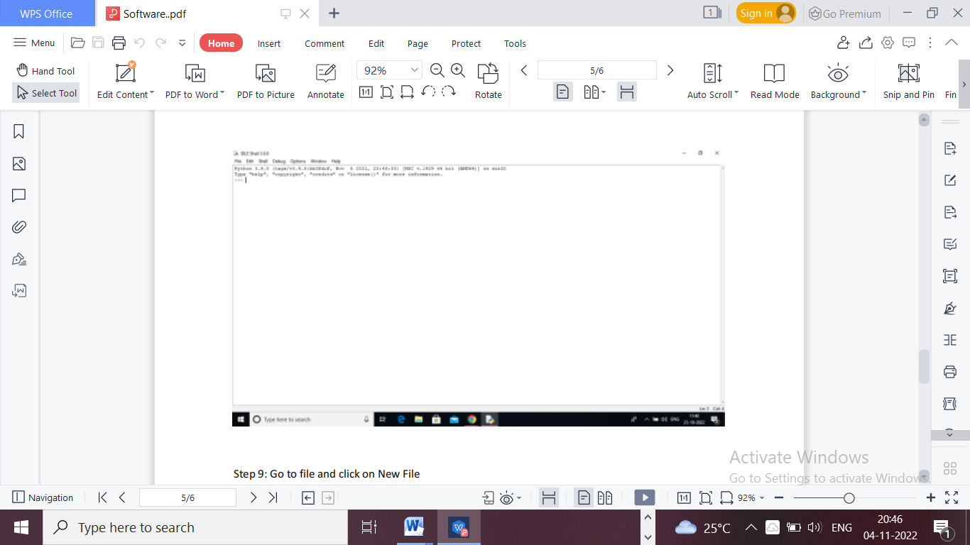

**Step 9: Go to file and click on New File**

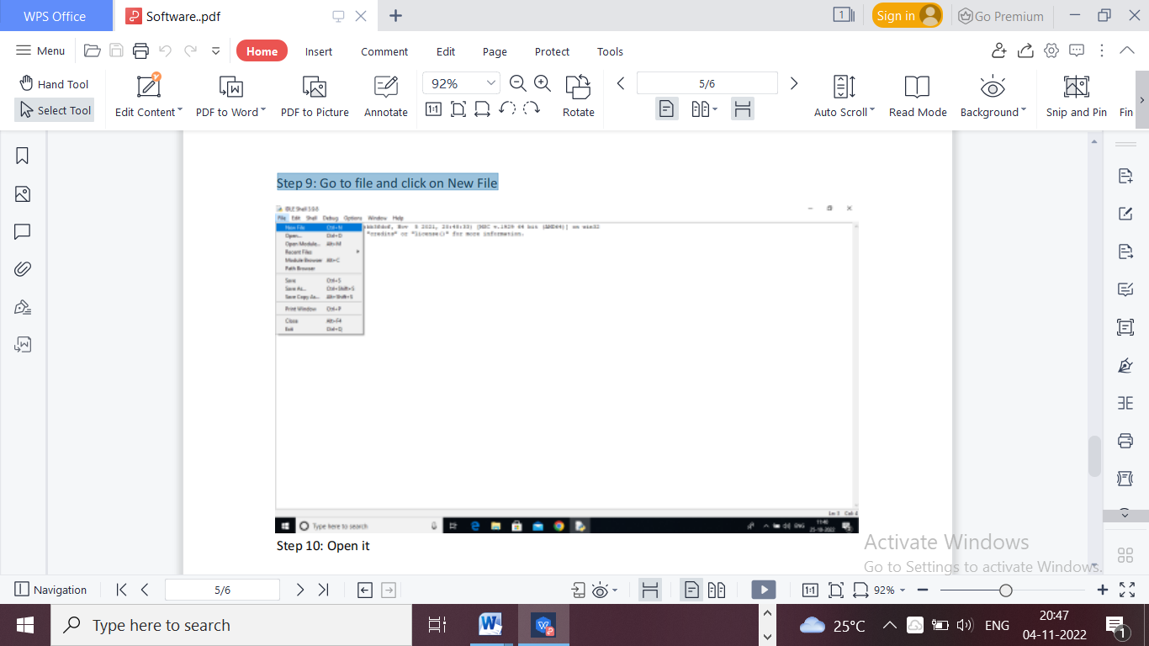

**Step 10: Open it**

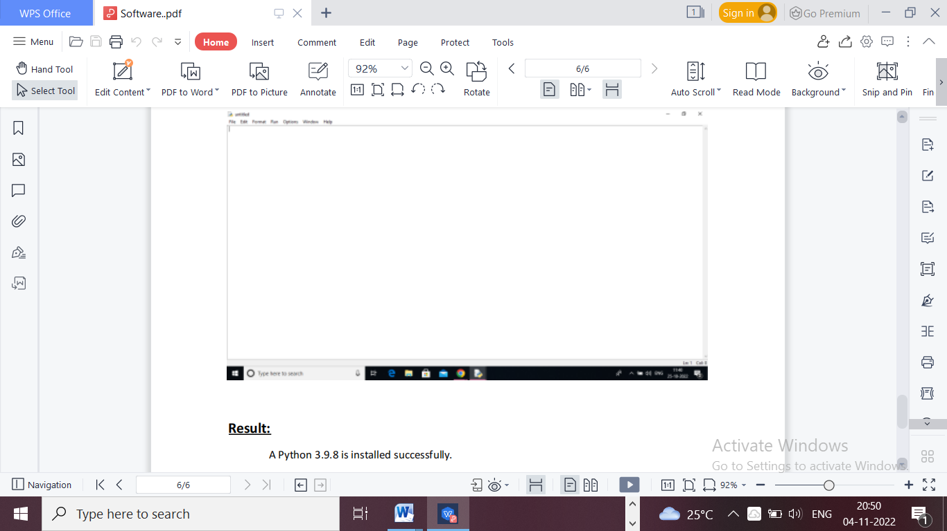

**Result:**

A Python 3.9.8 is installed successfully