# Prerequisites

|  |  |
| --- | --- |
| Date | 16 November 2022 |
| Team ID | PNT2022TMID47453 |
| Project Name | Project - Industry-Specific Intelligent Fire  Management System |

**Prerequisites:**

To complete this project, the prerequisites are

* IBM Cloud Services
  + IBM Watson IoT Platform
  + Node-RED Service
  + Cloudant DB
* Software
  + Python

**IBM Cloud Services**

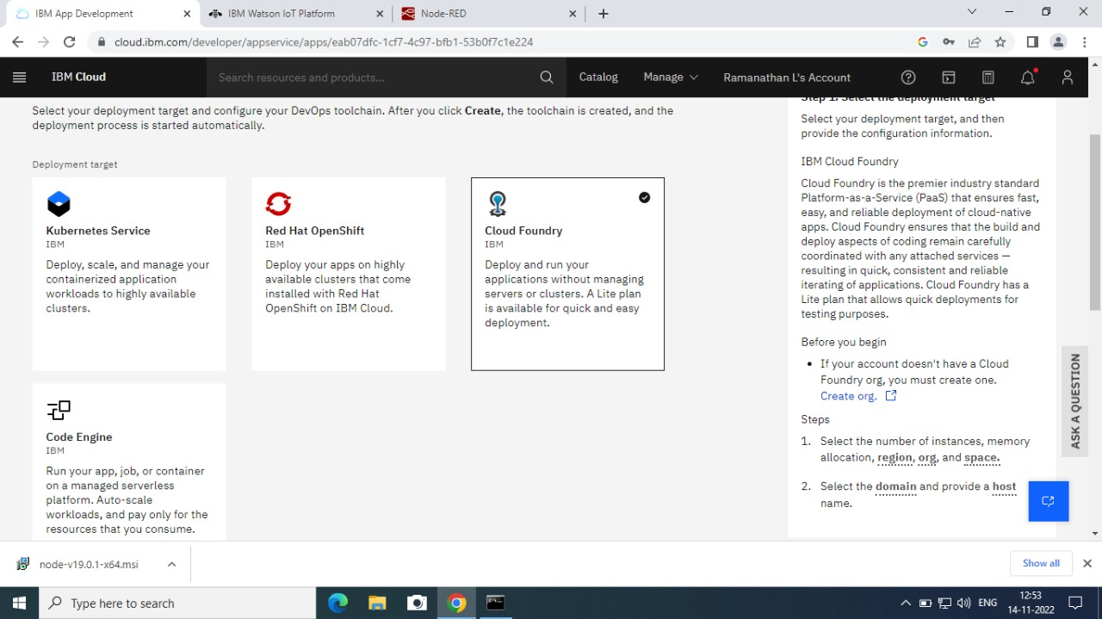

# IBM Watson IoT Platform

IBM Watson IoT platform acts as the mediator to connect the web application to IoT device, so create the IBM Watson IoT platform

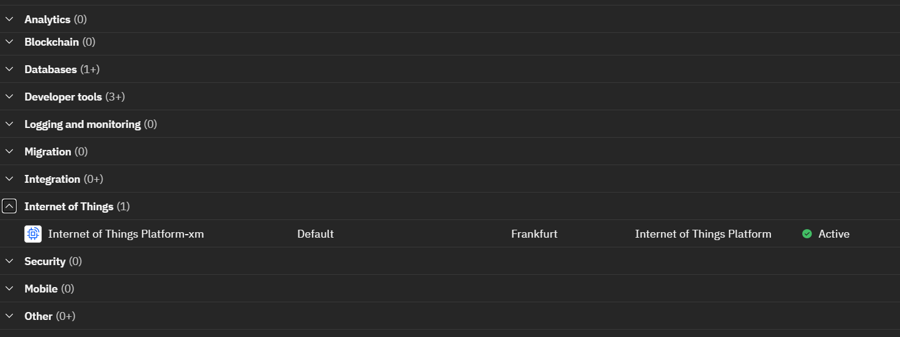

## Node-Red

**To create a web application, we need to create a Node-RED service.**

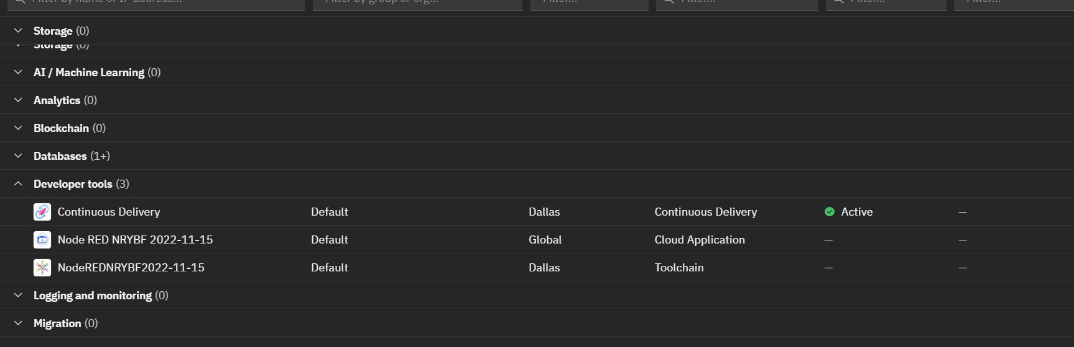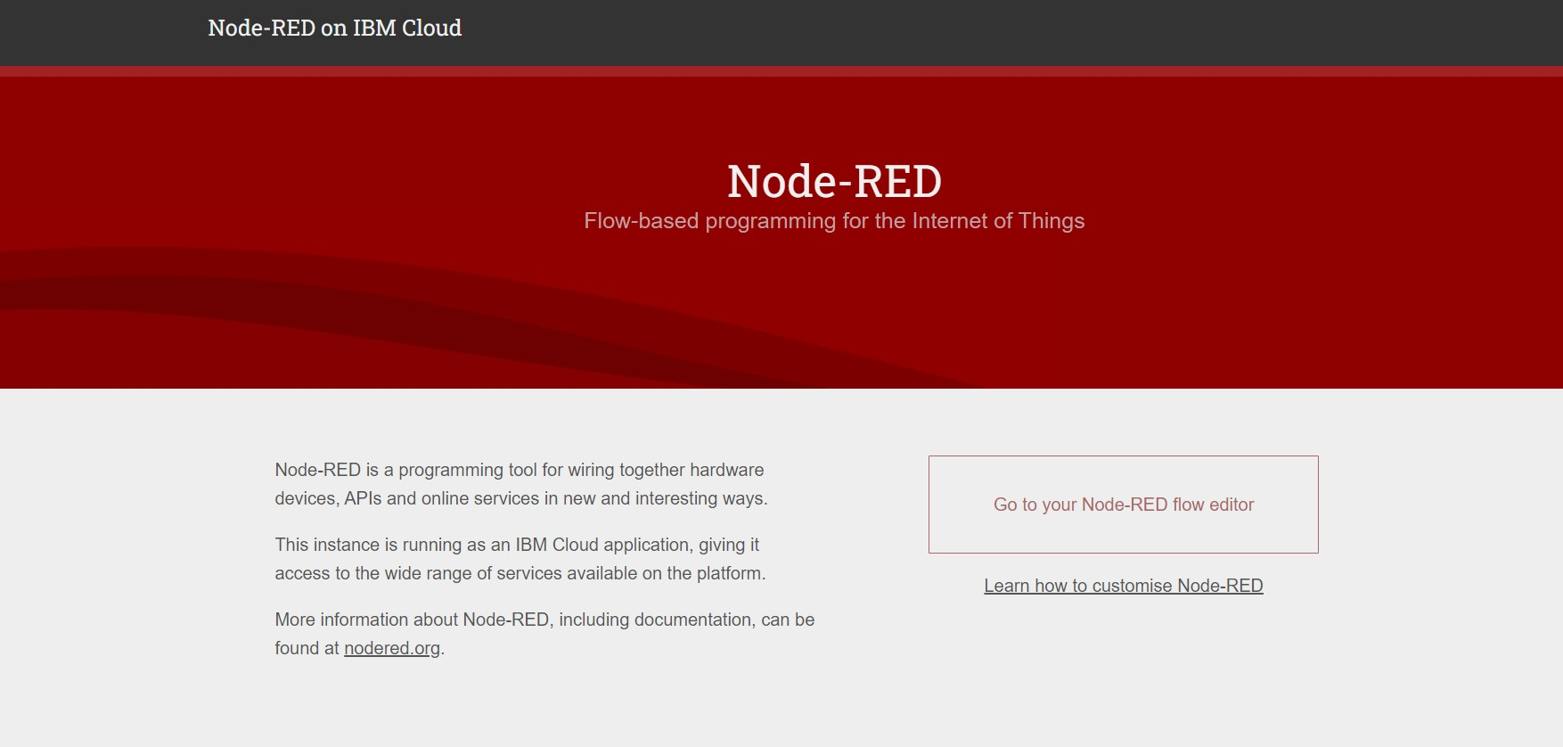

## Cloudant DB

To store the sensor values, Cloud db is created.

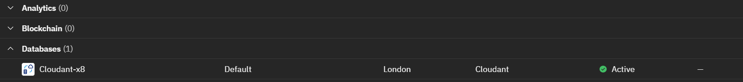

## Python

To Develop a python script to publish random sensor data to the IBM IoT platform, we need to install Python 3.7.0 Shell

