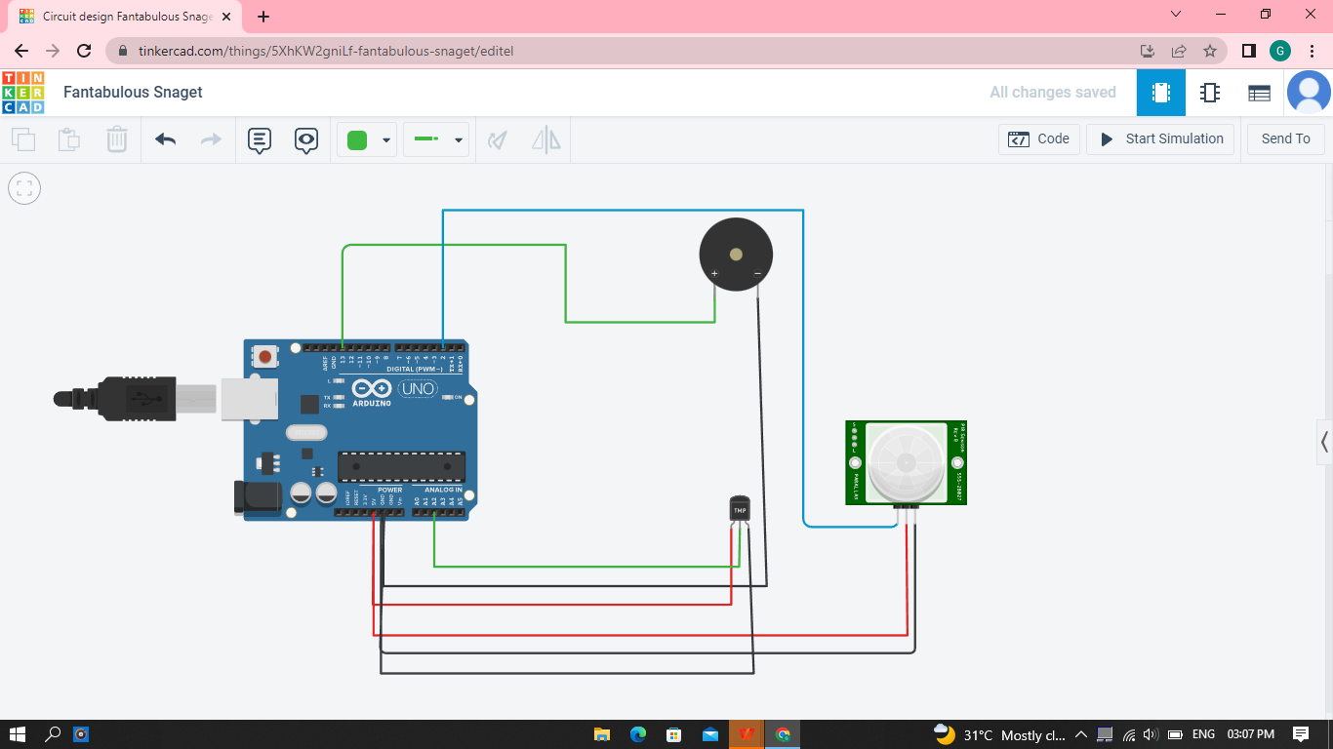

**CIRCUIT DIAGRAM**

void setup()

{

Serial.begin(9600);

pinMode(2,INPUT);

pinMode(13,OUTPUT);

}

void loop()

{

int motion=digitalRead(2);

Serial.print("Position is");

Serial.println(motion);

if(motion==1)

{ tone(13,100);

delay(500);

}

else{ noTone(13);

}

double data=analogRead(A2);

double n=data/1024;

double volt=n*5;

double off=volt-0.5;

int temp=off*100;

Serial.print("Temperature is:");

Serial.println(temp);

if(temp==60)

{

tone(13,400);

delay(500);

}

Else

{

noTone(13);

}

}

**OUTPUT :**

**TEMPERATURE ABOVE**

**60 C**

